Checklist
- Cheques, notes and coins must be separated into the correct bags (as shown below), as they are taken to different processing centres
- Put one Barclays paying in slip in each of the coin, note and cheque bags
- Do NOT put coins and notes on the same Barclays paying in slip – please use a separate Barclays paying in slip
- Coins do not need to be put into individual denomination bags
- Each note denomination must be separated and either secured with an elastic band, batched using the Barclays note wrappers or put into a ‘poly note envelope’ for the specified value
- If you wish to separate any different income then use an inner bag (provided by G4S) within the appropriate cheque, note or coin bag
- If you use an inner bag it must have its own Barclays paying in slip
- If you use an inner bag then you must complete a Barclays cash and cheque insert slip
- You must NOT use photocopies of paying in slips in any circumstances
- The outside of ALL bags (including inner bags where used) must be clearly labelled and sealed ready for collection
- You must not exceed the £7,500 cash limit for G4S collections (or £20,000 for those sites who have
a specific agreement with G4S)
- The portal posting for each General Fund paying in slip must be done at the same time as the paying in slips are completed.
For your G4S driver = 4 containers ONLY

The below should be all that you hand to your driver:

X1 cheque container x2 coin containers (if required) x1 note container
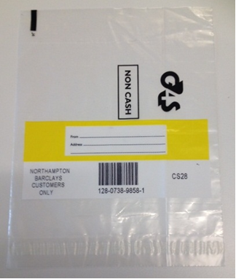
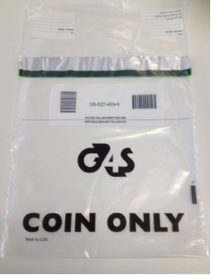
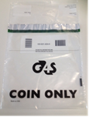
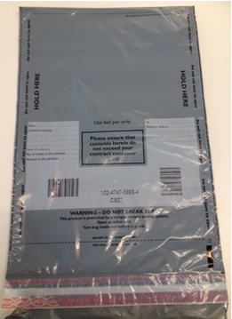

Further information

G4S stationery email: g4scustomerservices@uk.g4s.com
G4S no show driver/other enquiries: call 0844 800 4205 (ask for BCC Co-ordinator)
Guidance pack ‘paying in’ https://www.birmingham.gov.uk/downloads/download/1741/barclays_banking_arrangements_for_schools

