When bagging up for your cash collection service please follow the steps below to avoid monies being delayed or lost:

Step 1 - Preparing your coins

- You no longer need to separate coins into the different denominations bags.
- Complete a Barclays paying in (giro) slip for the total value of coins (see photo 6 below)
- If you are using more than one coin container you MUST ensure each coin container has at least one paying in (giro) slip inside to enable the cash centre to identify who has paid the coins in
- You can either place the paying in (giro) slip around the coin bags using an elastic band or place it with the coin bags
- If you complete more than one paying in (giro) slip for your coins e.g. for different types of income, please write this on to your cash and cheque insert slip (see photo 7 below). This is the A5 carbonated book you received from Barclays bank
- Place all your coin bags, paying in (giro) slips and the cash and cheque insert slip into your coin container and complete the details on the outside as shown below (see photo 1 below)
- You can use an inner bag (see photo 2 below) which will keep items separate within the coin container for example different weeks monies. This is optional but if you chose to do this place the coin bag(s) and paying in (giro) slip(s) into this and ensure you complete the outside of the inner bag. Please note: if you are part of a consignment agreement with G4S e.g. leisure centres, and currently use inner bags (see photo 2 below) to separate coins please ensure you continue with this arrangement
- Once you have completed the coin container ready for collection by G4S please seal it
- At all times if the container is not sealed please ensure it is securely locked away.

Photo 1 - Coin container
Please complete all sections please note:
- No. of credits refers to the number of paying in (giro) slips enclosed
- To: Barclays Cash Centre
- Leave Delivery address blank
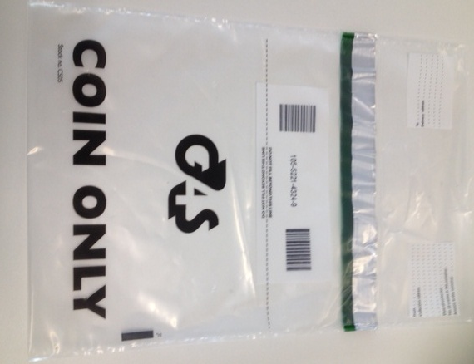

Do not fill past the dotted line

Photo 2 - Inner bag
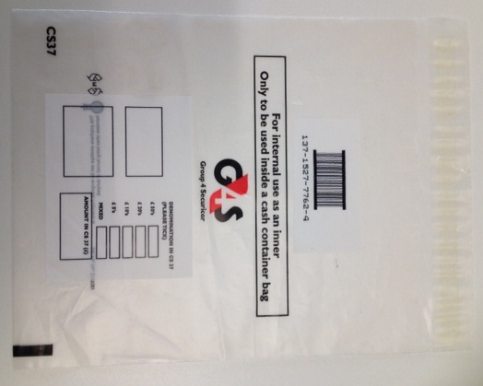

Please complete all sections

Step 2 – Preparing your notes

- Place the same denomination of notes into bundles i.e. £5’s together and secure with an elastic band (NOT a paper clip)
- If you have the required amount to fill a poly note envelope bag place your notes in here and seal this. Please note: these can be ordered via the Barclays paying in stationery order form
- Complete a Barclays paying in (giro) slip for the total value of the notes
- You can either place the paying in (giro) slip around the bundles of notes using an elastic band or place it with the bundles of notes
- If you complete more than one paying in (giro) slip e.g. for different types of income, please complete a separate cash and cheque insert slip (see photo 7 below). This is the A5 carbonated book you received from Barclays bank
- Place all the sorted notes, paying in (giro) slips and the cash and cheque insert slip into your note container and complete the details on the outside (see photo 3 below)
- You can use an inner bag (see photo 2 below) which will keep items separate within the notes container for example different weeks monies. This is optional but if you chose to do this place the notes and paying in (giro) slip(s) into this and ensure you complete the outside of the inner bag. Please note: if you are part of a consignment agreement with G4S e.g. leisure centres, and currently use inner bags (see photo 2 below) to separate notes please ensure you continue with this arrangement
- Once the note container is complete and ready for collection by G4S please seal it
- At all times if the container is not sealed please ensure it is securely locked away.

Photo 3 – Note container
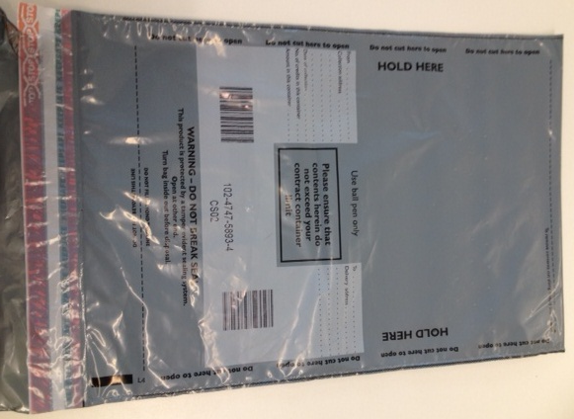

Please complete all sections:
- No. of credits refers to the number of paying in (giro) slips enclosed
- To: Barclays Cash Centre
- Leave Delivery address blank

Step 3 – Preparing your cheques

- Put all your cheques together and complete a Barclays paying in (giro) slip for the total value of the cheques
- You can place the paying in (giro) slip around the cheques using an elastic band
- If you complete more than one paying in (giro) slip e.g. for different types of income, please complete a separate cash and cheque insert slip (see photo 7 below). This is the A5 carbonated book received from Barclays bank
- You do NOT need to use an inner bag to separate cheques
- Place all cheques, paying in (giro) slips and the cash and cheque insert slip into your cheque container (see photo 4 below) and complete the details on the outside
- Once the cheque container is complete and ready for collection by G4S please seal it
- At all times if the container is not sealed please ensure it is securely locked away.

Photo 4 – Cheque container
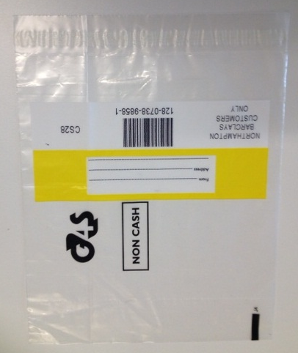

Complete both sections – please note the address is your site address

Step 4 - Putting it all together

Checklist – please ensure that for your coins, notes and cheques you have:

- Completed paying in (giro) slips as required and either attached them to or placed them with your coins, notes or cheques
- Completed a cash and cheque insert slip where you are using more than one paying in (giro) slip for your coin container, notes container and cheque container
- Placed your completed paying in (giro) slip(s), cash and cheque insert slip (if required), coins, notes and cheques in their appropriate containers as shown (see photo 5 below). Please remember if you are using two coin containers, each one has at least one paying in (giro) slip inside
- You have correctly labelled the outside of the containers (including inner bags where used) and sealed them in readiness for your collection
- You have NOT exceeded the £7,500 cash limit for G4S collections (or £20,000 for those sites who have a specific agreement with G4S)
- You have all your containers ready for collection (see photo 5 below)

What you should give to your G4S driver

Photo 5 – the 4 containers G4S can take away

X1 cheque container x2 coin containers (if required) x1 note container
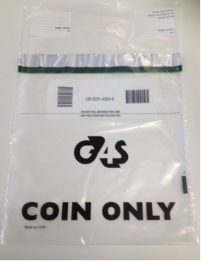
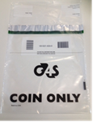
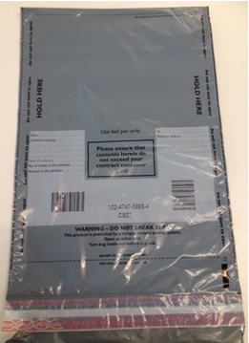
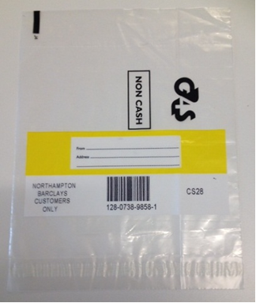

Total = 4 containers ONLY.
(Please note there will be more containers where you have agreed a higher cash collection limit with G4S)

Your paying in (giro) slip

These are in your Barclays paying in book and contain your site reference number (1st three numbers – bottom left hand corner of each slip). If you require additional paying in books please complete the ‘paying in book & paying in stationery order form’ on

Photo 6 – your paying in (giro) slip

Barclays cash & cheque insert slip (see photo 7)

These are provided by Barclays and MUST be used if you have completed more than 1 paying in (giro) slip to identify different types of income when bagging up coins, notes and cheques. We are asking you to complete this as it provides a summary of the paying in (giro) slips you are placing into a container. Additional insert slips can be ordered using the ‘paying in book & paying in stationery order form’ (Item ref: 1903 called Cash & Cheque Insert Slips) which can accessed through Voyager, inline or the HR Portal (see useful contacts below).

Photo 7 - cash and cheque insert slip

Useful contacts and further information

- For additional G4S stationery please email: g4scustomerservices@uk.g4s.com (please note you will need your contract number)
- If G4S do not show up for your collection or you have any other G4S enquiries please call the G4S Customer Services and ask for the Birmingham City Council Co-ordinator call: 0844 800 4205.

Further guidance on paying in arrangements can be found in the ‘Guidance Pack’ – paying in section. This can be accessed https://www.birmingham.gov.uk/downloads/download/1741/barclays_banking_arrangements_for_schools

