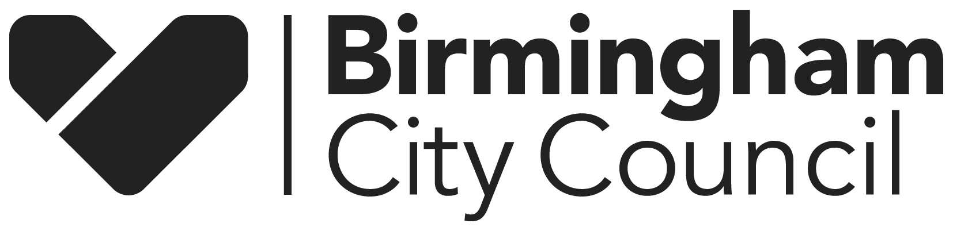

# NOTICE OF REVIEW OF POLLING DISTRICTS AND POLLING PLACES

Birmingham City Council is carrying out a review of polling districts and polling places in the City.

Details of the current arrangements can be viewed at the Elections Office, and on the Council’s website, [www.birmingham.gov.uk/elections](http://www.birmingham.gov.uk/elections).

If you would like to make comments, or have any questions, please contact the Elections Office by **Monday 18 November 2024** **at the latest.**

All proposals and comments will be available for inspection at the Elections Office on completion of the process, and will be published at the conclusion of the review.

It is intended to complete the review by the end of the year so any changes are reflected in a revised register to be published on 1 February 2025.

**You can contact the office in the following ways:**

**In writing:**

**Elections Office, Council House, Victoria Square, Birmingham B1 1BB**

**Phone: 0121 303 9454**

**E-Mail:** [**electionsoffice@birmingham.gov.uk**](mailto:electionsoffice@birmingham.gov.uk)

**10 October 2024**