# 844: High Street / Harborne Park Road Apartments Midland Properties and Finance (Birmingham) Ltd

**07.06.2023**

**844-D5A-00-XX-SH-A-0004-Planning_Amendment_Schedule-S2-P01**

## BCC Planning Comment Design Amendment

**1**

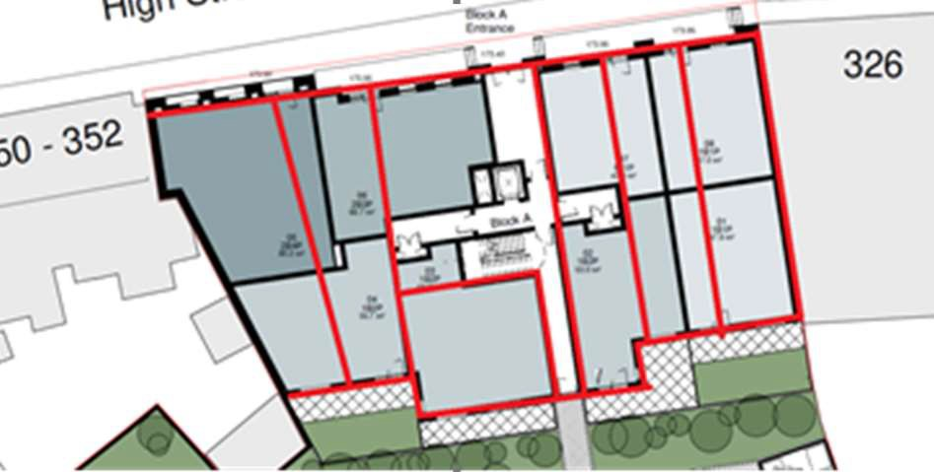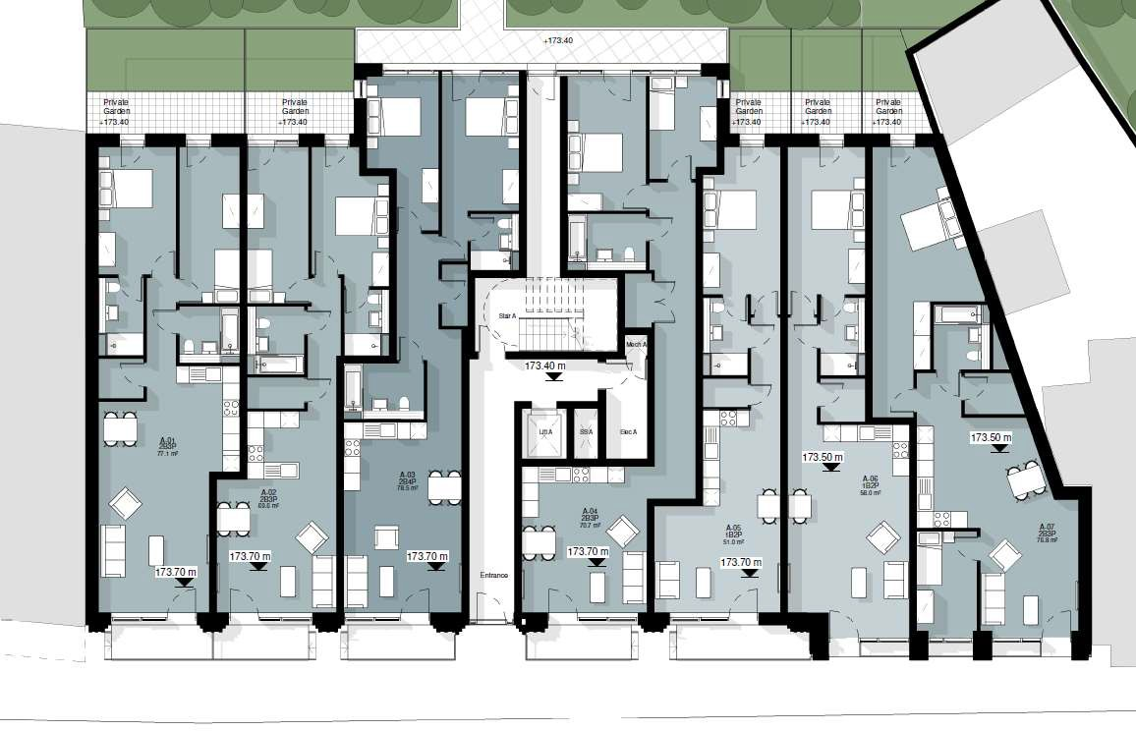

**Block A Ground Floor Plan**

(BCC) would suggest that this block is changed so as to form five linear units that are duel-aspect, with a front door leading to a kitchen and living room overlooking the street, and bedroom space to the rear overlooking the garden.

Ground floor layout reconfigured to locate all living rooms to street elevation with bedrooms to rear elevation overlooking courtyard, refer to amended plans, as illustrated below;

## 2

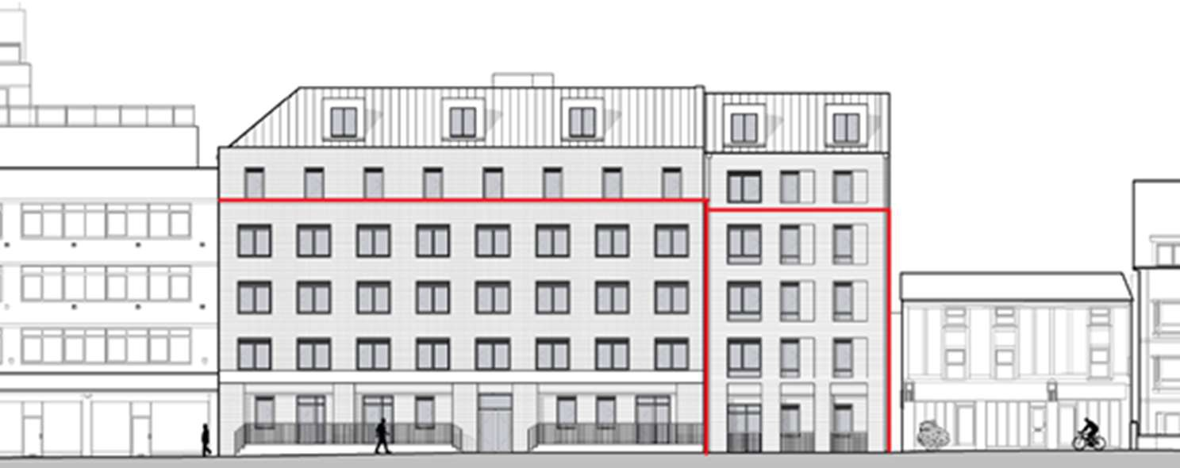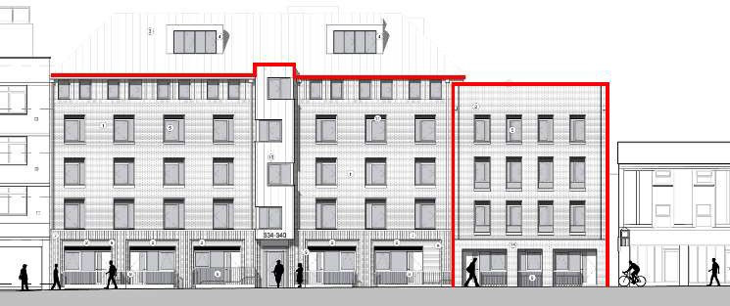

Block A height has been reduced to the height recommended by BCC, refer to amended elevations as illustrated below;

Block A frontage is too high and should be reduced as below

**Block A Height**

**3**

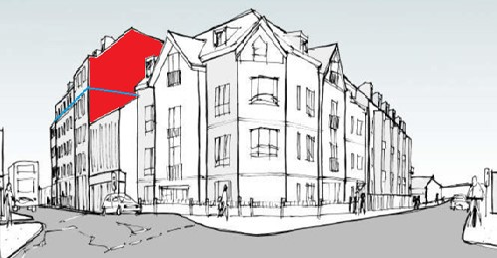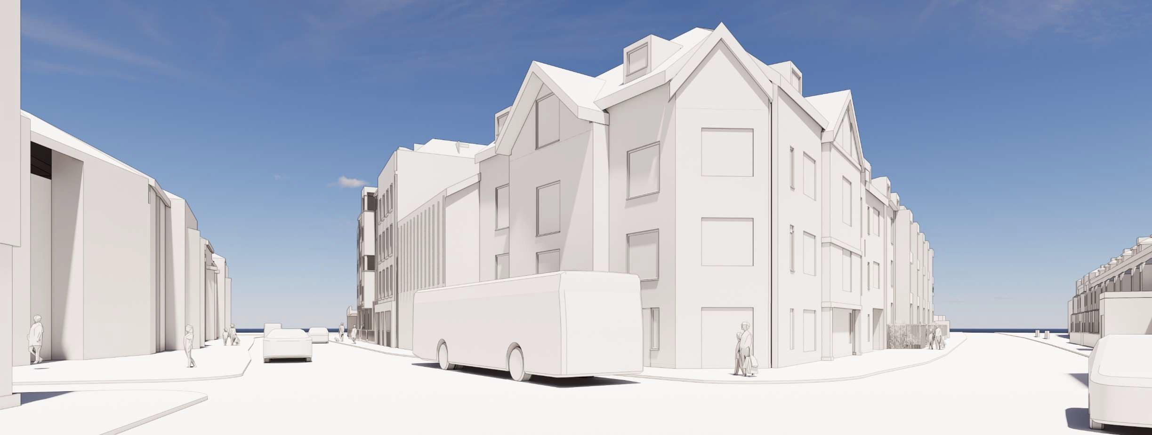

**Block A Gable Wall**

The view approaching the development from the west is of significant concern as the blank gable with crown roof is fully visible, unattractive and entirely unacceptable.

The gable has been remodelled to reduce its height and the number of apartments reduced to accommodate a stepped form reducing the visual impact when viewed from the junction as illustrated below;

## 4

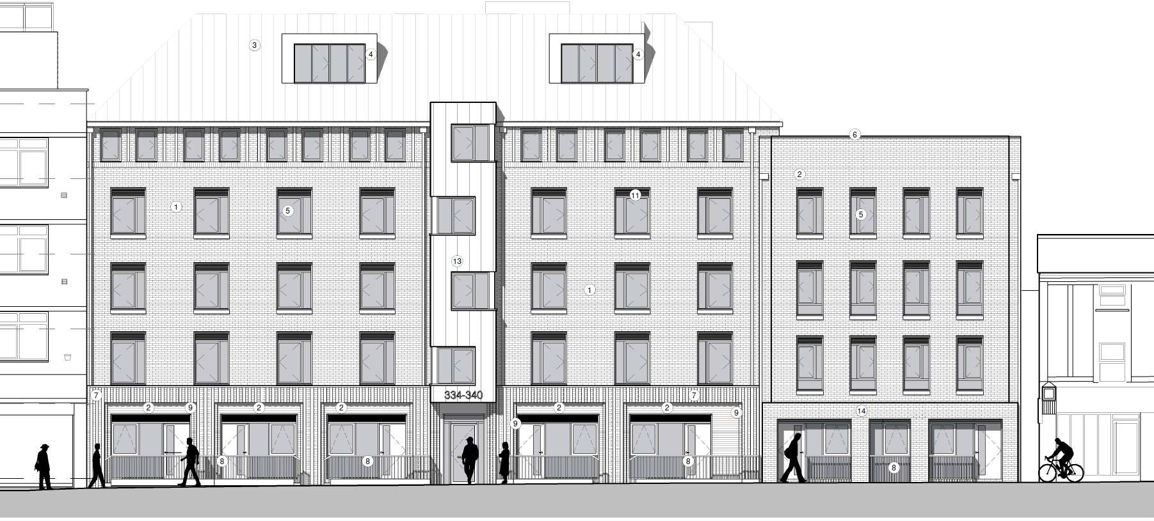

**Block A High Street Elevation Design**

The High Street elevation (Block A) is considered to be unremarkable, with a utilitarian ground floor supporting a mass of plain brickwork with windows punched into it. The two block approach is appreciated, but not enough is done to achieve clear separation between them. The slightly smaller right-hand side section is better, but neither are memorable. Considering the amount of development sought, more could be done to mitigate massing, which is still generous even at the reduced scale if one considers the established wider scale of Harborne (ignoring the regrettable adjacent development, which does not set a positive precedent).

The elevation has been redesigned taking into account the BCC requirements for overall heights to provide a more classically formed elevation with clearly defined base, middle and top incorporating diminishing scale openings set in regular bays and brickwork detailing with a projecting feature bay emphasising the entrance. Refer to the amended elevations submitted with this schedule.

**5 Block B Harborne Park Road Block**

The height of the elevation should be reduced to 3 storey and align with the previously consented scheme.



Harborne High Street Elevation Image

The elevation height and ridge line have been reduced to reflect the previously consented scheme and to be more in keeping with the properties opposite. Refer to the amended submitted elevations as illustrated below;

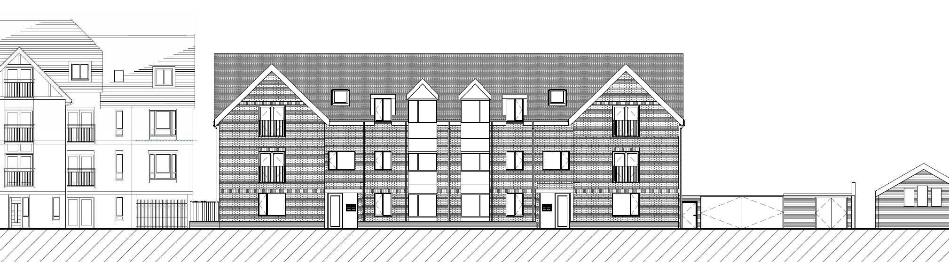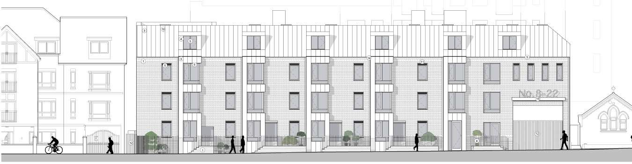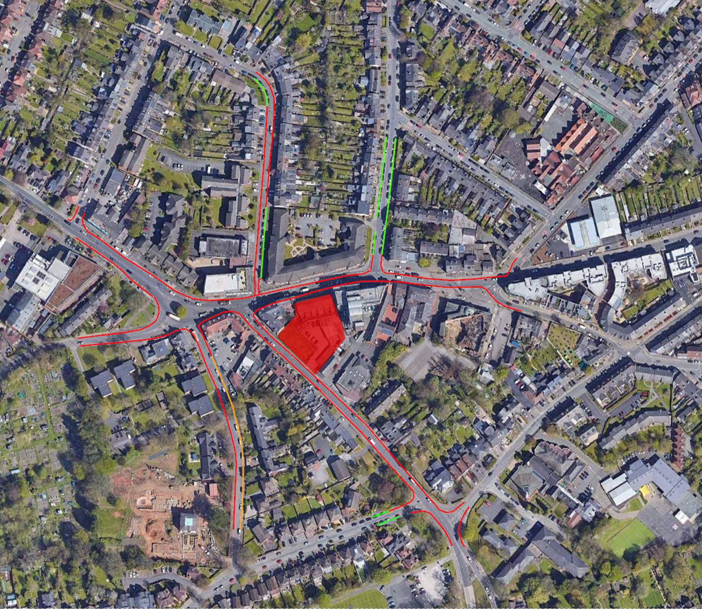

**Car Parking**

## 6

The scheme proposes no car parking and it is entirely realistic that a reasonable proportion of occupiers will own a car and will therefore be forced to find space on street to park. As there are double yellow lines on both the High St and Harborne Park Rd in the vicinity of the development, this would suggest any such parking would be pushed onto other local roads. Even then there is limited unregulated on street parking on these roads putting undue pressure on the existing residents who park there.

I am also concerned that there is no on-site parking for disabled users.

The scheme proposal is in line with BCC Parking SPD adopted in November 2021 for a development located in a sustainable location with strong public transport provision as outlined within the transport statement previously submitted. Assessment has been undertaken of parking opportunity within 250m of the site which supports the BCC view that there is little opportunity for unregulated on street parking as illustrated below.

Disabled parking bays have been added into the courtyard as requested and as illustrated on the amended plans submitted.

## 7

**Housing Mix**

I note that the scheme proposes 53 x 1 bed and 34 x 2 bed properties. The Council’s recent Housing and Economic Development Needs Assessment (HEDNA) identifies that there is greatest need for 2 and 3 bedroom properties, including within the sub-area within which the site falls. To reflect the housing needs locally there is a need to reverse the housing mix so more 2 beds than 1 beds are proposed. The HEDNA is available here: Evidence Base for the new Birmingham Local Plan | Birmingham City Council.

The mix has been revised through redesign of units and a reduction in the overall proposed number of dwelling to provide a majority of 2 bed apartments. All apartments comply with or exceed the requirements of the Technical Housing Standards - Nationally Described Space Standards

## 8

**Housing Type**

Build to rent is covered from para. 9.46 of the HEDNA. The growth of the build to rent sector is highlighted and the report provides advice to the Council in terms of developing a planning policy to cover the sector. Specifically para. 9.64 highlights that growth in the sector should be encouraged in the Central sub- area and in Edgbaston and Selly Oak in close proximity to the University. There is currently no evidence to suggest a demand for build to rent in Harborne.

It has been agreed that the site falls within an area of rental need as included in the HEDNA document and a further market assessment will not be required.

## 9

Proposed condition;

ECOL09 should be applied to secure that.

Proposed condition accepted

In terms of the landscape and ecological enhancement I would suggest that ECOL 08 be applied for the enhancement aspects and the modified LAND 01 condition as below for securing the required landscape detail.

"Requires the submission prior to occupation of hard and soft landscape details

A scheme of hard and soft landscape works shall be submitted to and approved in writing by the Local Planning Authority prior to occupation and these works shall be carried out as approved.

These details shall include:

1)

A scaled plan at 1:100 showing all existing vegetation and landscape features to be retained;

and where used, locations of individually planted trees, areas of woodland, shrubs, hedges, herbaceous planting, bulbs, and areas of grass.

2)

Within ornamental planting areas, plans should be sufficiently detailed to show the locations

of different single species groups in relation to one another, and the locations of any individual specimen shrubs.

3)

Planting schedules noting species, plant sizes and proposed numbers/densities, and details

of the proposed planting implementation programme.

4)

Location, type and design of materials to be used for hard landscaping, including ground

surfacing, paving, kerbs, edges, steps and furniture.

5)

Specifications, where applicable for the following:

•

•

permeable paving;

tree pit design – indicating root available soil volumes and matched to species demands at mature size;

* underground modular systems;
* sustainable urban drainage integration;
* surfacing within tree Root Protection Areas (RPAs)
* Green/ brown roof details

**Ecology**

6)

Specifications for operations associated with plant establishment and maintenance that are

compliant with best practice.

7)

Retaining structures, noting their height, design and facing materials.

8)

Minor artefacts and structures.

9)

Proposed and existing functional services above and below ground.

All hard and soft landscape works shall be implemented in accordance with the approved details.

The works shall be implemented prior to the occupation of any part of the development or in accordance with a programme agreed with the Local Planning Authority and thereafter maintained.

Any trees or shrubs which, within a period of two years from the completion of the development, die, are removed or become seriously diseased or damaged, shall be replaced in the next planting season with others of similar size and species.

Reason: In order to secure the satisfactory development of the application site, ensure a high quality of external environment and reinforce local landscape character in accordance with Policies PG3, TP3 and TP7 of the Birmingham Development Plan 2017 and saved Paragraph 3.14 of the Birmingham UDP 2005."

**10**

Proposed condition accepted

Severn Trent have proposed the following condition;

* The development hereby permitted should not commence until drainage plans for the disposal of foul and surface water flows have been submitted to and approved by the Local Planning Authority, and the scheme shall be implemented in accordance with the approved details before the development is first brought into use. This is to ensure that the development is provided with a satisfactory means of drainage as well as to prevent or to avoid exacerbating any flooding issues and to minimise the risk of pollution.

**Drainage**

**11**

**Energy Use**

Policy TP3 sets out a number of ways in which development should be designed and constructed.

Policy TP4 requires all new development to incorporate the provision of low and zero carbon forms of energy generation or connect into a network where is exists, unless it can be demonstrated that the cost of achieving this would make the proposed development unviable. A combined energy and sustainable construction statement has been submitted. The statement is unacceptable. On 15th June 2022 building regs changed. As the application was submitted post building regs changes (application form dated 23/08/22), the application will be required to meet the reduction requirements of 31% against the baseline, in line with the updated guidance note:

A sample number of the units have been assessed against the new criteria and proven to pass. This is illustrated in ??????? Report from Halligan Associates. Should this be acceptable we suggested a condition to demonstrate full and detail compliance pre-commencement of development through further submission of detail design calculations.

h ttps://[www.birmingham.gov.uk/downloads/file/12999/guidance_note_on_sustainable_construction_and_energy_statements](http://www.birmingham.gov.uk/downloads/file/12999/guidance_note_on_sustainable_construction_and)

Therefore, the entirety of the energy and sustainable construction statement will require review.

## 12

*2, Requires the prior submission of a Sustainable Drainage Operation and Maintenance Plan*

*No building or use hereby permitted shall be occupied or the use commenced until a Sustainable Drainage Operation and Maintenance Plan (including details of agreement with an adopting body and proposed inspection and maintenance actions) has been submitted to and approved in writing by the Local Planning Authority and the sustainable drainage for the development has been completed in accordance with the approved sustainable drainage scheme.*

*The approved drainage system shall be operated and maintained thereafter in accordance with the approved agreement with the adopting party and the approved Sustainable Drainage Operation and Maintenance Plan*

Proposed condition accepted

The following conditions have been suggested;

*1, Requires the prior submission of a sustainable drainage scheme*

*No development shall take place until a surface water drainage scheme for the site, based on sustainable drainage principles and an assessment of the hydrological and hydro geological context of the development, has been submitted to and approved in writing by the Local Planning Authority. The scheme shall be implemented in accordance with the approved details before the development is completed and thereafter maintained.*

**Lead Local Flood Authority**