

**STATEMENT OF COMMUNITY ENGAGEMENT**

334-346 HIGH STREET & 8-22 HARBORNE PARK ROAD, HARBORNE, BIRMINGHAM

June 2022



# CONTENTS:

Page No:

1. INTRODUCTION 1
2. POLICY GUIDANCE AND BEST PRACTICE 2
3. PUBLIC CONSULTATION STRATEGY 4
4. MONITORING 6
5. ANALYSIS OF RESPONSES 8
6. PRE-APPLICATION DISCUSSIONS 10
7. CONCLUSIONS 14

## APPENDICES:

APPENDIX 1 - SHOP FRONT ADVERTISEMENT

APPENDIX 2 - PHOTOGRAPHS OF SHOP FRONT ADVERTISEMENT APPENDIX 3 - COPIES OF SOCIAL MEDIA POSTS

APPENDIX 4 - EXHIBITION BOARDS APPENDIX 5 - FEEDBACK FORM TEMPLATE APPENDIX 6 - EXHIBITION PHOTOGRAPHS

## INTRODUCTION

* 1. This Statement of Community Engagement (SCE) has been prepared on behalf of Midland Properties and Finance (Birmingham) Ltd and supports a full planning application for residential development 334-346 High Street and 8-22 Harborne Park Road, Harborne, Birmingham, B17 9PU. The applicant seeks to deliver 87 apartments across two new residential building blocks.
  2. The Structure of this SCE is as follows:

**Chapter 2** – sets out the national and local policy context and best practice guidance used to inform a meaningful, inclusive and positive approach to the engagement of the local community in shaping the development proposals.

**Chapter 3** – describes the public consultation methods that were utilised, following best practice and policy guidance.

**Chapter 4** – provides an analysis of the monitoring which was undertaken as part of the consultation process.

**Chapter 5** – undertakes an analysis of the comments received and topics raised, along with the applicant’s response.

**Chapter 6** – provides a discussion of the pre-application discussions with the Local Planning Authority including the evolution of the scheme as a result.

**Chapter 7** – concludes the report, noting that the approach adopted was inclusive, meaningful and successful, attracting a range of views which together have had a clear and positive influence on the design of the development.

## POLICY GUIDANCE AND BEST PRACTICE

* 1. Pre-application consultation is an essential element of the planning and development process. It is about engaging with local communities, stakeholders, groups and organisations with the aum of shaping a proposal so that the subsequent application takes into account, as far as is appropriate and possible, local views and opinions. The approach adopted by the applicant builds on best practice.

*‘To be proper, consultation must be undertaken at a time when proposals are still at a formative stage. It must include sufficient reasons for particular proposals to allow those consulted to give intelligent consideration and an intelligent response; adequate time must be given for this purpose; and the product of consultation must be conscientiously taken into account when the ultimate decision is taken.’*

*R V Brent London Borough Council ex parte Gunning [1985] 84 LGR 168.*

### National Planning Policy

* 1. The Government has set minimum standards for consultation on planning applications and these are to be found in Article 13 of the Town and Country Planning (Development Management Procedure) (England) Order 2015.
  2. The National Planning Policy Framework (NPPF) (2021) advises local planning authorities to “*encourage any applicants who are not already required to do so by law to engage with the local community and, where relevant, with statutory and non-statutory consultees, before submitting their applications.”* (para. 40).
  3. The NPPF also emphasises the importance of early engagement for the efficiency and effectiveness of the planning application system.

### Local Planning Policy

* 1. The Statement of Community Involvement (SCI) for Birmingham was adopted in January 2020. Regarding pre-application consultation, the SCI is recognises that whilst it is not mandatory or a legal requirement, that it is important for developers to engage with local communities prior to the submission of a formal planning application. The process enables communities and stakeholders to have early input into planning proposals and help to identify improvements and overcome objections at a later stage.
  2. The SCI adds that the level of engagement needs to be proportionate to the nature and scale of the proposed development. It also encourages developers

to have discussions with local residents to establish if a relevant proposal might enhance social value.

* 1. The details of pre-application consultations with the Council, local community and statutory consultees (if necessary) should form the basis of a Statement of Community Involvement which is submitted with the planning application.

### Good Practice Guidance

* 1. The Royal Town Planning Institute have published a Good Practice Guide to public engagement in development schemes. The guidance includes advice on the different approaches to engagement which can be considered appropriate at different stages of a project. At the pre-application stage this includes:
     + Raising awareness of the consultation in the local area – approaches include press notice, newsletter, leaflet drop, website.
     + Building understanding – approaches include leaflets, websites, information sheets, unstaffed exhibitions
     + Consult and communicate – approaches include staffed exhibitions, interactive displays, questionnaires for feedback, interactive website.

## PUBLIC CONSULTATION STRATEGY

* 1. Following the guidance set out in Chapter 2 of this report, the applicant undertook the following consultation strategy.

### Advertisements

* 1. The applicant put up an advertisement in the Midland Carpets and Furnishings Shop (which is on the application site) front window a week ahead of a scheduled public consultation event. This location was chosen given the high levels of footfall along the High Street. The advert presented a visual CGI of the proposed development with an invitation to the public consultation event.
  2. A copy of the shop front advert is included at **Appendix 1.** Photographs showing the advert are included at **Appendix 2.**
  3. The applicant, through their architects D5, also contacted the Harborne Village BID to raise awareness of the event with a request to share the advertisement.

### Social Media

* 1. On behalf of the applicant, D5 Architects also arranged for the development proposals to be advertised through social media, including sharing the advertisement with details of the public consultation exhibition event inviting members of the public to attend. The applicant published the advert on Twitter, Instagram and Linkedin all of which included the tag ‘#harborne’ to enable greater awareness of the advert when ‘Harborne’ was searched by users of various social media platforms.
  2. The advert was reshared on-line including the Instagram story which was reshared by ‘itsyourbuild Birmingham’ which has over 2,000 followers.
  3. Copies of the on-line social media posts are included at **Appendix 3** to this Statement.

### Public Exhibition

* 1. A public consultation exhibition was hosted by D5 Architects on the application site within the carpet showroom (Midland Carpetings and Furnishings Ltd) on Wednesday 4th May 2022. The event was held in the evening between 17:30 and 19:30pm.
  2. The exhibition was attended by representatives of the applicants design team (D5 Architects) and featured 4 display boards. Feedback forms were also set out, along with a deposit box for them to be anonymously stored.
  3. The consultation event was attended by 5 members of the public. Feedback received at the consultation event was reflective of topics discussed. A total of 5 responses were received. Topics raised included:
* Improvements to the existing site.
* Parking provision.
* Investment to the High Street and area.
  1. Copies of the consultation boards are included within **Appendix 4** and a copy of the feedback form is included at **Appendix 5.**
  2. Photographs of the event are included at **Appendix 6** to this Statement.

## MONITORING

* 1. Monitoring information was collected from members of the public at the consultation event. This information allows the applicant to assess the extent of engagement and whether certain sections of the population have been underrepresented or omitted through the consultation process. Completing monitoring information was optimal for respondents and a ‘prefer not to say’ option was included.
  2. Four ‘tick-box’ questions sought the following information from respondents:
* Distance from the site
* Capacity (i.e. local resident, local business, social group).
  1. The results of the monitoring information are set out within the remainder of this section.

|  |  |  |
| --- | --- | --- |
| **Question** | **No. of Responses** | |
| **Distance from the site** | |  |
| Within 5 minutes walk | 1 | |
| 5-10 minutes walk | 0 | |
| A car journey | 3 | |
| Prefer not to say | 1 | |
| **Capacity** | |  |
| Local Resident | 2 | |
| Local Business | 1 | |
| Local Social Group | 0 | |
| Local Councillor | 0 | |
| Other / Prefer not to say | 2 | |

### Table 4.1: Breakdown of responses via feedback forms

* 1. It is acknowledged that response levels when contrasted with the number of people living and working in the local area has generally been low. However, as set out in Chapter 3, various efforts were made by the applicant to raise awareness of the public consultation event.
  2. The response rate suggests that people did not feel strongly enough about the proposed development to either attend the exhibition event or to make any comments at this point in time.
  3. Of the responses received, the majority of respondents lived/worked within a car journey from the site and were generally responding as local residents.
  4. There will be further opportunity for residents to provide comment on the development to the Local Planning Authority during the formal planning application phase.

## ANALYSIS OF RESPONSES

* 1. All the comments received during the consultation period have each been read and recorded. This Chapter summarises the issues raised and sets out how they have been considered as part of the final design.
  2. A summary of the relevant comments received are set out below:
* The room sizes are big and will be pleasant.
* The development will bring housing into the area.
* Will be a good improvement on the existing buildings.
* The current shop looks tired along the High Street.
* Design looks good.
* The vacant land on Harborne Park Road needs development.
* Balance of parking is interesting.
* Bringing much needed new development to the top of the High Street.
* Excellent development for the area.
* Concern over the lack of parking spaces. Recognition of need to discourage car ownership but may push people to park on already congested side streets in the surrounding area.
  1. Out of the comments received there were no objections, with all comments expressing support for the proposed development to come forward.
  2. Two respondents raised queries related to the parking provision, notably the provision of zero parking spaces on-site. One respondent raised concern that whilst recognising the need to discourage car ownership, this could push parking onto the already congested side streets in the surrounding area.
  3. In responding to this concern, the applicant does not seek to amend the scheme to provide for parking spaces on site. This is because the applicant is seeking a car free site with zero parking which is considered appropriate given the location of the site within Harborne District Centre and its very close proximity to local services and facilities and availability of public transport.

This will encourage cycling and walking by reducing the reliance on the private car and supporting sustainable communities in this location, in line with the climate change agenda.

* 1. Furthermore, to encourage cycling, in line with the Council’s parking standards, the proposed development will include 88 bicycle spaces as well as 10 visitor spaces. This achieves the parking standards resulting in one cycle space per dwelling along with one visitor space per 9 dwellings.
  2. A Travel Plan would be provided to promote the use of sustainable travel to all future residents, which can be secured by way of a planning condition attached to any planning consent.
  3. In summary, the responses received showed 100% support for the proposed development. Whilst it is appreciated that the response rate is low, this suggests that people did not feel strongly enough about the proposed development to either attend the exhibition event despite the efforts of the applicant to advertise the event.
  4. In light of the positive responses received and consideration of all comments, the applicant did not deem it necessary to make any amendments to the proposed development as a result of the public consultation exercise.

## PRE-APPLICATION DISCUSSIONS

* 1. The applicant undertook pre-application discussions with Planning Officers at Birmingham City Council.
  2. A request for pre-application advice was submitted on 17th October 2019. The submission included a Stage One Feasibility Study and Site Location Plan.
  3. The pre-application submission sought advice on early proposals for the redevelopment of the site which included a new residential scheme of 88 apartments within three new development blocks. This includes a mix of 1 bed (75%) and 2 bed (25%) apartments (NDSS compliant).
  4. The building fronting the High Street was proposed as 5 storeys stepping up a further 3 storeys to the rear (total 8 storeys). This approach was to match the form of the adjacent commercial building.
  5. The second building fronting Harborne Park Road was proposed as 3 storeys in height stepping up another storey to the rear (total 4 storeys). A third 3 storey building was proposed along the eastern boundary.
  6. A central courtyard was also proposed between the three new buildings. The figure below is an extract of the early proposal submitted to the Council showing the massing of the development and set back upper floors:

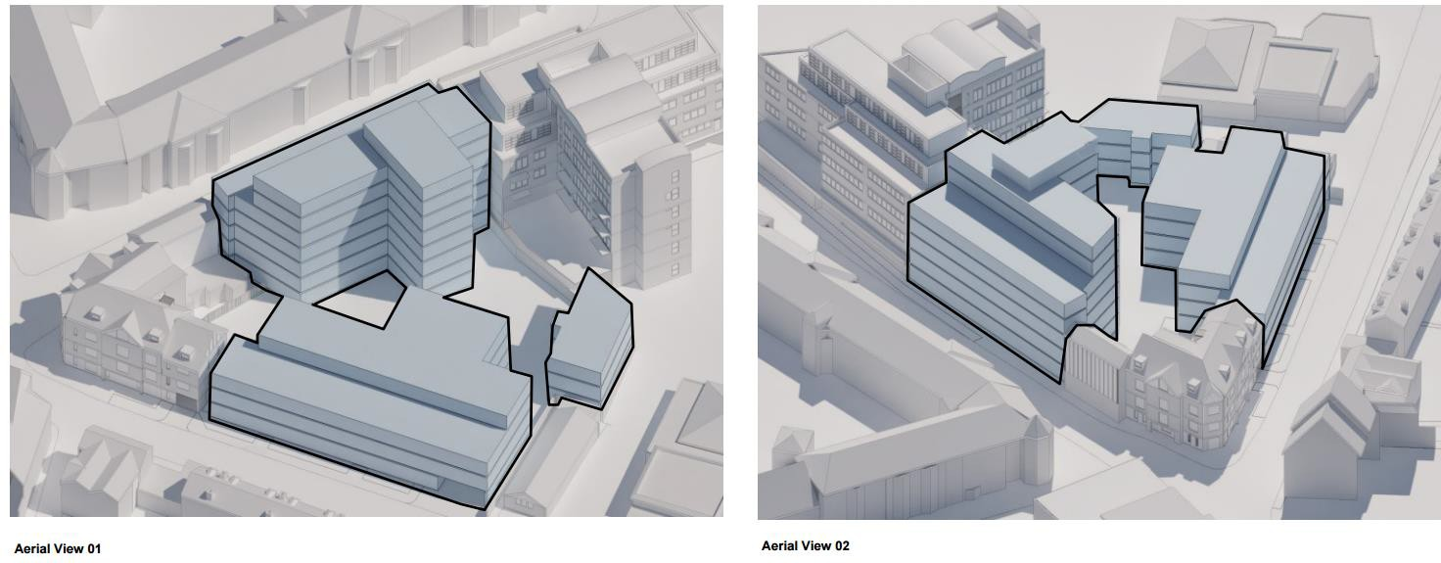

### Figure 1 – Early massing and heights of proposed buildings submitted as part of the pre-application discussions

* 1. The Council provided advice dated 9th December 2019 on the early proposals put forward in the Stage One Feasibility Study. Regarding the proposed design the Council advised that:
* The building facing the High Street should be no higher than four storeys with no set back
* The building facing Harborne Park Road should remain as three storey as approved under an earlier planning application with no set back
* Plot sizes to be reduced and protruding elements to the rear to be removed.
* Contemporary architectural design for the building on High Street with a more traditional pastiche design for the building facing Harborne Park Road.
* Concerns over privacy and overlooking of adjacent properties.
  1. The applicant took on board the comments received and presented amended designs through a revised Stage One Feasibility Study to the City Council. The amendments sought to reduce the overall scale and massing of the development, including:
* Reduction in total number of apartments proposed 88 down to 83 (76% one bed and 24% 2 bed apartments)
* Reduction to a single storey set back to the building facing High Street (now a maximum of 6 storeys).
* Further information on how the proposed design protects privacy and limits overlooking.
* Further justification for the proposed projected elements to the rear of the buildings.
  1. The figure below is an extract of the amended proposals as a result of the Councils’ advice, showing a reducing in height and general massing.

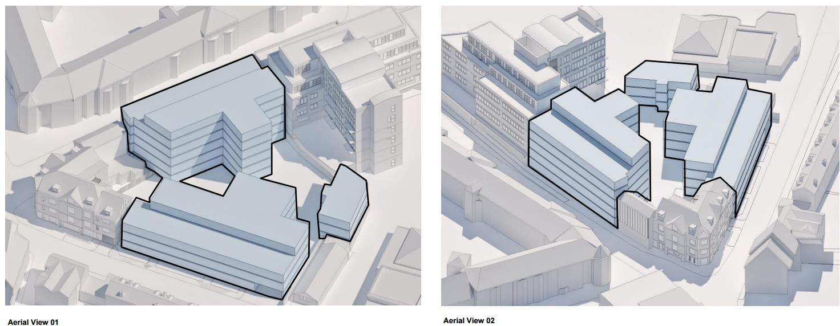

### Figure 2 – Amended design following advice from Council

* 1. In order to alleviate the Council’s initial concerns on privacy and overlooking, the applicant also provided further information on how this would be addressed through the design. The figure below is an extract of the additional information provided to the Council as part of the pre-application discussions.

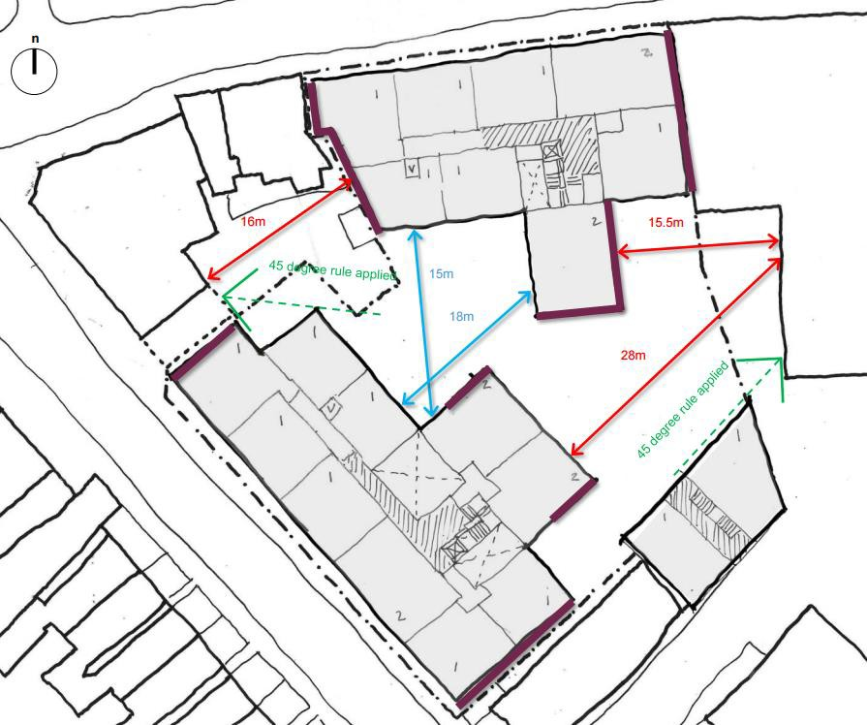

### Figure 3 – Details on protecting privacy and preventing overlooking

* 1. Upon further consideration of a scheme with reduced scale and massing the City Council’s Design Officer remained of the view that there should be no set backs on the buildings with concerns regarding the intensification of the site.

The Council accepted the proposed projected elements to the rear of the building.

* 1. The applicant has taken on board the Design Officers comments and made changes to the scheme which now form part of the final design. These changes include:
* Changing the proposed set backs on the upper floors of the buildings fronting High Street and Harborne Park Road to a mansard roof design which reflects the form of adjacent buildings.
* To reduce the intensification of the site reducing the size of the third 3 storey building that was proposed on the eastern boundary. This is now a single storey building housing a bin and cycle store as well as a plant room.
  1. The result of the pre-application process with the City Council has led to the final design which proposes 87 new apartments within 2 new development blocks facing High Street and Harborne Park Lane. The size of the courtyard area has increased by removing the accommodation out of the courtyard area into the 2 main blocks. The reduction to 2 blocks (as opposed to the 3 blocks originally submitted in the pre-app) leads to a less intensified scheme and an overall reduction in footprint and massing whilst taking a design form that is characteristic of the streetscene.

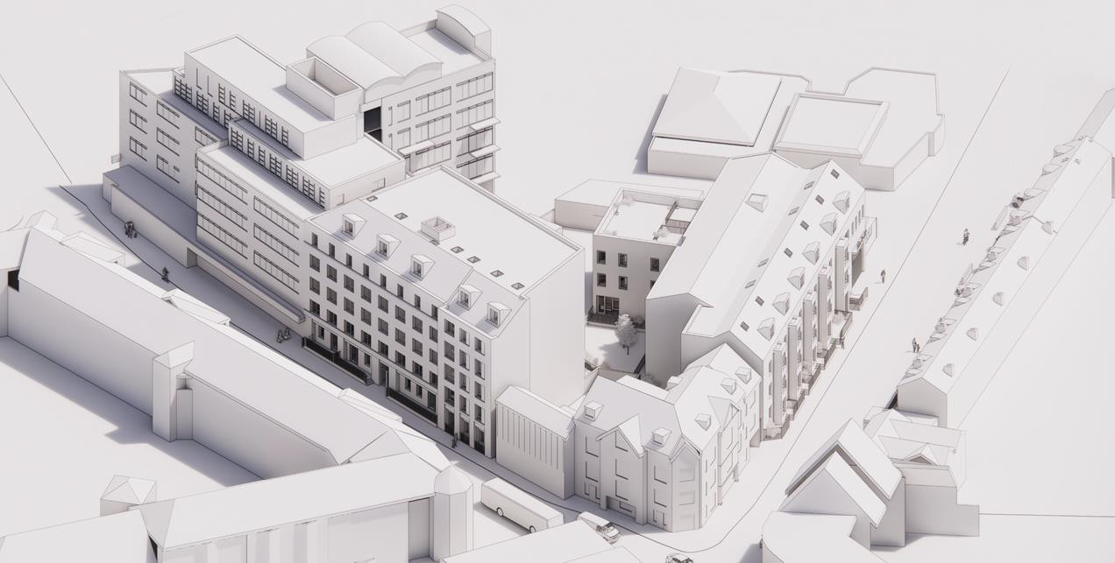

### Figure 4: Final design submitted for planning

1. **CONCLUSIONS**
   1. This Statement of Community Engagement has been prepared by Evolve Planning and Design on behalf of the applicant, detailing the process views have been sought from the local community and relevant bodies, including pre-application discussions with Planning Officers at Birmingham City Council, concerning a proposed residential development at 334-346 High Street and 8- 22 Harborne Park Road, Harborne.
   2. This Statement has set out how the consultation processes employed have been based on relevant policy and best practice guidance, and how the local community have been reached and involved.
   3. This Statement has also demonstrated how feedback from both the public consultation and pre-application advice from the City Council have contributed towards the evolution of the scheme, resulting in the final design that has been submitted as part of an application for full planning permission.

# APPENDIX 1





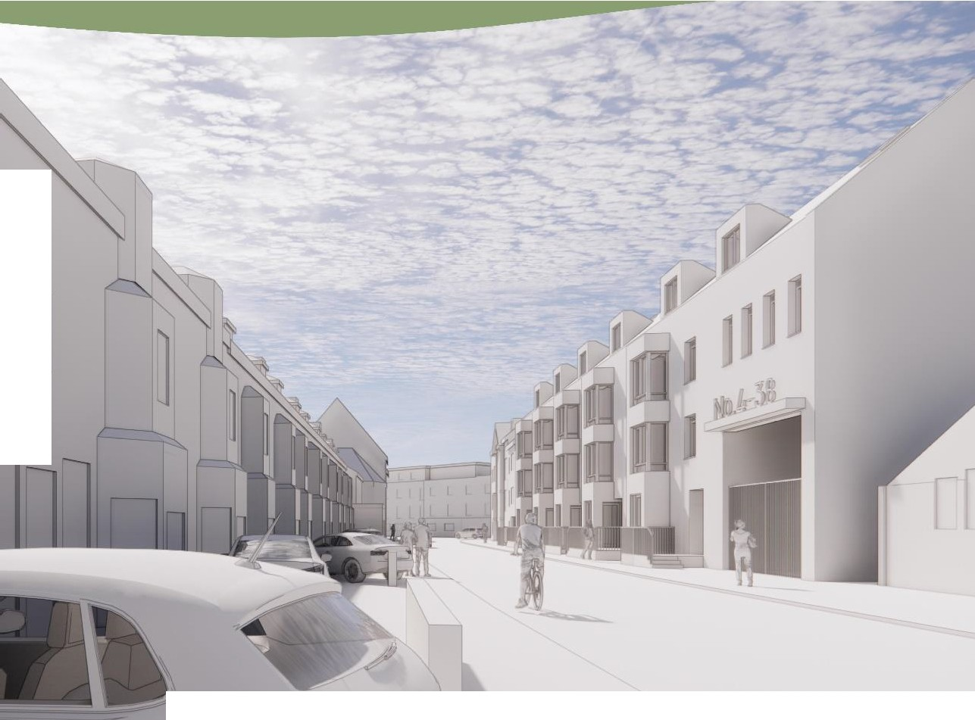

l





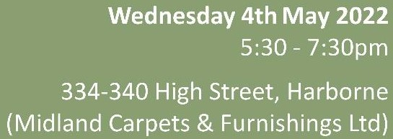



**APPENDIX 2**

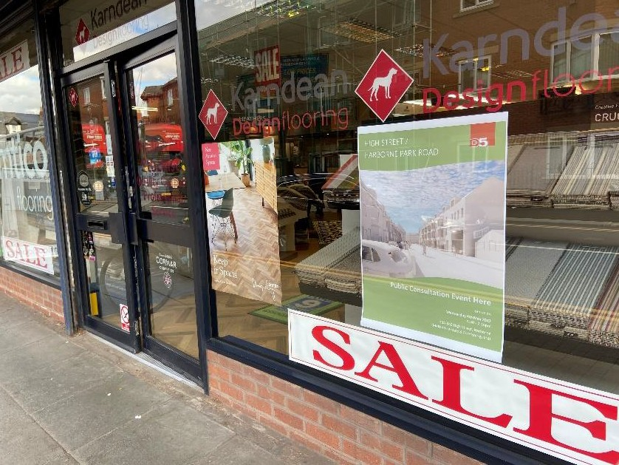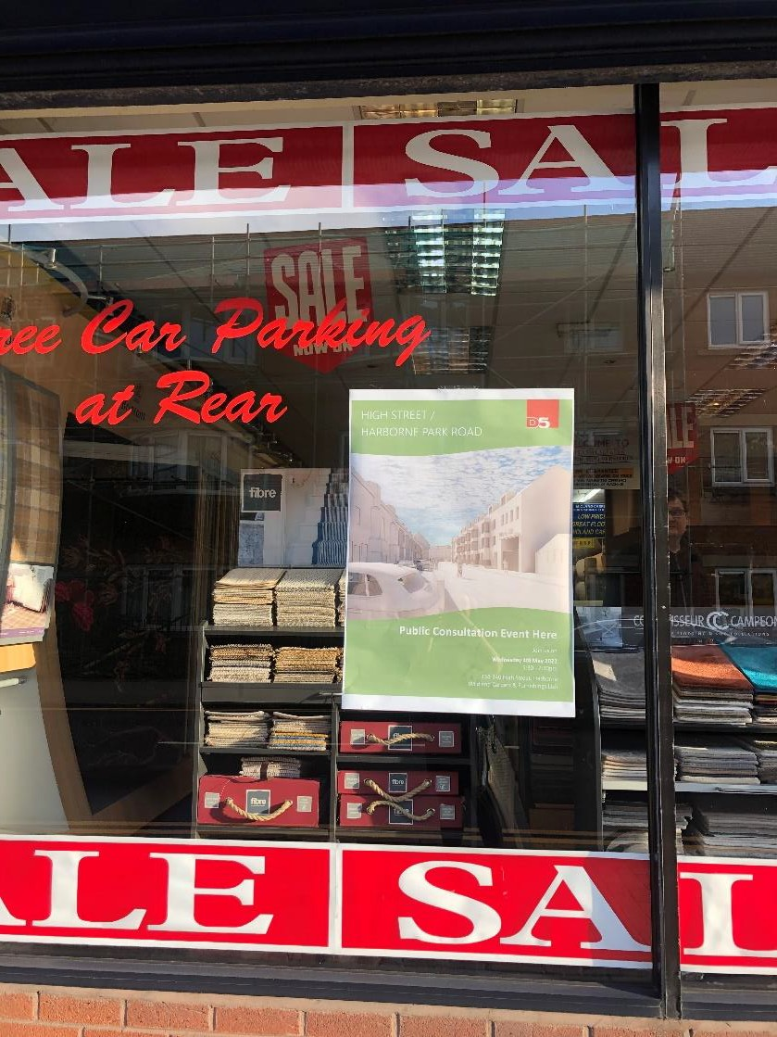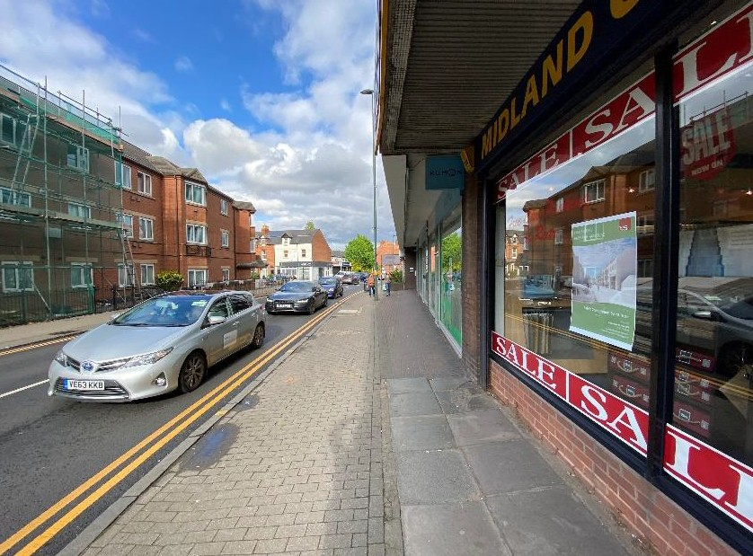



**APPENDIX 3**

**Instagram & Instagram Story:**

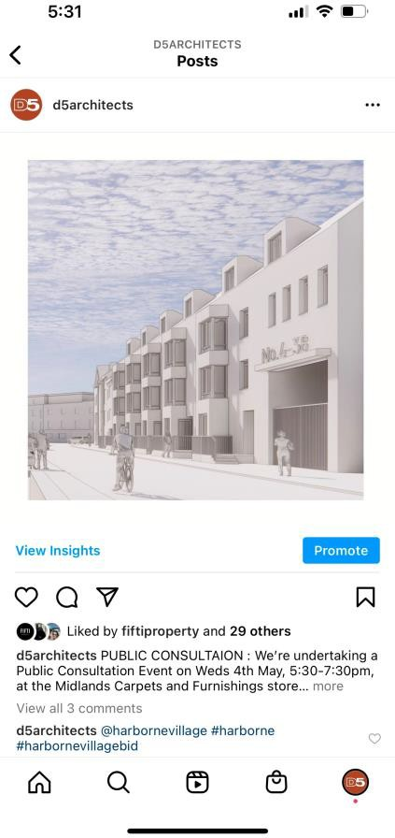

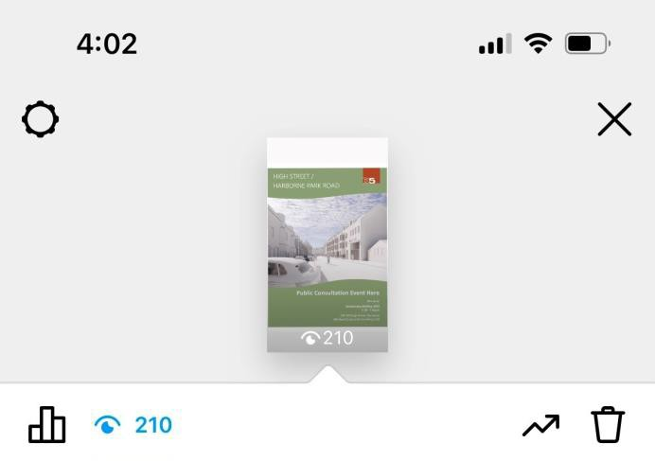

**Twitter: LinkedIn:**

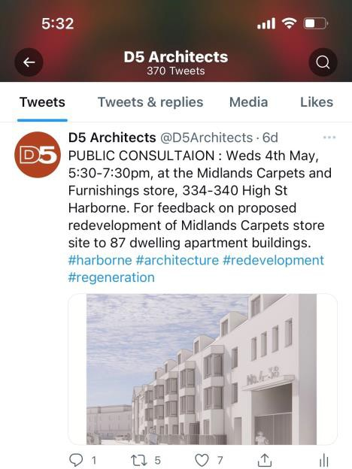

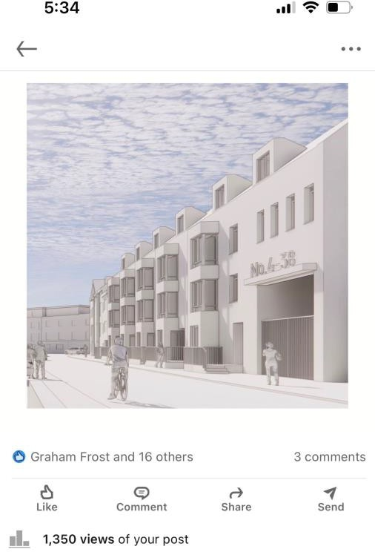



**APPENDIX 4**

High Street/ Harborne Park Road II

Thesite has two street frontages- one facingonto the High Thesiteis well located within Harborne and offers many

Street and one facingonto Harbcrne Park Road.The area of site amenities, with several transports links in close proximity. facing onto the High Street is currently occupied by the Midlands Opportunity for leisure activities such as Harborne Walkway and Carpets and Furnishings retail unit. The area of sitefacingonto the WorcesterandBirmingham Canat arealsocloseby, with the

Harborne Park Road is currently vacant. option of bicycle hire andaccess to many cycle routes.

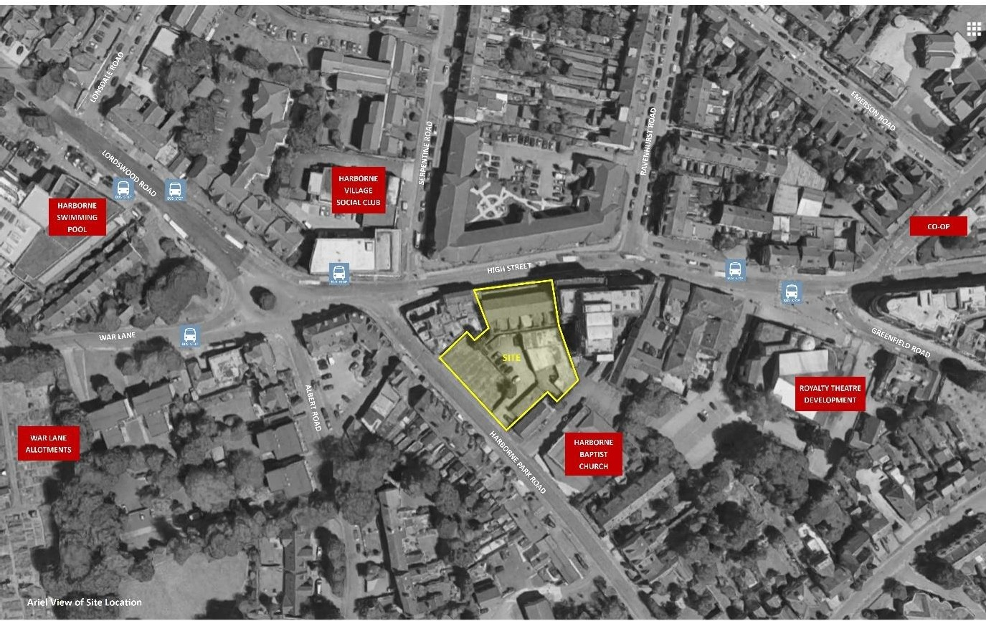



Hig h Street Shops



Local Resta urant s



Good Public Tran sport

Links

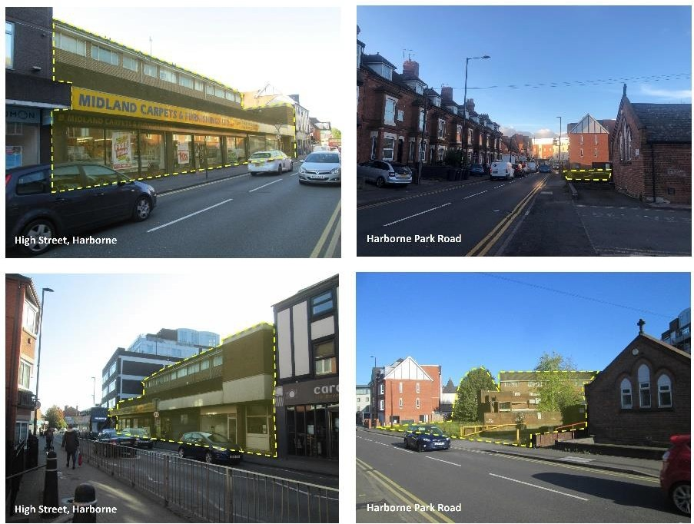

_I *)*

1' ' --

- - - - -

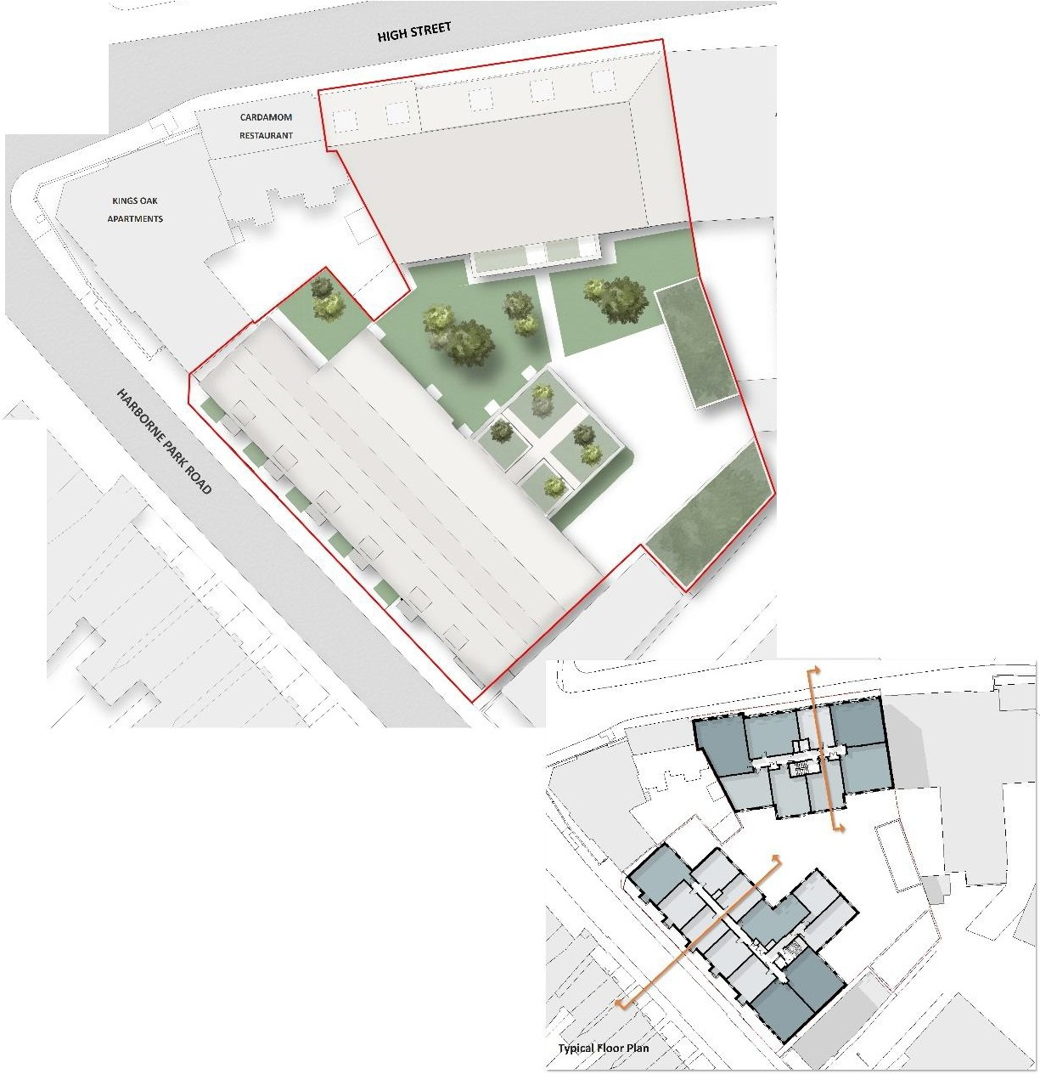

11



/ /

/ /

*//,,,, ,,*

Proposed it{Plan

**The Proposal**

We are proposing:

Theredevelopment of the HlghStreet and vacant land alongHarborne Park Road Creation of 87 new homes

Homes in a mix of sizes and types 100% cycle parking for residents

Creation of a landscapedcourtyard garden withrooftop amenity for residents

A development in a sustainable location within the heart of Harborne

The reanimation of the streetscape connecting the site back into theHarborne community

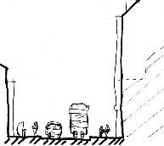

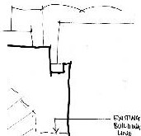

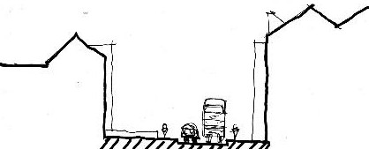

Proposed High Street Section Sketch Proposed Harborne Park RoadSection Sketch

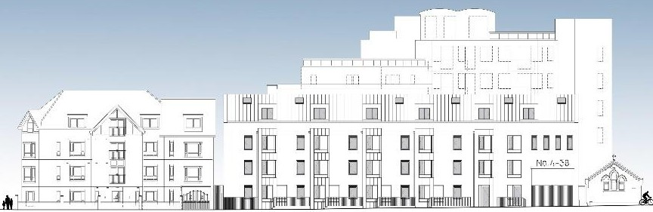

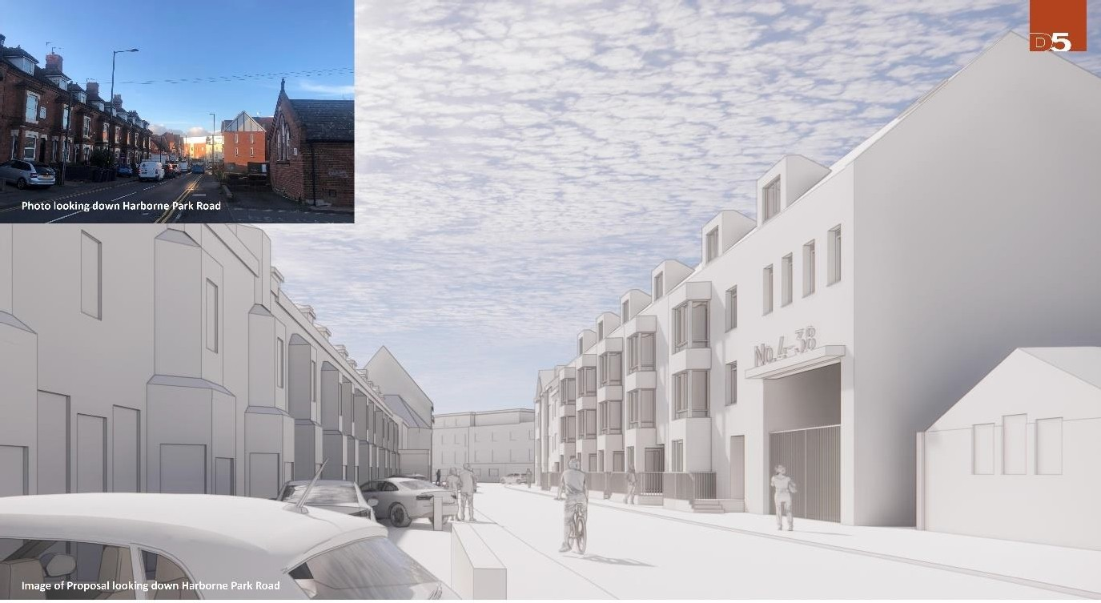

Materials & Appearance

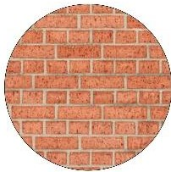   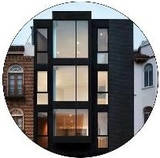 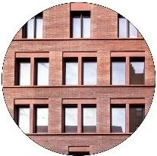

Red Facing 6rick

Reflecting the Historic dwellings along Harborne Park Road.

Terraco tt.i Detai ls

Adding teKture ,md toneto the simple

material pallet.

PitchedRoofs

Varying pitches in the proposed roofs respond to the sites contemporary and historic context.

Bay Windows

Responding to the rhyt hm oft he existin g Harborne Park Road dwelling bay windows.

Simple Fenes tration

Elev,Hion s fo llo w form and function througha simple approa ch to proportio n.

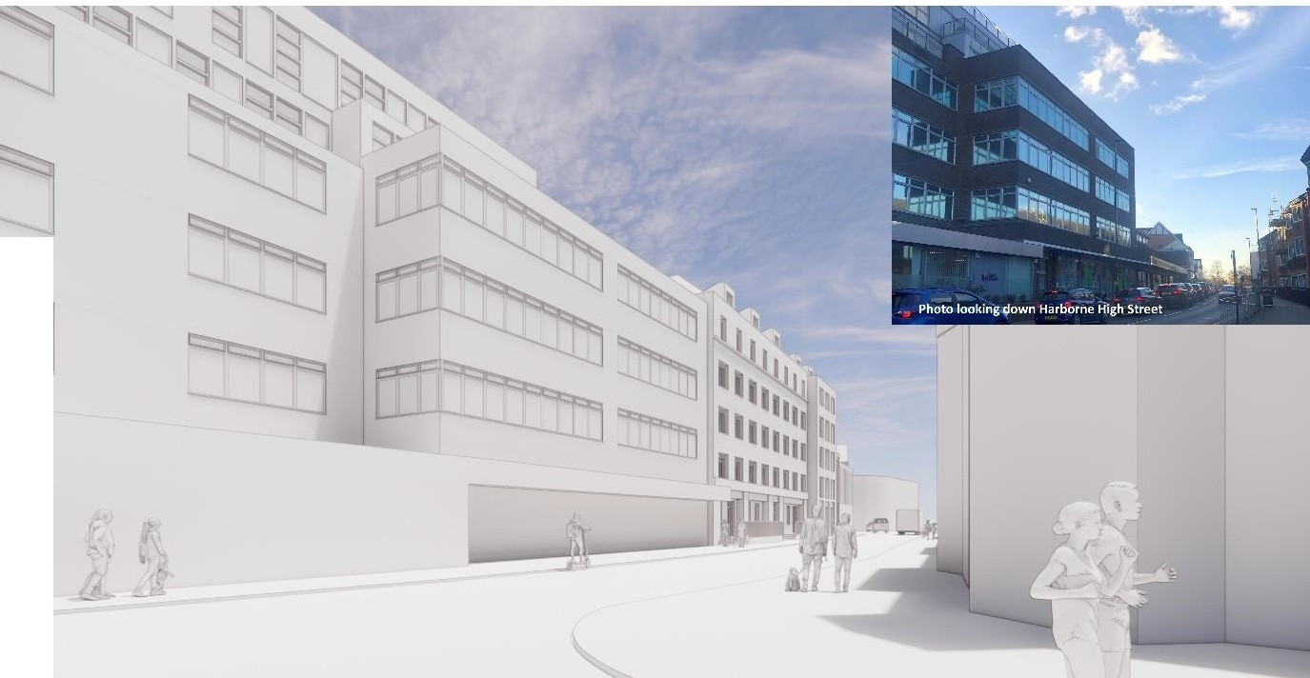

I

II

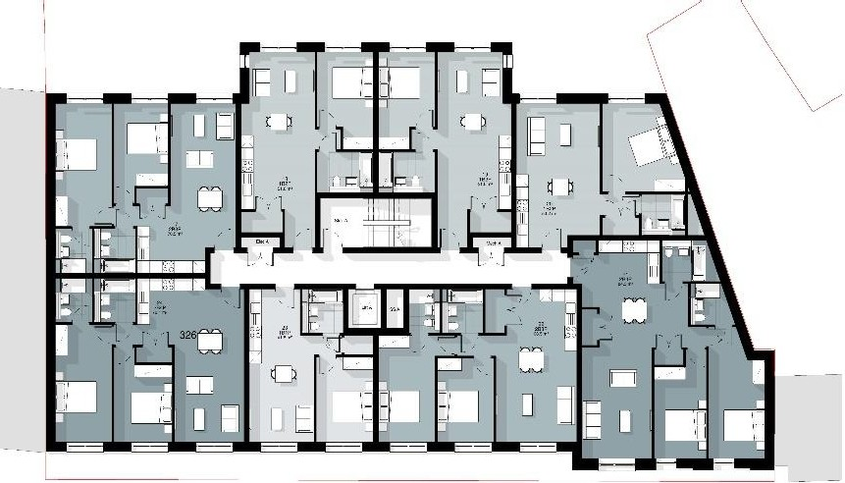

Proposed Harbome High Street Building

**The Plans**

A mixtureof 1 and 2 bed apartments are proposed.

Homes are designed to be spacious, airy,have ample natural daylight and ventilation.

Private outdoor amenity spaces.

Shared outdoor garden areas.

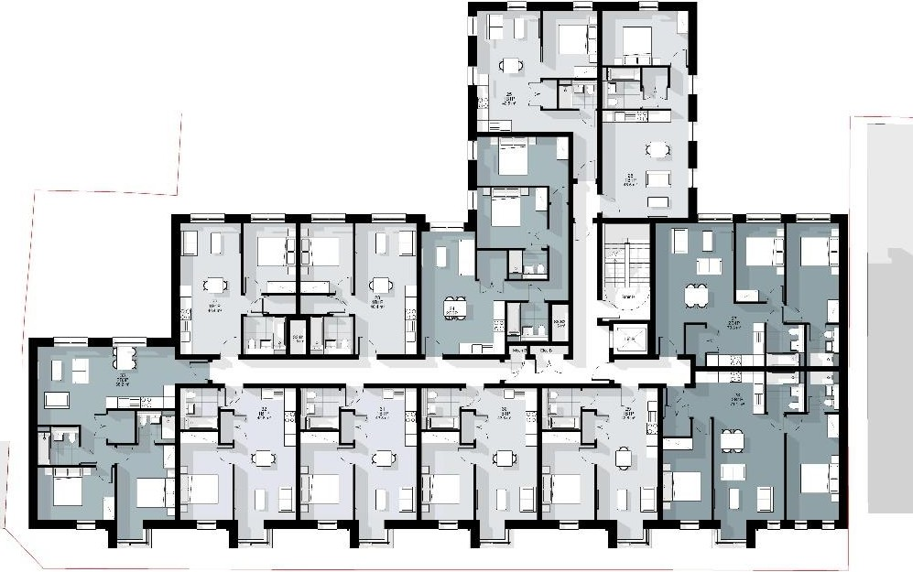

--,J

I I I

I

* - - -

Proposed Hnborne Park Road lklilding

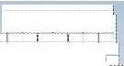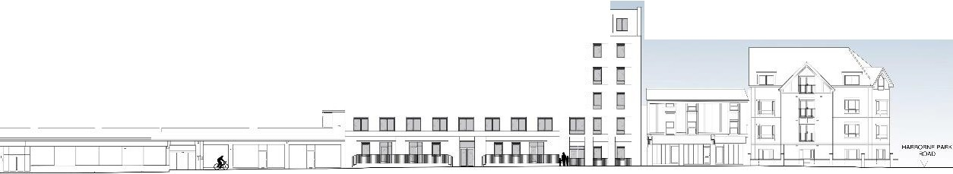

---=[I]=----------cc"---"



# APPENDIX 5

-

|  |  |
| --- | --- |
| **High Street/ Harborne Park Road**  Public Consultation Event on Wednesday 4th May 2022.  Please share your thoughts on the project with us through this feedback form .  **Post Code e ::** .- . .•....•... | |
|  |  |
| **Distance from the site**  □Within 5 minutes' walk □ 5-10 minutes' walk □A car journey □Prefer not to say | |
| **K:apacity**  D Local Resident D Business D Local Counci lor D Repre sentat ive of local group or organisation  D Other | |
| **Please share your comments and thoughts on the scheme below** | |
|  | |
|  | |
|  | |
|  | |
|  | |
|  | |
|  | |



# APPENDIX 6

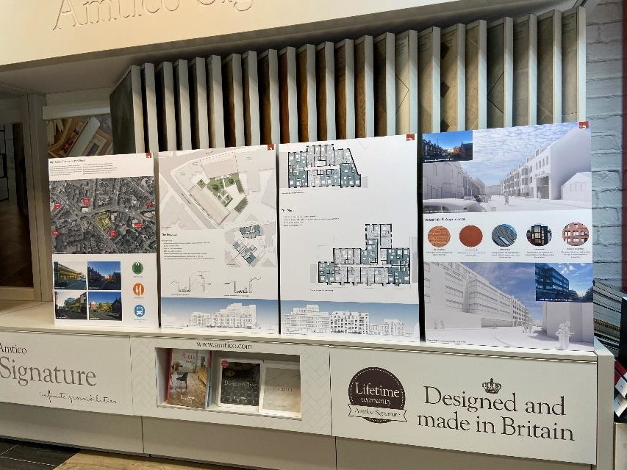

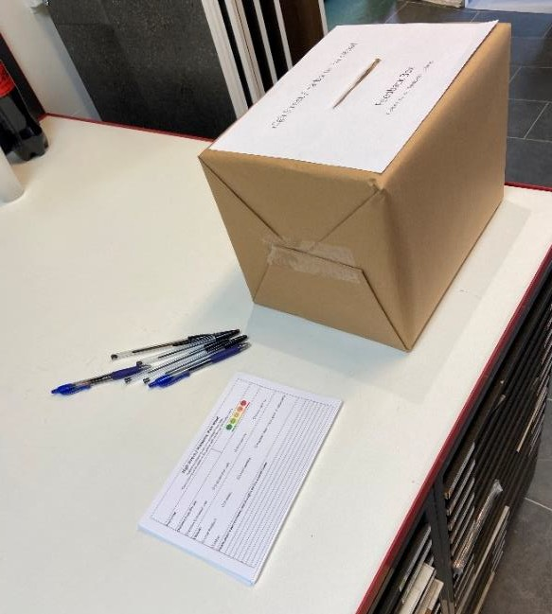

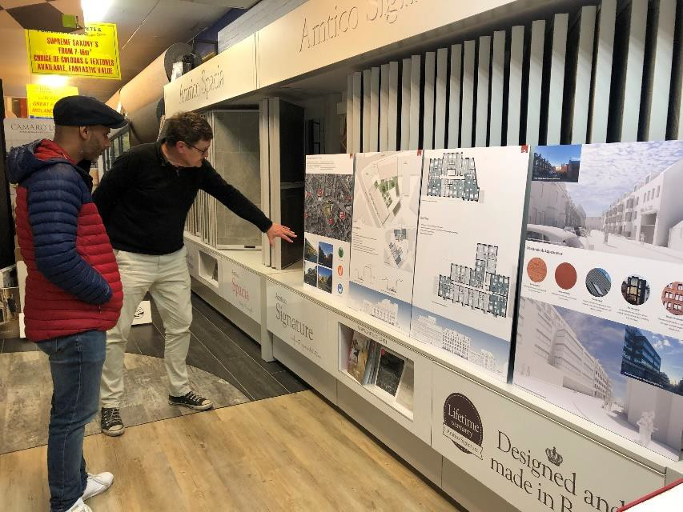

**21**

