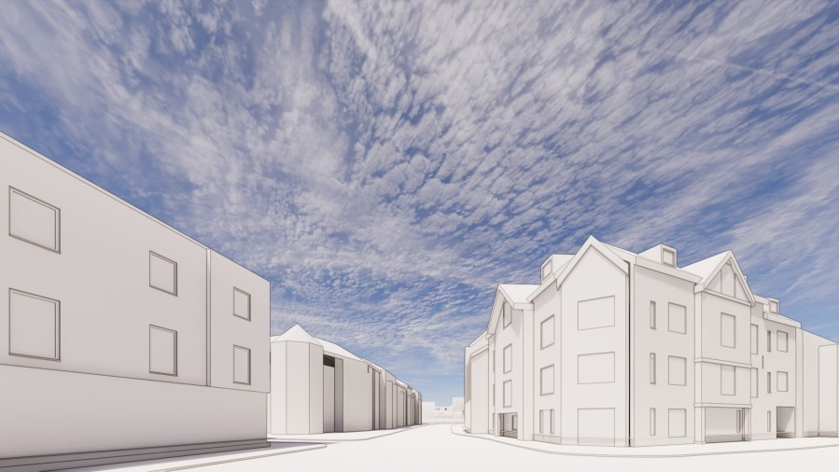

**Introduction**

* 1. The following illustrates updated massing proposals in response to comments received from BCC through the application with regard to;

Overall massing too tall to street elevations

Dominant and unacceptable gable visible from the western approach

* 1. The revised massing illustrated will result in a reduction in the number of apartments accommodated within the scheme. If the proposed massing is accepted by BCC other concerns in the application can be addressed to;

Create double aspect apartments on ground floor with bedrooms to the courtyard elevation

Revise the unit mix to ensure two bedroom apartments account for over 50% of the total apartments Revised street elevation to High Street in response to comments received

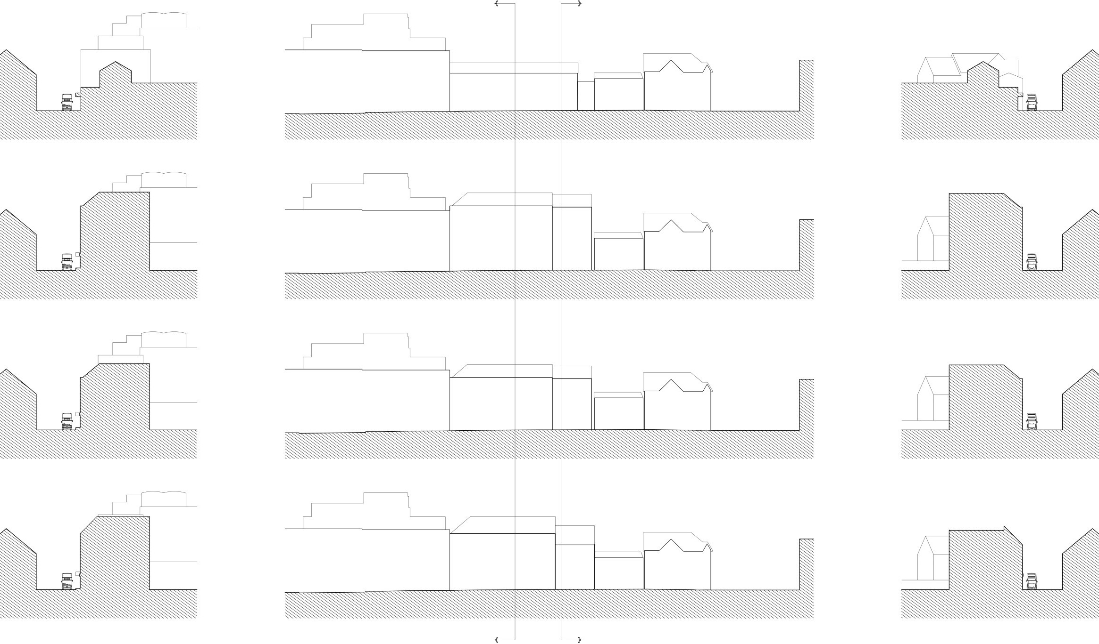

LHS

RHS

2.01 BCC require the High Street elevation to be reduced in height.

# A B

## Existing Massing

Form set back and stepping down from the taller 326 High Street building

## Original Application

Set back left hand side continues massing

from 326 High Street with the right hand side

bay stepping forward to back of pavement

line.

## BCC Suggested Massing

As per the original application by 3m lower on the High Street frontage, large gable to right hand side reduced.

## Proposed Massing

Reduced height to left hand bays similar to

BCC suggestion, right hand bays reduced fur- ther to create stepping form on High Street and articulate the gable to Cardamon restau- rant building

# A B

## Section A-A

**Through LHS Block Looking East Along High Street**

**Section B-B**

**Through RHS Block Looking West Towards Junction With Harborne Park Road**

High Street frontage as proposed in original submission

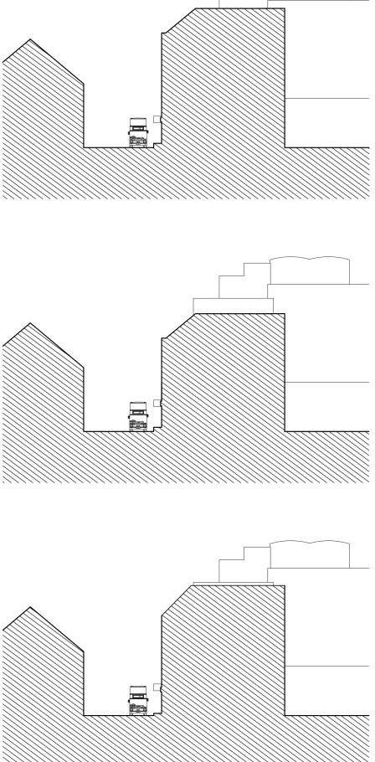

16,300mm

C. 13,300mm

14,100mm

High Street frontage as proposed by BCC

High Street frontage as proposed in original submission

High Street frontage as proposed by BCC

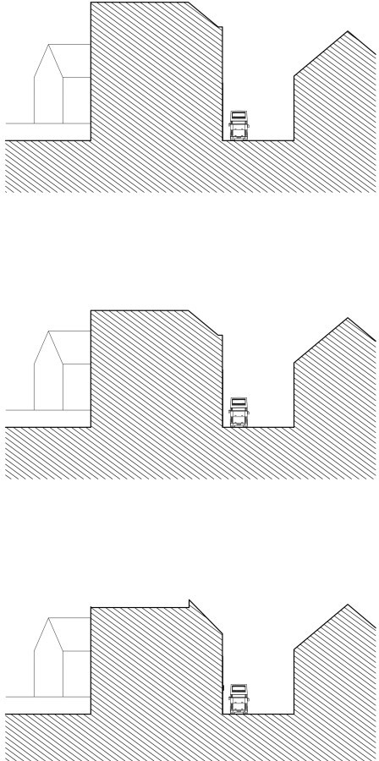

15,800mm

C. 12,800mm

11,200mm

High Street frontage as proposed in revised design

High Street frontage as proposed in revised design to giver greater articulation along the frontage, reduce the mass next to the adja- cent building and create a stepped gable when viewed from the junction.

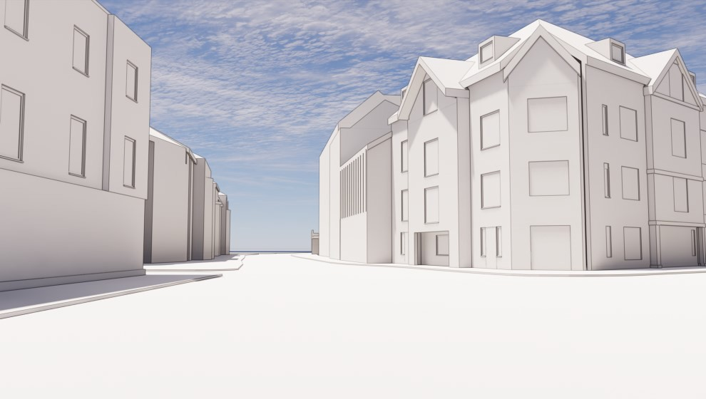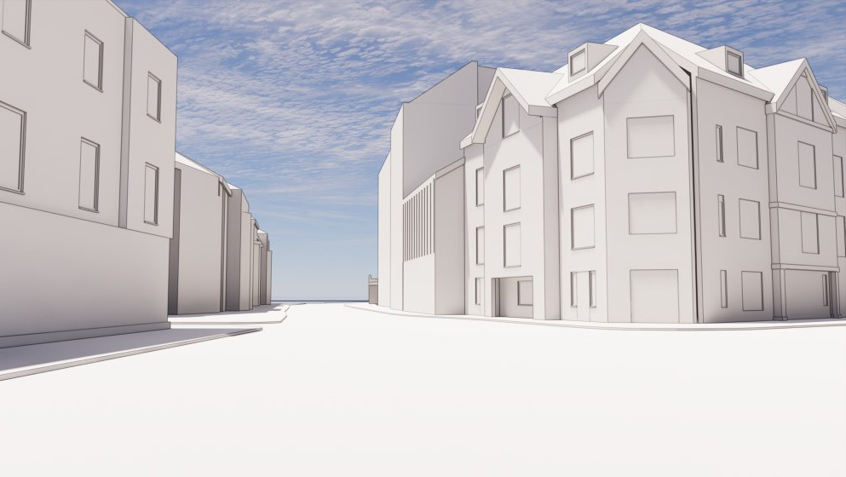

## 2.00 High Street Elevation

* 1. Comparative views of the original massing proposed in the application on the left and the revised proposed massing on the right.
  2. Pitched roof forms create a stepping gable providing a strong townscape response in keeping with existing local context with minimal visual intrusion within the street.

**Original Massing_View from Crossroads Reduced Massing_View from crossroads**

3.01 BCC review of the original design submission was that building height should better reflect the existing forms across the street and be similar to that of previously approved application 2017/07064/PA

# C

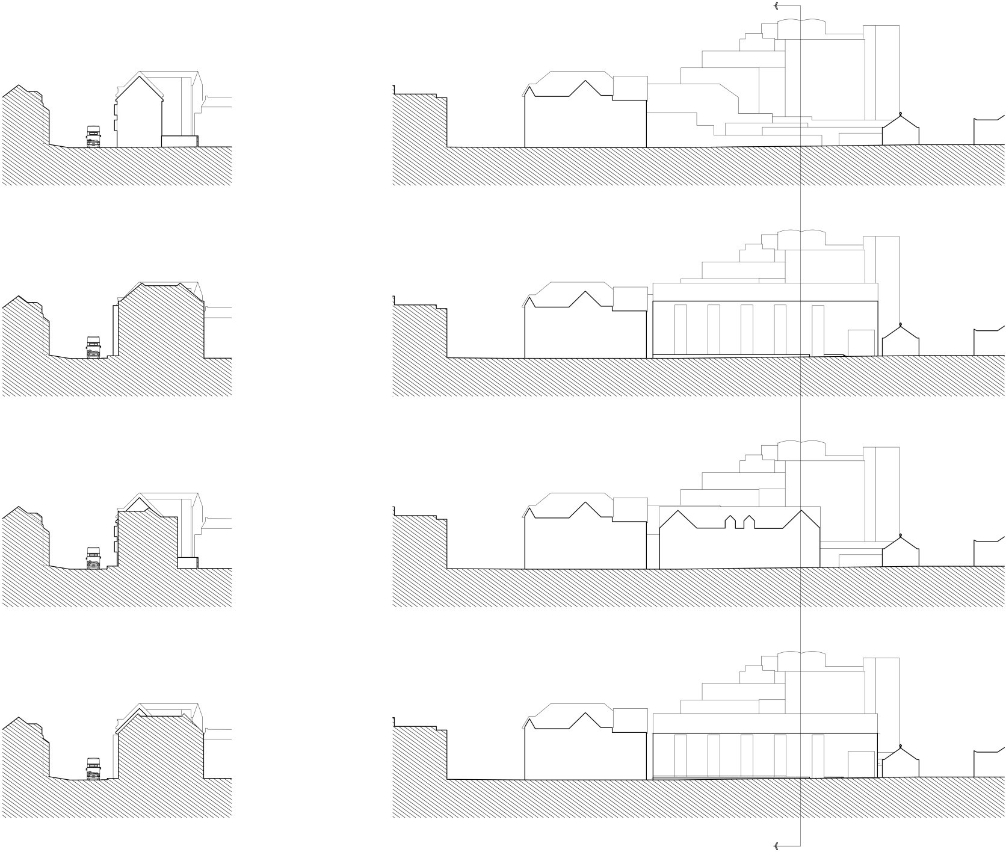

**C**

## Existing Massing

Broken street frontage with weak presenta- tion of the site adding emphasis to the mass of 326 High Street in the background

## Original Application

Building based set up to create separation with from the pavement.

## BCC Suggested Building Height

Previously consented scheme with ridge line height of 11,800mm above pavement level.

## Proposed Massing

Reduced overall height and reduced vertical separation between pavement and ground floor to achieve an overall height of 12.4m which aligns closely with the ridgeline and eaves of existing buildings on the opposite side of the road. The overall proposed form also steps down in level from the existing

corner building.

## Section C-C

**Through Harborne Park Road looking to- wards the High Street Junction**

14,300

Harborne Park Road building height as proposed in original submission

Harborne Park Road building height as con-

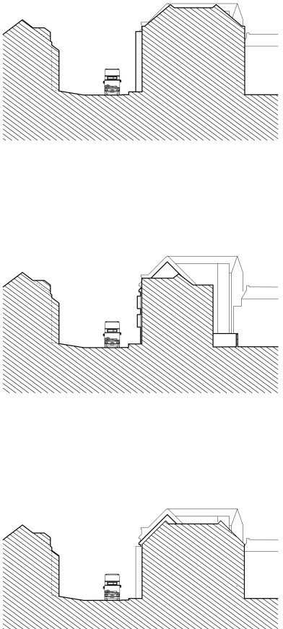

C. 11,750mm

12,150mm

sented in application 2017/07064/PA

Harborne Park Road building height as re- vised proposal with ridge and eaves lines

sitting lower than thos of the adjacent corner block and more in keeping with the existing houses opposite.

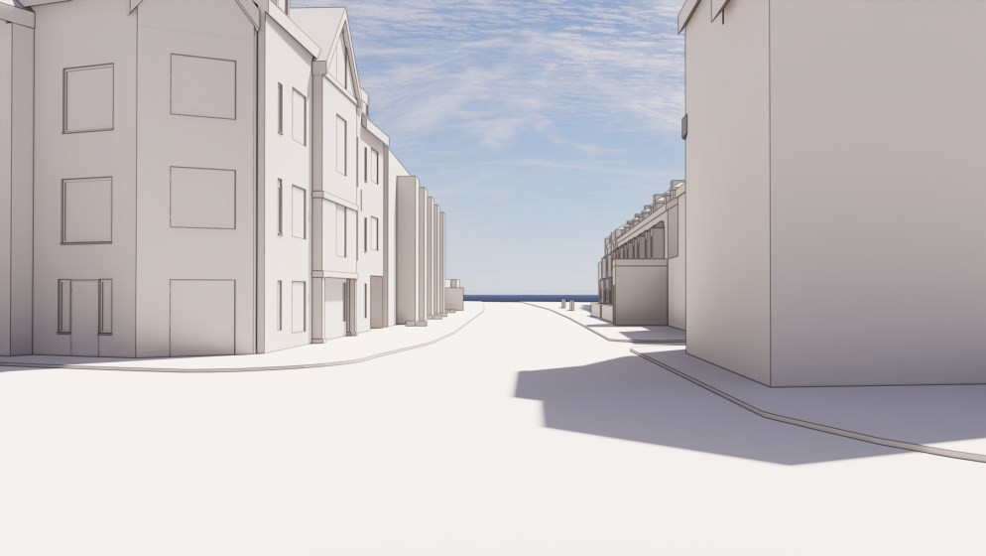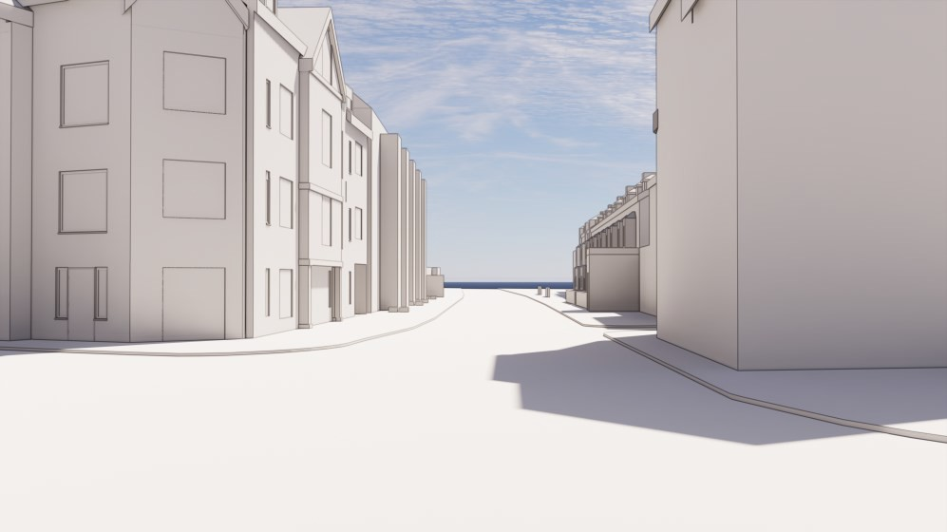

## 3.00 Harborne Park Road

* 1. Comparative views of the original massing proposed in the application on the left and the revised proposed massing on the right.
  2. Projecting bay windows within the proposed also reduced in height with overall massing but retaining the rhythm along the street frontage reflecting the similar arrangement seen in the existing building opposite.

**Original Massing_View from Crossroads Reduced Massing_View from crossroads**