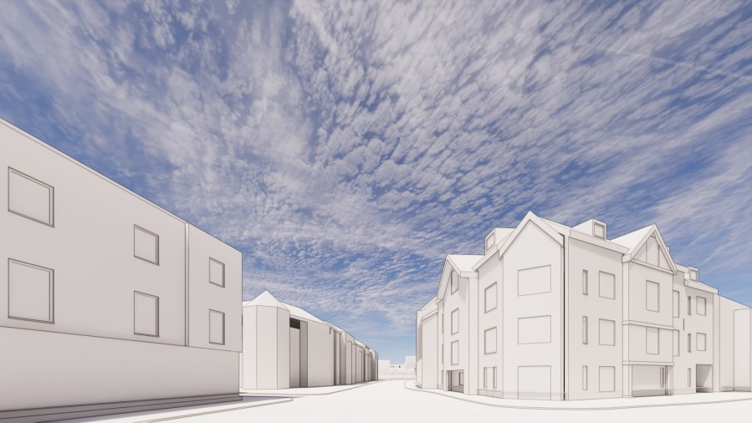

# 1.00 Introduction

This addendum document outlines the changes made to the Harborne High Street Elevation (Block A) in relation to planning application ref: 2022/06737/PA 334-340, High Street and 8-22 Harborne Park Road. Following on from comments received from BCC with regard to;

Overall massing too tall to street elevations.

Dominant and unacceptable gable visible from the western approach.

Single aspect High Street facing ground Floor apartments.

Utilitarian ground floor appearance with a mass of plain brickwork with windows punched as well as not being memorable.

# 2.00 High Street Elevation Height

**BCC Suggested Massing**

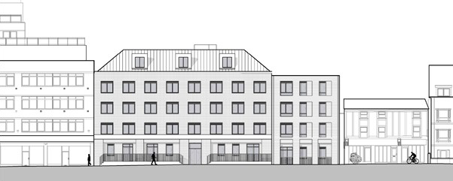

Concerned about the relationship with the adjoining properties, 350-352 High Street, therefore setting the height of the frontage below 350-352 and removing the pitched roof adjacent Cardamon.

# Proposed Massing

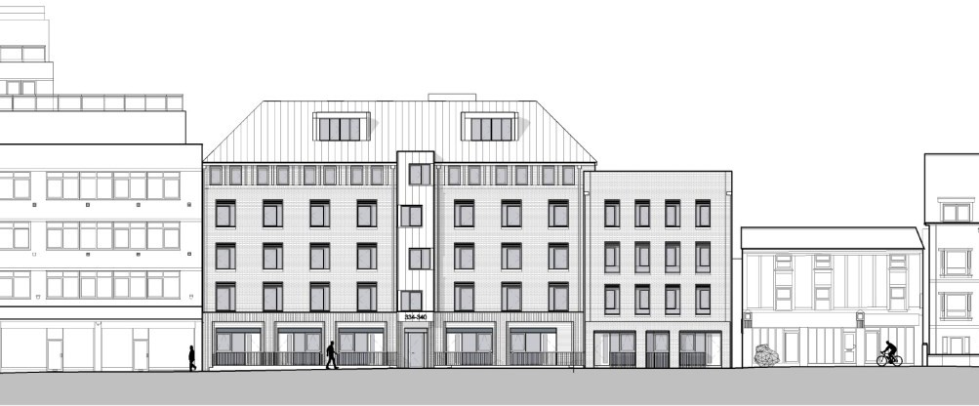

Overall height and massing has been reduced in accordance to the BCC suggestion, where the left hand bays have been reduced to sit below the line of the adjacent building.

The right hand bays reduced further to create stepping form on High Street and articulate the gable to Cardamon restaurant building. When viewing the proposal from the High Street and Harborne Park Road junction the gable smaller in scale and has been remodeled to a softer form.

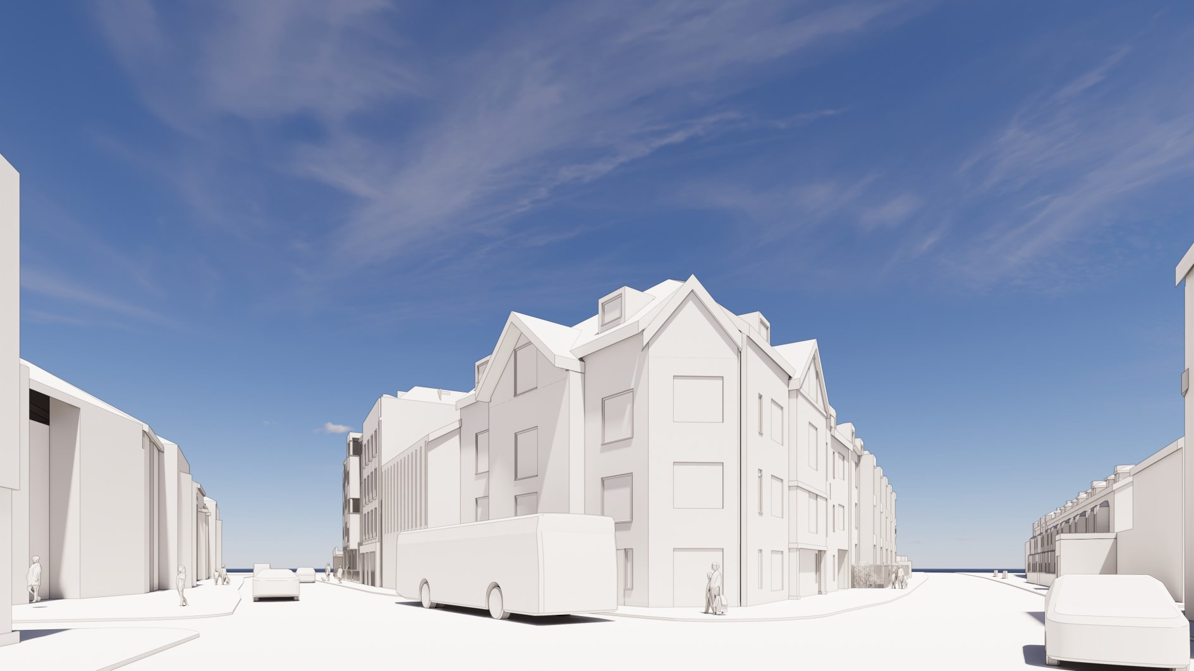

# 3D View: Harborne High Street and Harborne Park Road Junction

**3.00 High Street Elevation Appearance**

As well as reducing the height the elevation has been redesigned to provide a clearly defined base, middle and top which reflect a more classically formed elevation. Windows are still set out on a regular grid line however, more detailing and diminishing scale has been added to the appearance, further emphasising the classical proportions.

A projecting feature above the entrance has been incorporated to clearly identify the building entrance as well as providing a gentle nod to detailing on the proposed Harborne Park Road block.

The base of the building has been altered to suit the new arrangement of dual aspect ground floor units and is further articulated through a vertical projecting brick detail, creating texture and interest at ground floor level.

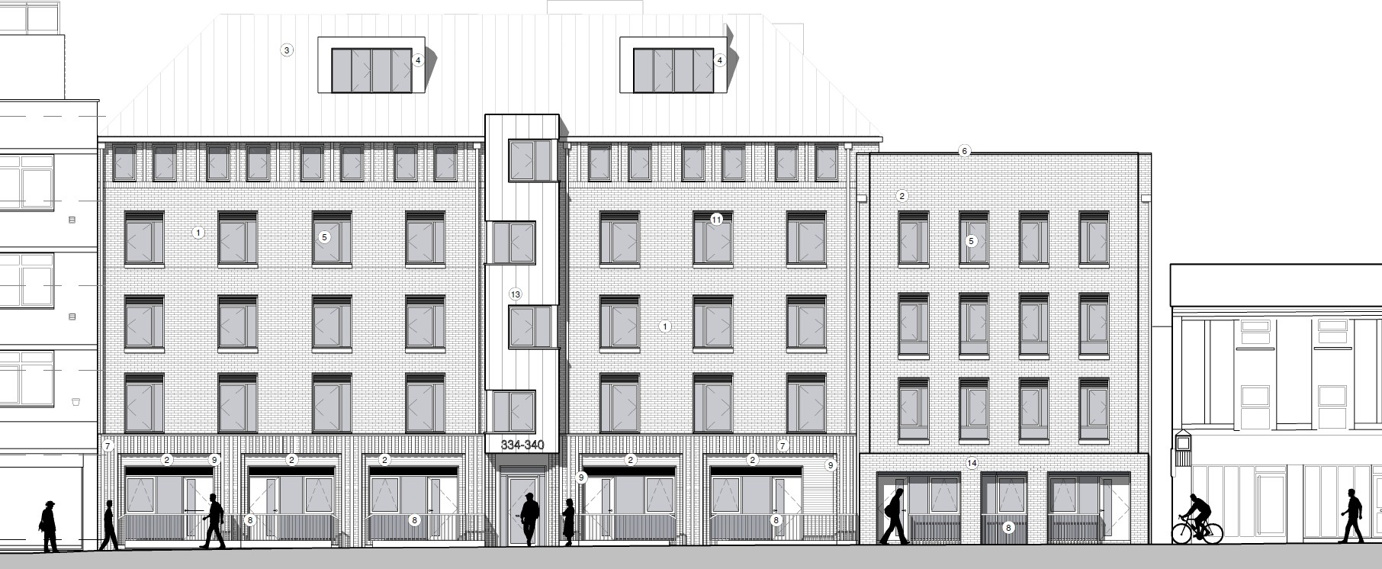

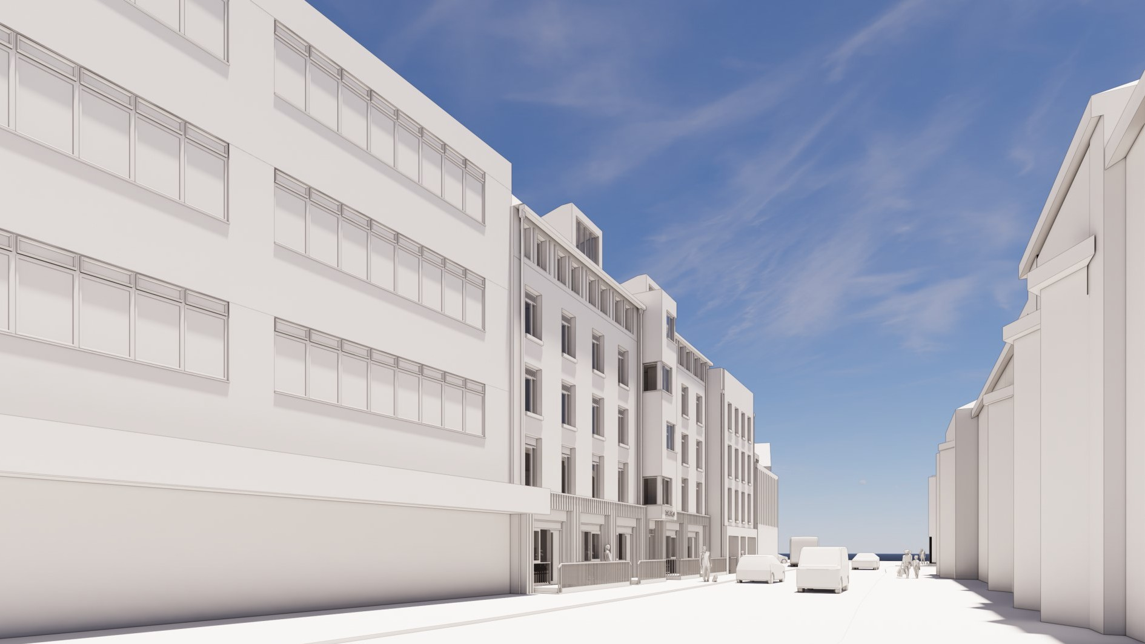

# 3D View: Looking down Harborne High Street

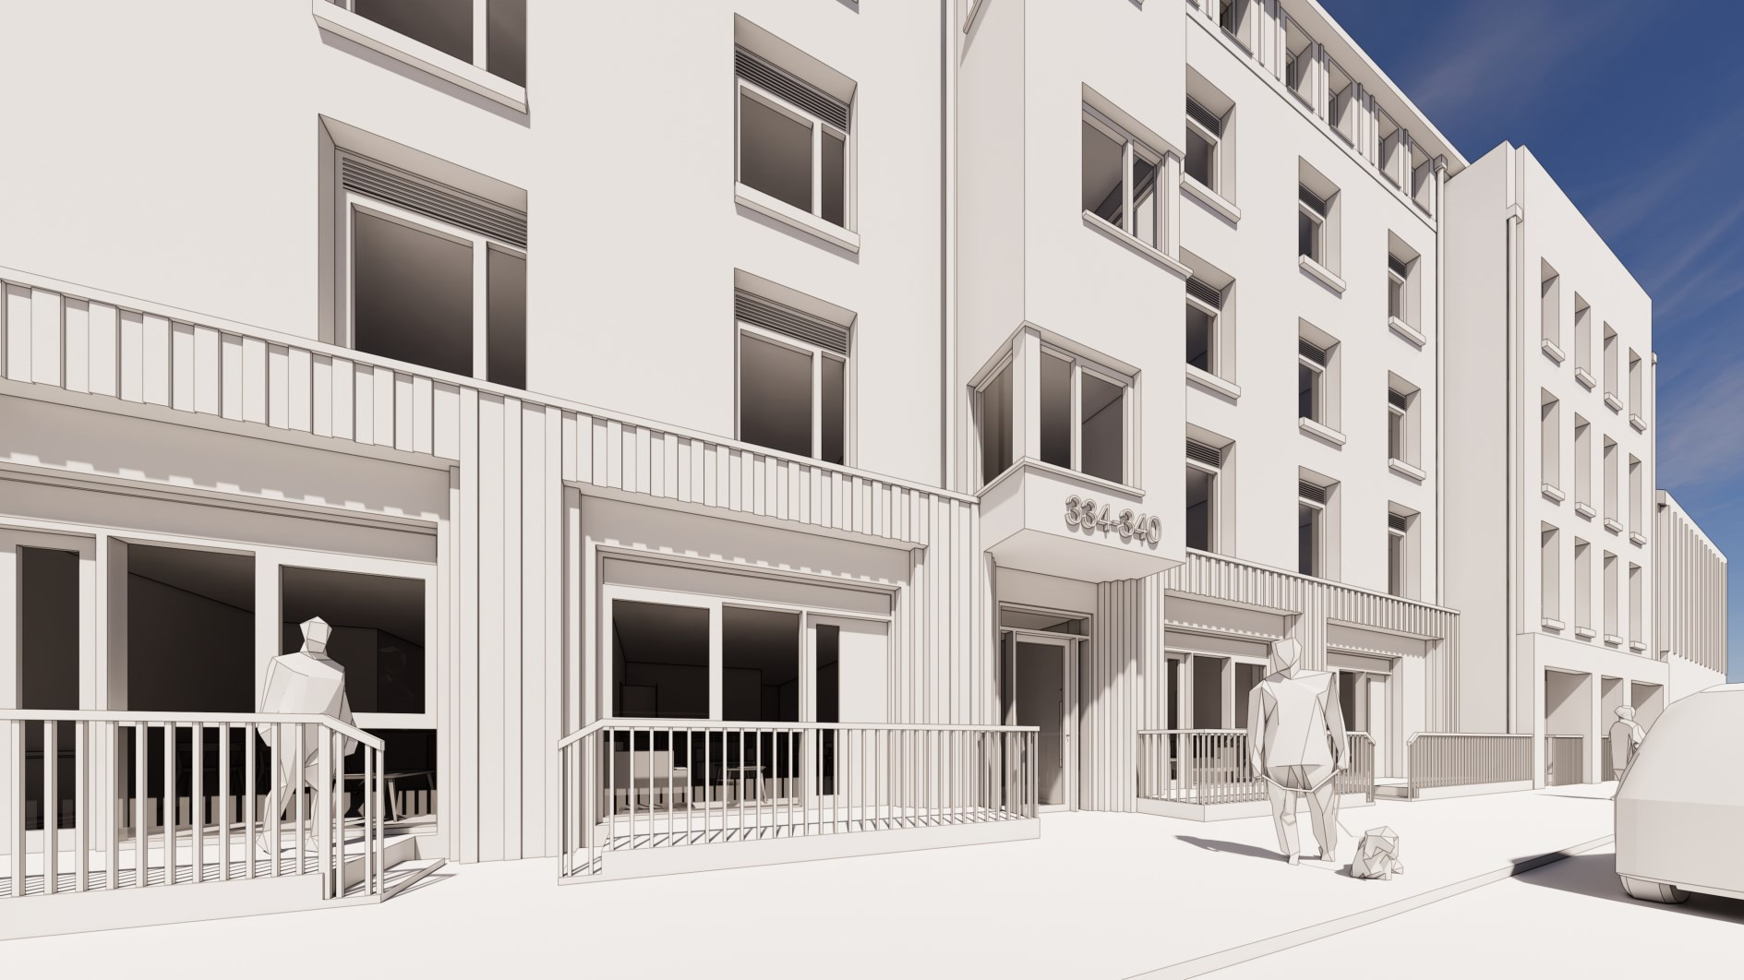

**3D View: Block A, Harborne High Street**