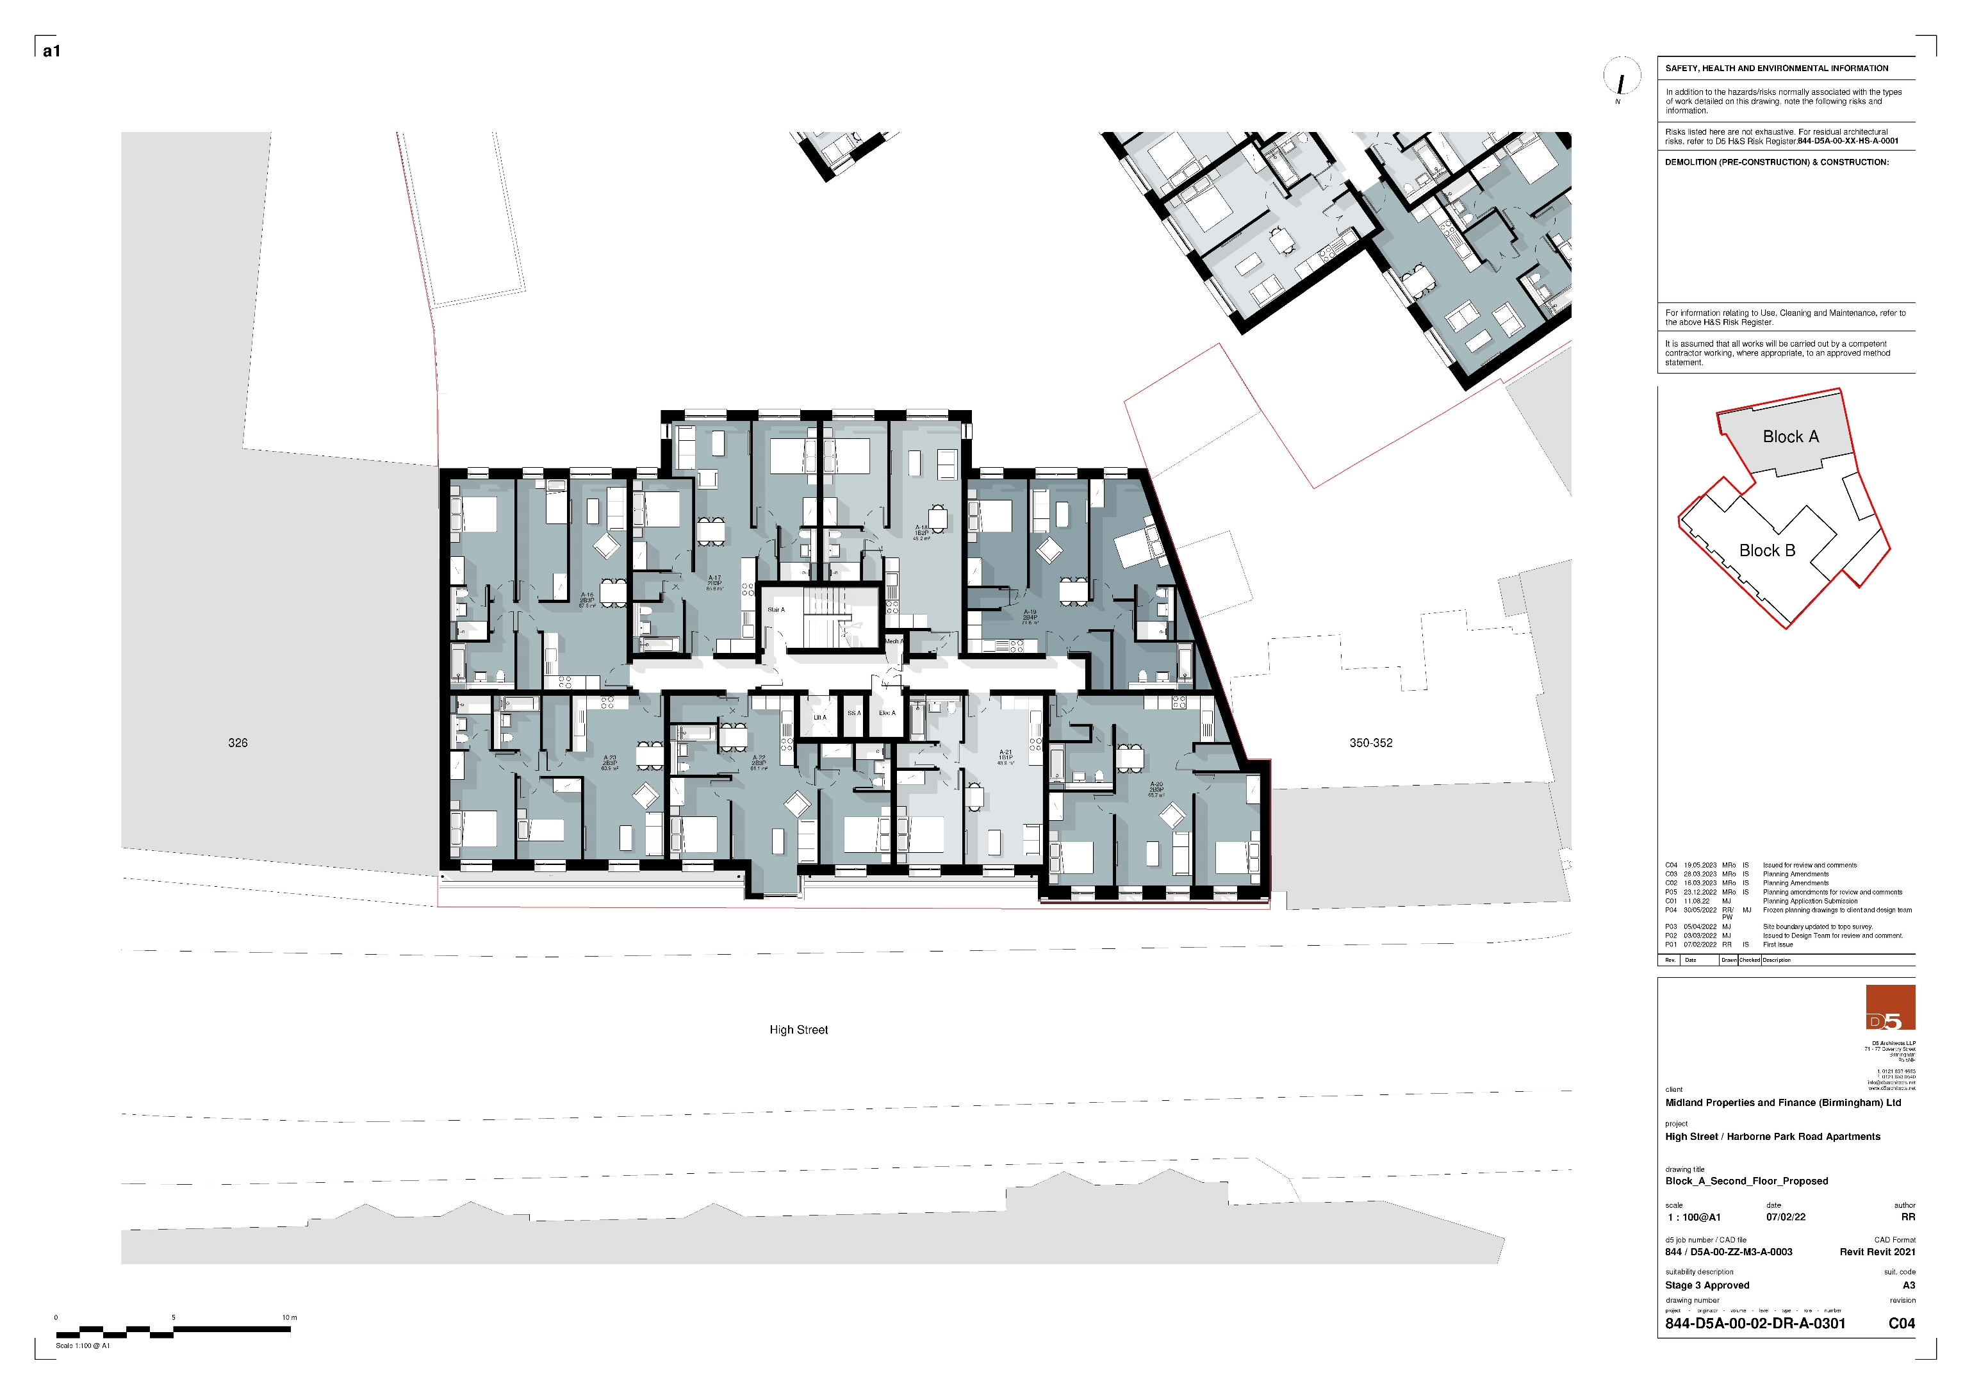

# -Block A Second Floor Proposed