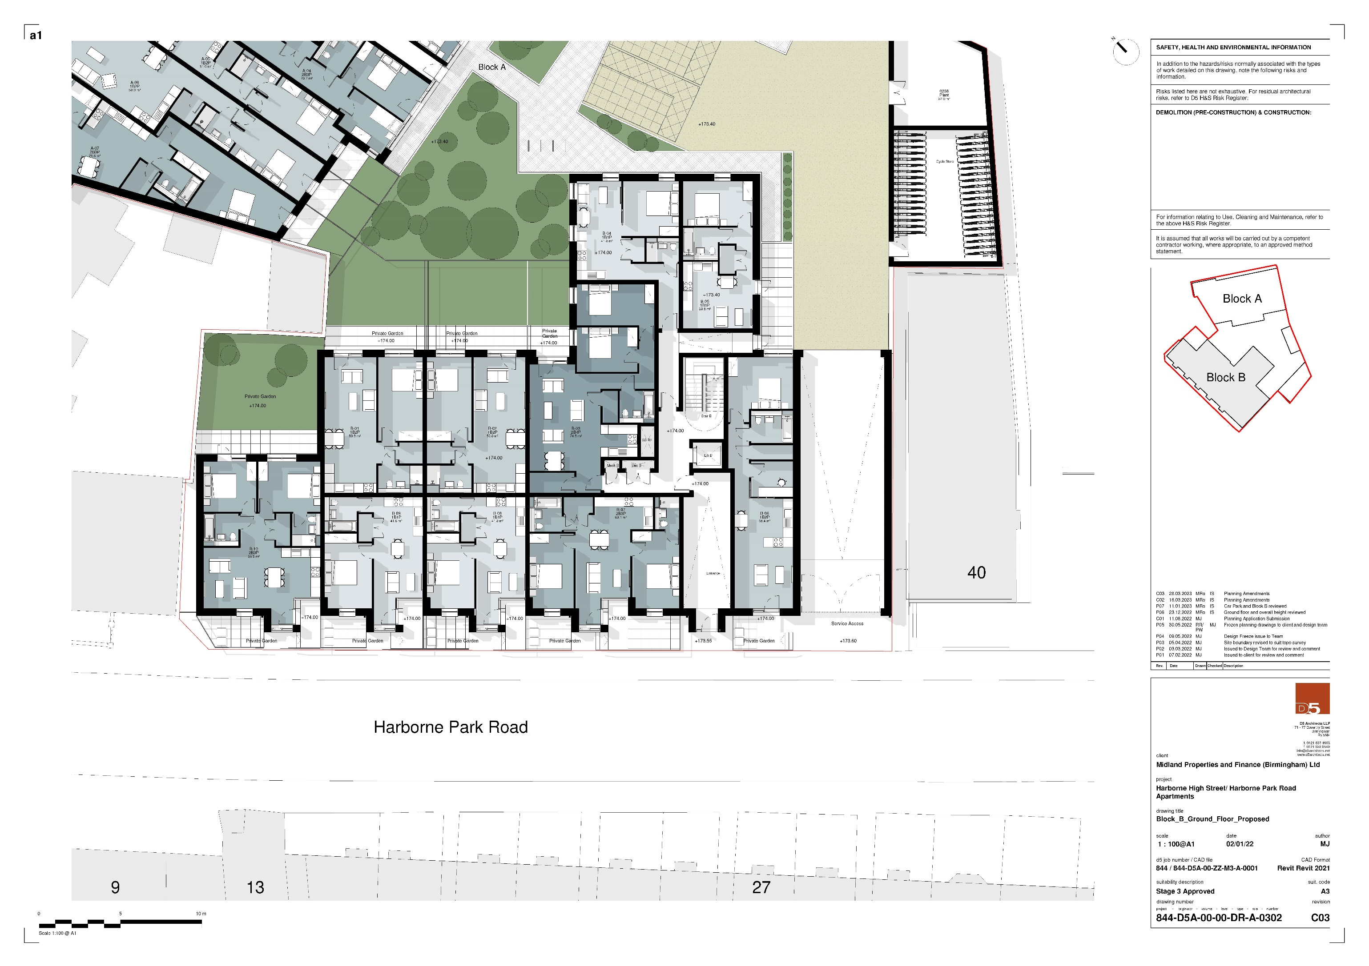

# Block B Ground Floor Proposed