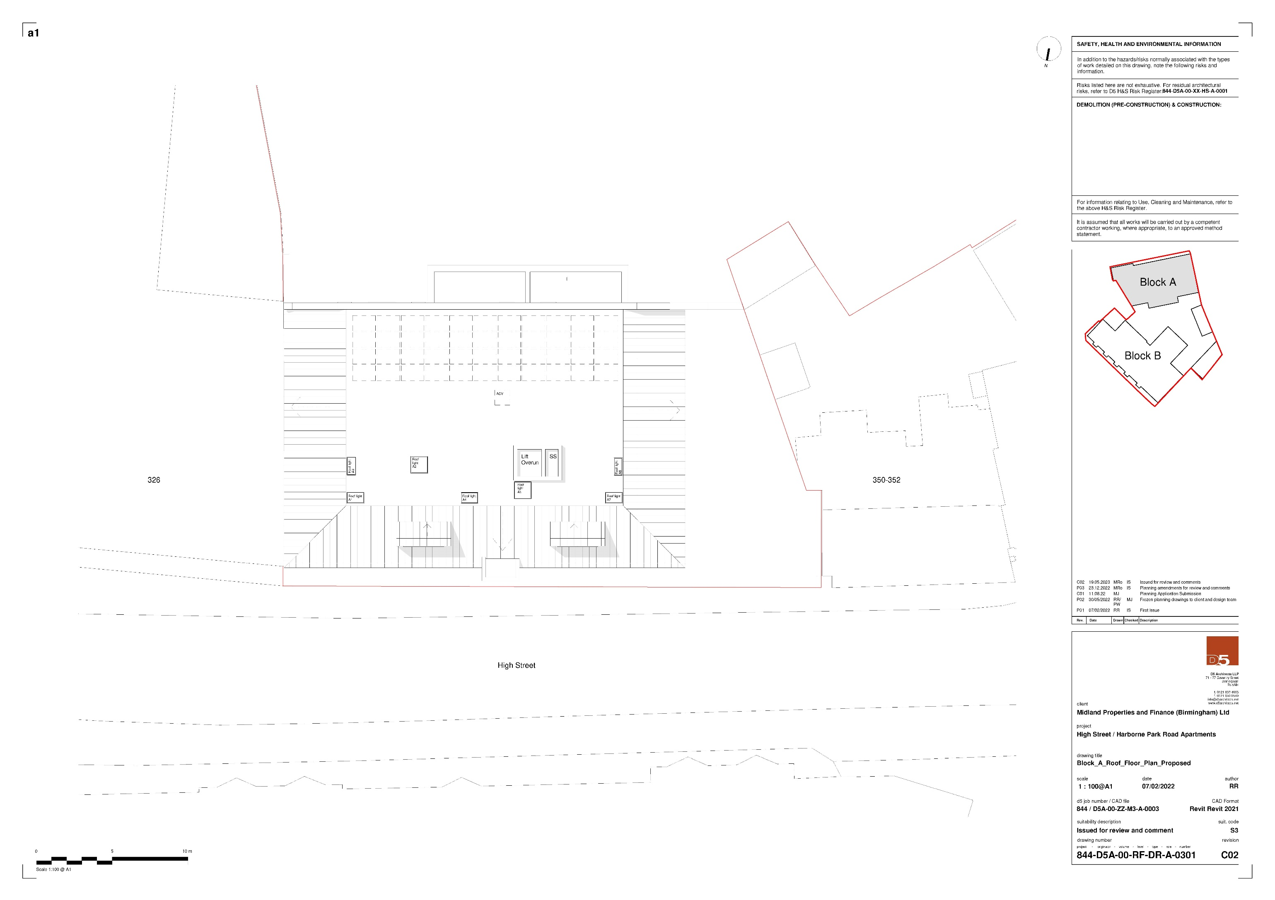

# Roof Floor Plan Proposed