

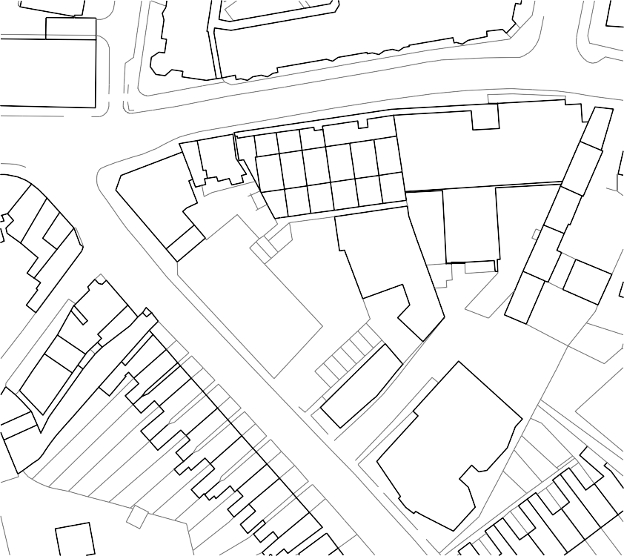

Date: 17.10.2019

Scale @ A3: Varies

CAD Format: Autocad CAD File:

844-D5A-00-XX-M2-A-0002 site location

Rev: P02

**D5 Architects LLP**

71-77 Coventry Street

Birmingham B5 5NH

t. 0121 633 4663

f. 0121 633 0540

[info@d5architects.net](mailto:info@d5architects.net) [d5 architects website](http://www.d5architects.net/)

343

343

Harborne Park Road

Harborne Park Road

25

25

23

21 23

19

8

8

8 10 to 12

10 to 12

352

352

350

22 to 33

39 to 48

22 to 33

39 to 48

338

350

338

326

326

318

318

6

6

1

1

7

7

13

13

39

9

27

39

5

7

5

7

354

354

346

346

1

3

1

Southlink Charter Centre

Southlink Charter Centre

313

High Street Harborne

High Street Harborne

Harborne High Street/ Harborne Park Road Apartments

A3

**Midland Properties and Finance (Birmingham) Ltd**

**P02** Site and Location Plan

Stage 3 Approved

**844-D5A-00-XX-DR-A-0002**

# Site Location Plan

Scale: 1:1250

N

Site Plan

Scale: 1:500

Harborne Village

Apartments

349 to 353

Harborne West

LB

Harborne Baptist

Church

Harborne Village

Apartments

349 to 353

Harborne West

LB

Harborne Baptist

Church

# **Location Plan**