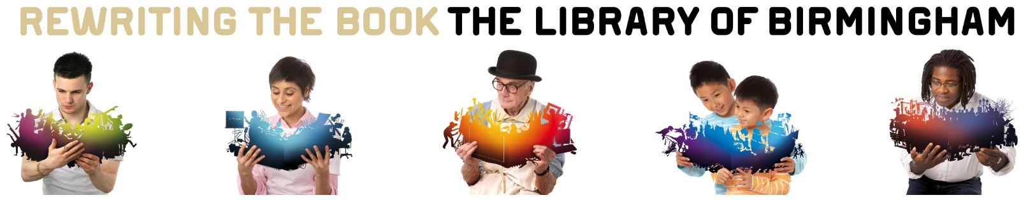

# Working with the Library of Birmingham Wellbeing Zone

The Library of Birmingham is the largest public library in Europe. With its landmark building, studio theatre, exhibition gallery and world-class collections, the library is a unique cultural venue that attracts thousands of visitors every day.

The library works with partners throughout Birmingham and across the UK. If you would like to deliver an event in the Library’s Wellbeing Zone, please complete the *Enquiry Form* below and return it to [enquiries@libraryofbirmingham.com](mailto:enquiries@libraryofbirmingham.com?subject=COMPLETED%20EOI) with the words “Wellbeing Zone COMPLETED Enquiry Form” included in the email subject line.

Please consider the following points when completing your form:

Linking with Birmingham Public Health’s Be Bold: Be Birmingham strategy([Creating a Bolder, Healthier City (2022 to 2030) | Birmingham City Council](https://www.birmingham.gov.uk/downloads/file/23756/creating_a_bolder_healthier_city_2022_to_2030)) – Which themes does your proposal link to?

* + Healthy and affordable food
  + Mental wellbeing and balance
  + Active at every age and ability
  + Contributing to green and sustainable future
  + Protect and detect
* Linking with Birmingham City Council (BCC) priorities ([Corporate Plan | Birmingham City Council](https://www.birmingham.gov.uk/info/20011/your_council/237/corporate_plan)) – how does your proposal compliment:
  + Employment, skills and local economy
  + Community resilience, cohesion and living standards
  + Opportunities for children and young people
* Birmingham – How does your event relate to the people, businesses and communities of Birmingham? Will your proposal promote Birmingham as a great place to live, visit and do business?
* Visitors – Who will your event attract to the Library of Birmingham?
* Promotions – How will you let people know about your event?

**All *Wellbeing Enquiries* are assessed according to specific criteria.**

**Please complete all parts of the form.**

|  |  |
| --- | --- |
| Wellbeing Zone Event Enquiry Form | |
| If you would like to work with the Library’s Wellbeing Zone on an event, please complete this Enquiry Form and return it to [enquiries@libraryofbirmingham.com](mailto:enquiries@libraryofbirmingham.com?subject=COMPLETED%20EOI)  Please include the words “Wellbeing Zone COMPLETED Enquiry Form” in the email subject line. | |
| **Contact Details** | |
| Name |  |
| Organisation |  |
| Status of Organisation | *e.g. charity, commercial, educational* |
| Phone Number |  |
| Email |  |
| Date Form Completed |  |
| **About You** | |
| Marketing and promotion plan |  |
| Experience | *What experience do you have of putting on events/exhibitions?* |
| **Event Details** | |
| Name of Event |  |
| Date/s & Time/s of Event |  |
| Event Description | *Please give full details of event* |
| Visitors | *Who will be attracted to the Library by your event?* |
| Expected Attendance | *How many people will come to your event?* |
| Promotional Statement | *Provide a short statement promoting your event (50 words max)* |
| **How will your event compliment the following:** | |
| Healthy & affordable food |  |
| Mental wellbeing & balance |  |
| Active at every age & ability |  |
| Contributing to a green & sustainable future |  |
| Protect & detect |  |
| BCC Priorities |  |
| Birmingham |  |
| **Event Requirements (**Please note: The Wellbeing Zone is a public space and all events are the responsibility of the organiser**. Library staff will not be available to support your event)** | |
| Space | *Please provide exact details of space required* |
| Equipment | *Please list all the equipment that you will provide* |
| Staff | *How many members of staff will you make available for the event?* |
| Marketing | *How will you promote your event?* |
| Legal | *What insurance, licences or other legal requirements does your event need?* |
| **Please complete all sections of this form – incomplete forms cannot be assessed.** | |