

# Green User Guide

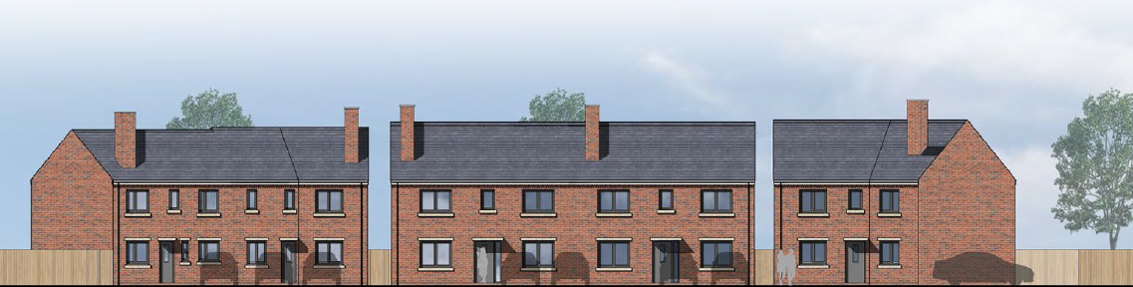

**1 Tudor Rose Grove**

**Birmingham**

**B72 1PF**

**Section 1** Roles & Responsibility

**Section 2** Garden Maintenance

**Section 3** Discover Your Local Green Spaces

**Section 4** Further Information & Links

**Contents**

**Section 1   
Roles & Responsibilities**

**Section 2**

**Garden Maintenance**

* Front & Back garden plan
* Planting Palette
* Maintenance Tips

**Section 3**

**Discover Local Amenities and Green Spaces**

* Your Neighbourhood

**Section 4**

**Further Information and Links**

**TOP TIP**

Take a photograph of your planting beds when you move in and as leaves start to appear. Then you can identify your plants, where they are and if any weeds pop up in between pull them out.

**Section 1** *Roles & Responsibilities-the formal bit!*

1. **Introduction**

To sustain the aesthetics/upkeep of the new development and enable establishment, all residents are required to properly maintain and manage the newly planted areas, including existing plants, trees and grass.

The planting is part of the 12 months defects inspection.

**1.1 Private Owner**

1. The owner shall be responsible for the maintenance and management of;

* All planting and grass areas to the front and rear of the property as shown on the plan in Section 2.
* Fence/wall and other structures as part of the premises on purchase.
* There will be a joint responsibility between the 6 dwellings for the area of landscaping at the top of the hammer head.

1. Owner to carry out operations with the correct equipment and is responsible for taking health & safety precautions, by having the appropriate measures in place before commencing works. Personal Protective Equipment (PPE) may be required for certain activities
2. Owners are advised to seek professional advice, pay and commission work for skilled/expert operations, such as works to mature trees and premises.
3. Private owners wishing to carry out alterations to the building or planting that are likely to have implications on protected areas and features shall need to submit an application for permission.

Installation of temporary structures creating the loss or impact of protected areas/features will also need approval.

**TOP TIP!**

Empty the back of your mower to stop build-up of grass within the blades…

…use a hand brush to remove excess grass when finished.

**Section 2** *Garden Maintenance*

1. **Dwelling Plan**

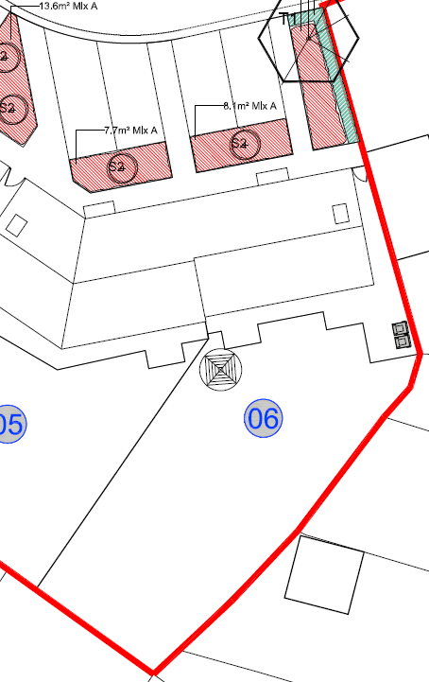

**Key**

Street Tree

Shrub

Hedge

Boundary

**2.1 Development Planting Palette**

Hedge Details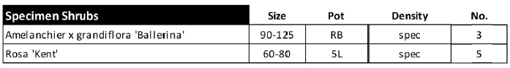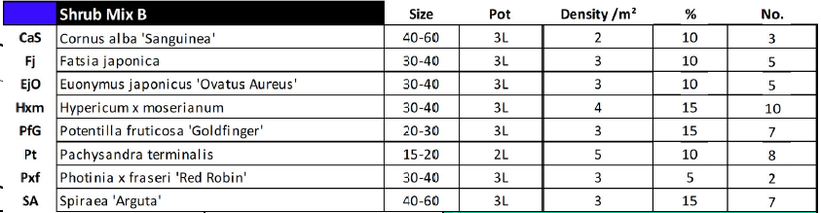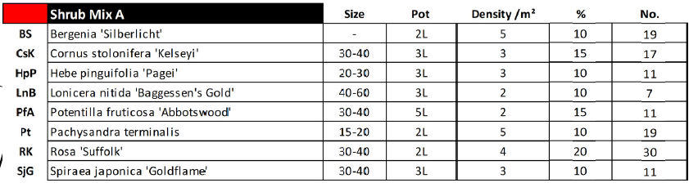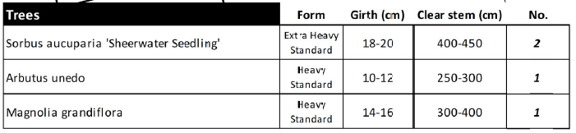

**2.2 Your Planting Palette**

| Name (Shrubs) | Image |
| --- | --- |
| Rosa ‘Kent’ | Photo of Rosa ‘Kent’ |
| Eleagnus x ebbingei | Photo of Eleagnus x ebbingei |
| Bergenia ‘Silberlicht’ | Photo of Bergenia ‘Silberlicht’ |
| Cornus stolonifera ‘Kelseyi’ | Photo of Cornus stolonifera ‘Kelseyi’ |
| Hebe pinguifolia ‘Pagel’ | Photo of Hebe pinguifolia ‘Pagel’ |
| Lonicera nitida ‘Baggessen’s Gold | Photo of Lonicera nitida ‘Baggessen’s Gold |
| Potentilla fruticose ‘Abbotswood’ | Photo of Potentilla fruticose ‘Abbotswood’ |
| Pachysandra terminalis | Photo of Pachysandra terminalis |
| Rosa ‘Suffolk’ | Photo of Rosa ‘Suffolk’ |
| Spiraea japonica ‘Goldflame’ | Photo of Spiraea japonica ‘Goldflame’ |

**2.3 Maintenance Tips**

**2.3 Maintenance Tips**

Did you know gardening brings so many health benefits and can give you hours of fun? If you don’t mind putting on a few old clothes and shoes, gardening is an easy way to get some exercise, your very own green gym! Evidence shows that it is also very therapeutic; touching flowers/soil, smells and sounds of wildlife, can help calm the mind.

This section provides the garden boundary and information on the type of plants you might find in your garden. It offers some useful maintenance tips to help you make the most of your garden. Do not be afraid to experiment by adding new and exciting plants within the beds. Take a trip to your local garden centre to experience and explore a whole tapestry of plants. Garden staff will give you lots of advice too.

*Coming soon* – Birmingham City Council’s Parks Department are looking to develop an online resource to help keen gardeners, providing extra tips and information to maintain gardens.

**Grass:**

* Cut the grass during the growing season (generally April-October) using a sharp cutter e.g. lawn mower, to remove the cuttings from the area to a compost bin/ green bin/ recycling centre for garden waste.
* Cut at intervals of no more than 10-14 days depending on the growing conditions.
* Should bare patches of grass develop, are is to be cultivated to 150mm depth and seed with amenity grass seed at the rate of 35 gm per square metre and the ground lightly raked over on a still dry day when the top 25mm of soil is dry. Use mix approved by Local Planning Authority.

* On a lovely dry day between April and October, you could enjoy mowing the grass in your garden – have a go at cutting up and down in strips to give it a professional look
* For a neat edge, try using a half-moon/edging iron with a board to cut along the line of grass, sometimes a strimmer helps too
* Inaccessible areas of knee-length long grass can be easily trimmed by using a strimmer
* Natural rain is perfect for your grass. During a drought, please follow government advice on watering grass

***Equipment***

* Lawn mower
* Watering can
* Fork/Hoe

***Optional***

* Grass strimmer
* Rake
* Half- moon/edging iron

***Did you know…***

By raking leaves off your grass, you give it air and keep the grass healthy

* Do not worry if you find bare patches, simply fork over the area (about 5-10cms) and sprinkle some grass seed
* Regularly water the newly seeded areas to help them grow and establish – try not to mow this area while it is growing

**Shrubs/Plants:**

* Shrubs give, colour, atmosphere & structure to the garden. They are not very difficult to maintain
* Simply remove weeds from between the shrubs; if there is bark mulch, you may need to scoop it aside and then spread back. Any stubborn weeds can be removed using the hand trowel and fork
* Young shrubs need a little more attention, check that they are healthy for example, are the leaves green or do they need a little more support? Insert canes and attach it to the plant with garden string to help support them
* Secateurs are great for retaining the shape of the shrubs. It’s springy motion, enables you to cut/snip stems, leaves and deadheading with ease
* Regularly check the plants in warmer weather and keep the soil moist, but not wet – avoid over watering
* The best time to water is early morning or evening.

**Hedges:**

* New hedge – your new hedge will be roughly 80cms high and may appear as individual shrubs to begin with. They will be positioned in a zig-zag form so that it can knit itself into a hedge as it grows
* Using shears or even secateurs lightly trim any leading shoots/branches to keep the shape and size of the hedge the same while it is young
* Established hedge – the specified hedge can grow up to 4metres! Aim to keep the hedge 1.2m high so it is easy to maintain.
* Trim the new growth, top and sides to keep the hedge in a ‘batter’ shape. This can be carried out using shears or hedge trimmer, which ever tool you are comfortable with
* For this species, prune/cut back in late spring (April to May) after fruiting and end of season in September. Rake and collect the cuttings
* Regularly water the base of the new hedge in warmer weathers, during the first few seasons. The water should be sinking deep into the soil – avoid over watering

***Did you know…***

Some secateurs can cut up to 2cms, they are great for gentle pruning…mulching helps to suppress weeds and retain moisture.

Top up where you can!

***Equipment***

* Gloves
* Secateurs
* Hand Trowel
* Hand Fork
* Watering Can

***Optional***

* Garden Hose
* Canes & String/Ties

**Trees:**

* Trees create wonderful focal features, provide shade and home to wildlife. Any work to trees should be avoided during bird-nesting season, between March-August
* Some simple pruning can enable best care for your tree. Prune; suckers that grow from the roots or base of your trunk, sagging limbs close to the ground, limbs that are dead/diseased or broken and branches that cross and obstruct outward growth
* The stakes and ties are helping the tree to establish itself; as the trunk grows and when you see this support is no longer required, carefully remove the stakes and cut the ties
* Remember to brush up and collect the fallen leaves and fruit of tree to keep clean the base around the grassed area and paving
* Young trees will need some care and watering, keep the soil moist but not too wet – avoid water logging
* Any complicated work like crown lifting and thinning will require a tree surgeon. Remember only carry out work to trees that you are comfortable with
* Remember to prune the tree with your feet firmly on the ground; ladders and climbing to prune are a hazard

**Top Tip!**

You could create a line between two canes to act as a cutting guide before trimming…while you work, step back to see your hedge take shape…follow the instructions that come with the tools

***Equipment***

* Gloves
* Garden Shears or Hedge Trimmer
* Rake or Brush
* Watering Can
* Goggles
* Protective Footwear

***Optional***

* Secateurs
* Garden Hose
* Canes & String/Ties

***Did you know…***

‘Batter’ shaped hedges (keeping the bottom slightly wider than the top), allows light to reach all sides of the hedge

***Did you know…***

Branches that are close together increase the growth of fungus and attract some pests…e.g., the Oak tree can have over 500 species of insects inhabiting it!

***Equipment***

* Gloves
* Long Reach Pruner
* Pruners/Loppers
* Pruning Saw
* Rake or brush

**TOP TIP**

It is easy to remove weeds when the soil is slightly moist…kneel on a soft pad to protect your knees…use an old bucket to collect your cuttings and weeds

**Section 3** *Discover Your Local Green Spaces*

**3.0 Your Neighbourhood**

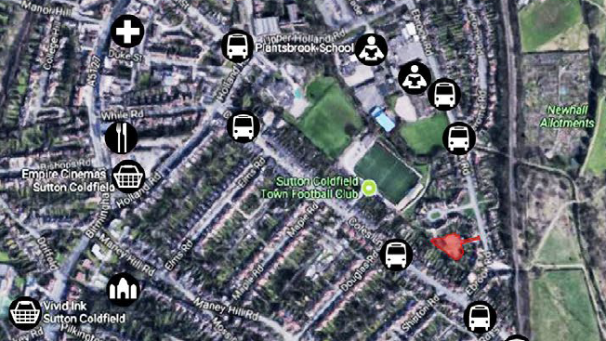





You are here

1. Sutton Park is the largest Urban Park in Europe. The park is a 2.5 mile walk from the Ebrook Road and will equate to an average of 10,000 steps if you walk there and back. It has one private golf club (Streetly), one public golf club and a sailing club (both in Boldmere). There is one pub near to Town gate, one restaurant in the heart of the park and a bistro by Blackroot Lake. Sutton Park is hosting the Triathlon in next year’s Commonwealth games.

Even closer is New Hall Valley Park, the entrance is diagonally opposite Tudor Rose Grove under the railway bridge. New Hall Allotments are also only a short walk away.

1. On your way to the park, you will see a number of local amenities, such as gyms, swimming bath, cinema, as well as a large shopping complex.
2. See section 4 for contact information of the leisure facilities near your neighbourhood.
   1. **Getting Around**

By Car – There are good links to the M6 Toll and junction 6 of the M6, and M42 located less than 5 miles away.

By Bus – The closest bus stops are located 0.2 miles away on Ebrook Road and 0.2 miles away on Coles Lane, providing multiple and regular routes including Sutton Coldfield, Erdington, Perry Common, Gravelly Hill and Birmingham City Centre.

By Train – Sutton Coldfield Train Station is less than 1 mile away and Wylde Green Station is 1.5 miles away. Both stations provide access to areas such as Lichfield, Longbridge, Redditch, Four Oaks and Birmingham New Street.

* 1. **Clubs & Activities**

Sutton Coldfield Football Club on Coles Lane provide training for under 21’s, under 18’s and juniors. They can be contacted on 0121 354 2997.

There are several tennis, hockey, bowls, rugby and cricket clubs nearby too.

Just fifteen minutes away by car, Woodlands Adventure and Outdoor Learning provides a fun day trip filled with outdoor activities like paddle sports, a climbing wall, assault courses, raft building, high ropes and nature studies! They can be contacted on 0121 353 7329.

Sutton Coldfield East and West District Scouting and Guides groups have a number of packs nearby.

Sutton Arts Theatre – a local amateur dramatic theatre is only a 10-minute walk away.

* 1. **Park Friends Group**

Sutton Park Nature Reserve is at the heart of a Friends of Parks group, made up of local residents who support open spaces. This is done in many ways, including but not limited to:

- Carrying out practical tasks such as clean ups, habitat management and planting

- Bidding for funds to make park improvements

- Letting the council know of any improvements would be most important to the local community

- Actively promoting the benefits and values of open spaces and green areas

- Helping the council with surveys and consultations

Friends groups are members of the Birmingham Open Spaces Forum, which campaigns for better resources and recognition for parks. Visit the BOSF website to find out more about your local group and make a difference in your community!

**Section 4** *Further Information & Links*

* [BOSF website](http://www.bosf.org.uk/) Birmingham Open Spaces Forum
* [Residents Association website](http://www.birmingham.gov.uk/info/50008/tenants_groups_associations_and_boards/577/residents_associations) Residents Association
* [Find a Park website](http://www.birmingham.gov.uk/findapark) Parks
* [Community Cycle club website](http://www.birmingham.gov.uk/directory/42/community_cycle_clubs) Cycle Clubs
* [Allotments website](http://www.birmingham.gov.uk/directory/7/a_to_z) Allotments
* [Wyndley Leisure Centre website](http://www.birminghamleisure.com/wyndley-leisure-centre) Leisure Centres
* [Birmingham Community Centres website](http://www.birmingham.gov.uk/directory/59/community_centres_in_birmingham) Community Centres
* [Birmingham Libraries website](http://www.birmingham.gov.uk/directory/14/libraries_in_birmingham) Libraries
* [Sutton Sports & Social club website](http://www.suttonsportssocialclub.business.site/) Sports & Social Club
* [Kinetic Insight website](https://www.kineticinsightpro.com/birmingham) The Active Wellbeing Society – sign up to free activities in your local park such as walks, rambles, running, cycling, gardening, tai chi or Zumba!