Newtown
WARD PLAN 2018 – 2022

Contents

Item Page
Ward Description 3

Places of Interest 4

Key Information 6

Policy context 9

Priorities 2012-14 10

Useful Contacts 13

Ward Description

Newtown Ward, also referred to as Aston New Town is an inner city ward located to the north west of the city. It has a population of 12,485 making it the 35th most populous ward in the city. The ward has a younger age profile than the city as a whole and has a higher BAME population share.

Newtown is one of the most deprived wards in the city and has the 6rh lowest average income out of 69 wards in the city. Resident employment rates in the ward are much lower than the city average and claimant count unemployment proportions are well above the Birmingham average.

Newtown is centred on the A34 road, locally named New Town Row which runs from Birmingham City Centre through north-west Birmingham into Walsall, and part of the A4540 which is the ring road around the centre of the city. Newtown is bordered by a number of other areas such as the Jewellery Quarter, the Gun Quarter and the University of Aston. To the west is Hockley Flyover and to the northwest is Lozells and to the north east is Aston.

Approved in 1968 Newtown was became the largest project in the Aston area of Birmingham to construct 16 tower blocks

Ward is made up of the following roads A34, A38 main New John Street West/Summer Lane. A4540/ B4100 Jewellery Quarter, with Wheeler Street running straight through.

Ward Councillor(s):


Councillor Ziaul Islam – Email Ziaul.islam@birmingham.gov.uk

Alternatively contact
Council House
Victoria Square
Birmingham,
B1 1BB
Telephone 0121 303 2039 (Labour Group Office)

The Newtown Ward is within the parliamentary constituency of Ladywood. The local Member of Parliament for Ladywood within which Newtown situated is Shabana Mahmood

Newtown was a large project in the Aston area of Birmingham, England to construct 16 tower blocks. It was approved in 1968. As of April 2007, five of these tower blocks have been demolished and refurbishment work commenced on Manton and Reynolds House in 2011 as part of a wider initiative to regenerate Newtown. It saw the clearance of council houses around Alma way and the construction of modern homes with a youth centre. Loosely related to the initiative was the reconstruction of Holte and Lozells Schools.

Existing tower blocks
- Hodgson Tower
- Baldwin Tower
- Inkerman House
- Sadler House
- Fallows House
- James House
- Lloyd House
- Reynolds House
- Thornton House
- Weston House
- Manton House

Demolished tower blocks
- Wiggin Tower
- Brooks Tower
- Bower House
- Sayer House
- White House

Places of interest and History

Aston Hippodrome.

It was a popular theatre. Opened to the public on 7 December 1908 at a cost of £10,000. Designed by James and Lister Lea who also designed the Bartons Arms public house just a few yards away on the other side if the street.

The theatre was damaged in 1938 by a fire which resulted in a £38,000 refurbishment. On 4 June 1960, the theatre building ceased performances. The building was renovated into a bingo hall and remained so until its demolition in September 1980. The Drum, an arts centre, is located on the theatre site.

The Bartons Arms - Is a public house in the High Street part of the A34 in Newtown area of Aston.

Built in 1900 -1901 architects James and Lester Lea for Mitchells & Butler (M&B). It is a grade two listed building, and is on the Campaign for Real Ale’s National Inventory of Historic Pub Interiors.

The pub is known for its wall to wall Minton- Hollins tiles and its snob screen, which allowed middle class drinkers in an adjacent bar, but not to seen by them. The current public bar was originally divided into three. There are function rooms upstairs, originally for billiards and club use.

Laurel and Hardy stayed there in May 1954, while appearing at the adjacent Aston Hippodrome.

The pub was purchased in 2002 by Oakham Ales who restored the building to its former greatness before reopening it in 2003, after three years out of use. On 28 July 2006, the pub damaged by fore, reportedly caused by electrical fault.
- The Drum, an arts centre
- The Elbow Room, a nightclub

Wallace Lawler Centre - Named after Wallace Leslie Lawler. He was a British Liberal politician. He was elected a Member of Parliament by gaining Birmingham, Ladywood from Labour at a by-election on 26 June 1969.

However, Lawler only served one year, as Labour’s Doris Fisher gained the seat from him at the 1970 general election. He was the last Liberal to serve as a Member of Parliament in Birmingham, as Liberal Democrat John Hemming gained Birmingham, Yardley in 2005.

Key information
Age Profile
Age | Newtown  (No) | Newtown (%) | Birmingham (%) | England (%)
16-64 | 8448 | 67.7 | 64.3% | 64.8%
Under 18 | 3715 | 29.8 | 25.5% | 21.4%
18-24 | 3098 | 24.8 | 12.1% | 9.4%
25-44 | 3380 | 27.1 | 28.7% | 27.5%
45-64 | 1599 | 12.8 | 20.7% | 25.4%
65+ | 693 | 5.6 | 12.9% | 16.3%

Ethnicity
Ethnic Group | Newtown  (No) | Newtown  (%) | Birmingham (%) | England (%)
White Total | 2218 | 17.8 | 57.9 | 85.4
British  Irish  Other White  Mixed/ Multiple Ethnicity | 1678  152  388  806 | 13.4  1.2  3.1  6.5 | 53.1  2.1  2.7  4.4 | 79.8  1.0  4.7  2.3
Asian Total | 3626 | 29.0 | 26.6 | 7.8
Indian  Pakistani  Bangladeshi  Chinese  Other Asian | 1052  693  1128  288  465 | 8.4  5.6  9.0  2.3  3.7 | 6.0  13.5  3.0  1.2  2.9 | 2.6  2.1  0.8  0.7  1.5
Black Total | 4894 | 39.2 | 9.0 | 3.5
Black African  Black Caribbean  Black Other  Other Ethnic Group | 2017  1778  1099  401 | 16.2  14.2  8.8  3.2 | 2.8  4.4  1.7  2.0 | 1.8  1.1  0.5  1.0

Newtown Ward: has a population of approximately 12,485

Total claimant unemployed rate of;
Newtown Economic Activity Source: 2011 Census
Economic Activity | Newtown No | Newtown % | Birmingham % | England %
16-64 Population | 8,448 | - | - | -
Economically Active Total | 4,720 | 55.9% | 69.3% | 77.0%
Employed | 3,454 | 40.9% | 60.0% | 71.2%
Unemployed | 1,266 | 15.0% | 9.3% | 5.8%
Economically inactive Total | 3,758 | 44.5% | 30.7% | 23.0%

- Ranked 1st on the indices of multiple deprivation for Birmingham; National Ranked 33rd.

Housing
Housing tenure profile in Newtown Ward i.e. owner occupier, rented, housing or mixed] properties.

All Household | Owned  Outright | Owned with Mortgage/loan | Shared ownership | Rented BCC | Housing Ass/registered  Landlord | Private  Landlord or letting agency | Other private rented | Living rent free
4235 | 263 | 497 | 35 | 2238 | 512 | 507 | 42 | 141

Average Income 2016

Newtown £11,893 Birmingham £16,185 England 18,788

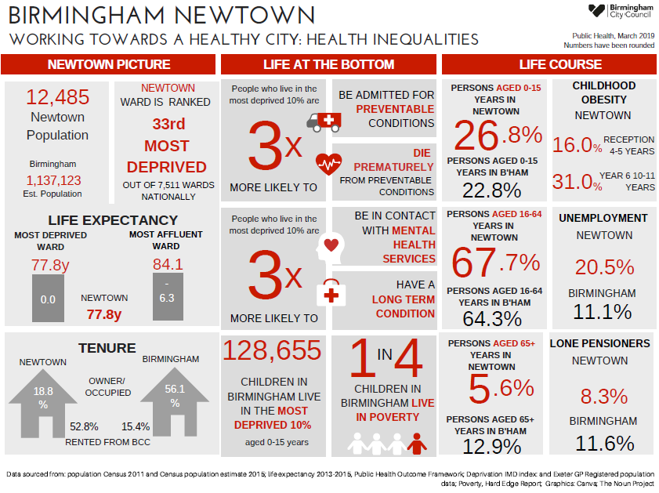

There are 5 schools within the ward. 3 primary schools and 1 secondary.
- Aston Manor Academy (Secondary)
- St Georges Primary School
- Chilwell Croft Academy
- St Chad RC Primary
- Nishkam High School – Great Kings Street North (Secondary)

Significant resources in the ward include:

- Royal Mail Sorting Office and Deport
- 4 Public Open Spaces. Burbury Park, St Georges Park (Uxbridge St), Clifford Street (Yellow) Park and Phillip Street Park.
- Extra Care Support for retired and elderly persons (Panel Croft)
- 3 Shopping areas (Newtown shopping centre, Wheelers Street and Great Hampton Street/ Uxbridge Street)
- Newtown Post Office – Newtown Shopping Centre
- BCC Customer Service Centre (New Aston House)
- BCC Children and Families Centre (New Aston House)
- BCC Newtown Community Centre (closed March 2019)
- Well–Being Leisure Facility (closed Swimming baths)
- St Georges Community Hub (former secondary school)
- Huda Centre (former known as Little Brown Jug – Unett Street)
- Wallace Lawler Centre- see notes on history. (Voluntary)
- West Midlands Police – Rapid Response Division – Summer Lane
- Zumunta Community Centre, Newtown Shopping Centre

Key stakeholders within the ward include:

- Birmingham City Council Children and Families Centre
- Birmingham Mind Services
- West Midlands Police – Summer Lane
Policy Context

The Paper Localism in Birmingham: A Framework for Future Policy, March 2018 set out objectives for future ward-based working which will focus on: improved service delivery in neighbourhoods, an agenda of “Neighbourly Neighbourhoods” and a commitment to a “Whole Place” and “Whole System” way of working.

The new ward planning process is one of the main mechanisms by which citizens and communities can participate in setting local priorities themselves. The ward plan will be used to develop and enhance local engagement and community governance. The ward plan will highlight local priorities and planned actions.

In January 2019 Cabinet approved the Localisation White Paper “Working Together in Birmingham’s Neighbourhoods”. This commits the City Council to a programme of transformation, “to make Birmingham a localist city, and transform the culture of the city council to support that”. It also commits the city council to:

- Strengthen Ward partnership working and Ward planning
- Strengthen neighbourhood resources
- Make services more responsive to local neighbourhoods

It sets four tests for the success of this programme by 2022:
- Services being different, better suited to the area, and more efficient.
- Officers working for ‘one council’, putting shared outcomes and local places first, not their service or directorate.
- Local councillors having more influence on services.
- Residents feeling they are more in control of their services and their local area.

This Newtown Ward Plan is about achieving these results in our own local Ward.

The ward plan aligns with Birmingham City Council Vision and Priorities 2017-2020

BIRMIINGHAM CITY COUNCIL VISION –A city of growth where every child, citizen and place matters.

BIRMIINGHAM CITY COUNCIL OUTCOMES – What we want to achieve:
- Birmingham is an entrepreneurial city to learn, work and invest in
- Birmingham is an aspirational city to grow up in
- Birmingham is a fulfilling city to age well in
- Birmingham is a great city to live in
- Birmingham residents gain the maximum benefit from hosting the Commonwealth Games

Ward Priorities

Although new ward arrangements provide an opportunity through ward meetings, councillors’ advice surgeries and stakeholder engagement to re-establish local priorities, it is important to revisit and note previously agreed ward priorities and the ward action tracker, which has tracked ward priorities for over 12 months.

Ward Tracker Priorities [Aston previous ward name]:

- Housing – Private Rented Sector/HMOs etc
- Environment – Cleaner street
- Highways

Local Innovation Fund Priorities:
Aston previous old ward priorities were.

- Community Cohesion/Engagement
- Young people engagement
- Local Environment Engagement
- Health and Employment

Local Community Safety Partnership and/or Neighbourhood Tasking Group Priorities:
- Community engagement,
- Street crime, etc.

Funding/Budgets

- The sum of £48k from the old ward arrangements have been devolved to the organisations within the ward to deliver Local Innovation Fund (LIF) Projects.

Project | Org. name | Sum awarded | Status
29 Plus Health | GHC | £4750 | Ongoing
Youth Diverse | Bidgley Power | £9,500 | Ongoing
Aston Community Heritage and Library | West Midlands Fire Service and Library Services | £12,000 | Ongoing
Newtown Community Hub | Huda Centre | £8,500 | Ongoing
Safe and Protected | BCC Youth Service and Gold mind Studio | £8,500 | Ongoing

- A share of the Proceeds of Crime funding may be allocated to the ward

Project | Org. name | Sum awarded | Status
None identified

- Highways Ward Minor Transport Measures budget £6500

Project | Org. name | Sum awarded | Status
Give way road marking for road safety at Newtown Middleway/New John Street West | Local Engineer/Amey | £1300 | Plan to complete by end of March 2020
Four ‘Give way’ warning signs on yellow high vis backing board and associated post with high vis band. Location Smith Street & Hampton Row | Local Engineer/Amey | £3300 | Due to complete by 31/03/2020
Centre line road marking from Barton Arms carpark to junction of Potters Lane with A34 High Street | Local Engineer/Amey | £1300 | Due to complete by 31/03/2020
NWATT double yellow lines at the junction of Rudgewick Croft and Chilworth Close with Sutton Street | Local Engineer/Amey | £1300 | Due to complete by 31/03/2020

- Housing Environmental Works budget - £28,000 details to be provided by Housing services.
Project | Location | Sum allocated | Status

- Section 106 funding

Project | Location | Sum allocated | Status
None active

- Neighbourhood Network Scheme (applicable – details to be provided)

Project | Location | Sum allocated | Status

- Community Infrastructure Levy (applicable – details to follow)

Project | Location | Sum allocated | Status

Please list any other sources of ward-based funding below.

Useful Links

https://www.birmingham.gov.uk/

https://public.tableau.com/profile/bcc.ck#!/vizhome/2018BirminghamWardProfiles/2018BirminghamWardProfiles

BirminghamEconomy@birmingham.gov.uk

Health & Wellbeing Services: https://www.the-waitingroom.org/

Declaration

This plan has been drafted following engagement and discussions with local residents and ward stakeholders. It was been agreed and adopted by those present at the Newtown Ward meeting on: 5th March 2020, which was held at Wallace Lawler Centre – Wheeler Street, Newtown.

Signed [elected member(s) signature(s):

Print: Councillor Ziaul Islam

Elected member (2) Signed:

Print:
Newtown Ward Plan – May 2019

A city of growth where every child, citizen and place matters.

Priority 1 Parks and Open Spaces

Action(s) / What needs to be done? | Where? | By Who? | By When | Stakeholders/  Resources | Update
Maintain Park | Unett Street
Litter bins too small | St Georges Park
Clean up and have preventative measures. Fly-tipping | Burbury and Yellow Park
Grass verges | Newtown – Gee St

Priority 2 Housing/ Private Lettings

Action(s) / What needs to be done? | Where? | By Who? | By When | Stakeholders/  Resources | Update
Newtown to have a review on tenancy agreement with all residents |  | BCC – Housing/Midland Heart
Removal of litter/overgrown grass and weeds surrounding building | Martineau Tower& other Tower blocks

Priority 3 Highway and Road Safety

Action(s) / What needs to be done? | Where? | By Who? | By When | Stakeholders/  Resources | Update
Parking – Double Yellow lines | Unett St Brearley Street
Traffic calming measures/evaluation | Newtown Shopping Centre

Priority 4 Parking inc Schools

Action(s) / What needs to be done? | Where? | By Who? | By When | Stakeholders/  Resources | Update
Mark out car park spaces to make more efficient use of space. | Uxbridge St Fallows House Attenborough Close | BCC – Housing
Cars outside of Newtown parking near schools |  | Police
Residents permits

Priority 5 Environment

Action(s) / What needs to be done? | Where? | By Who? | By When | Stakeholders/  Resources | Update
Rubbish to be removed regular/
Bins need to be bigger
More preventative measures/Clean up

