HALL GREEN NORTH
WARD PLAN 2018 - 2022

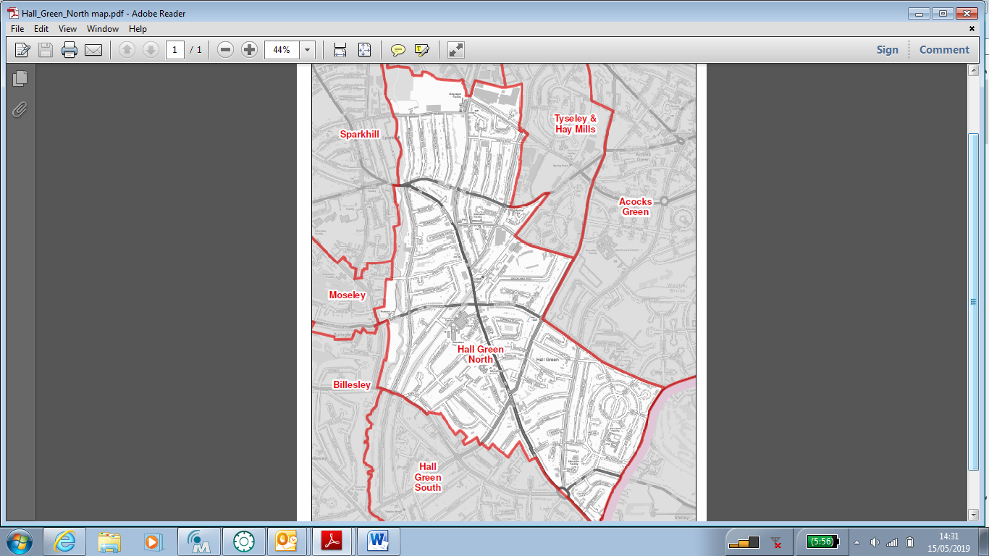

Contents

Item Page
Ward Description 4

Policy context X

Priorities 2012-14 X

Useful Contacts X

Ward Councillors
Lou Robson



Contact details
Council House
Victoria Square
Birmingham B1 1BB

Telephone 0121 303 2039
Email: lou.robson@birmingham.gov.uk

Akhlaq Ahmed

Contact details
Council House
Victoria Square
Birmingham B1 1BB

Telephone 0121 303 2039
Email: akhlaq.ahmed@birmingham.gov.uk

The local Member of Parliament for Hall Green Constituency within which Hall Green North is situated in is Mr. Roger Godsiff MP

Ward Description

Hall Green North is a suburban ward located in the south east of the city. It has a population of 21,509 making it the 14th most populous ward in the city.

The ward has a similar age profile to the city as a whole and a higher BAME population share.

Hall Green North is less deprived than the majority of the city's 69 wards but has average income below the Birmingham average.
Resident employment rates in the ward are a little above the city average and claimant count unemployment proportions are below the Birmingham average.

Age Breakdown
Number Ward % Brum% National%
All Residents | 21,509 | - | - | -
16-64 | 13,319 | 61.9% | 64.3% | 64.8%
Under18 | 6,056 | 28.2% | 25.5% | 21.4%
18-24 | 2,032 | 9.4% | 12.1% | 9.4%
25-44 | 5,943 | 27.6% | 28.7% | 27.5%
45-64 | 4,653 | 21.6% | 20.7% | 25.4%
65+ | 2,825 | 13.1% | 12.9% | 16.3%

Ethnicity
White Total | 7,757 | 36.1% | 57.9% | 85.4%
British | 6,400 | 29.8% | 53.1% | 79.8%
Irish | 832 | 3.9% | 2.1% | 1.0%
Other White | 525 | 2.4% | 2.7% | 4.7%
Mixed or Multiple Ethnicity | 759 | 3.5% | .4% | 2.3%
Asian Total | 10,388 | 48.3% | 26.6% | 7.8%
Indian | 2,652 | 12.3% | 6.0% | 2.6%
Pakistani | 6,034 | 28.1% | 13.5% | 2.1%
Bangladeshi | 626 | 2.9% | 3.0% | 0.8%
Chinese | 100 | 0.5% | 1.2% | 0.7%
Other Asian | 976 | 4.5% | 2.9% | 1.5%
Black Total | 749 | 3.5% | 9.0% | 3.5%
Black African | 233 | 1.1% | 2.8% | 1.8%
Black Caribbean | 405 | 1.9% | 4.4% | 1.1%
Black Other | 111 | 0.5% | 1.7% | 0.5%
Other Ethnic Group | 494 | 2.3% | 2.0% | 1.0%

Economic Activity | Hall Green North No | Hall Green North % | Birmingham % | England %
16-64 Population | 13,319 | - | - | -
Economically Active Total | 9,226 | 69.3% | 69.3% | 77.0%
Employed | 8,138 | 61.1% | 60.0% | 71.2%
Unemployed | 1,088 | 8.2% | 9.3% | 5.8%
Economically inactive Total | 4,125 | 31.0% | 30.7% | 23.0%

Occupation Breakdown
Higher Skilled Intermediate Skills Lower Skilled
37.9% 21% 41.1%

Average Income
Hall Green North Birmingham England
£15,654 £16,185 £18,788

Index of Deprivation*
The ward of Hall Green North is ranked 49t^{h} Highest in the table of the indices of deprivation in Birmingham and is ranked as the 1271th ward Nationally

(*Deprivation measures are markers of socio-economic status used in public health include: income, occupation, years of education, housing, health & various alternative indicators such as ownership of various goods such as car, washing machine etc).

Key information

Hall Green North Ward:

There are 7 schools within the ward and one college for further education.

Secondary
Hall Green School (mixed)

Primary

Hall Green Junior School
Hall Green Infants School
Yorkmead Junior and Infant School
St Ambrose Barlow RC Primary School
Robin Hood Academy
Al-Furqan Primary School

Further Education
South and City College

Significant resources in the ward include:
- Hall Green Library
- Sarehole Mill Museum
- River Cole corridor and open space at Shire Country Park, Sarehole Fields, Greet Mill Meadow
- Hall Green Parade and Stratford Road shops
- Small parades of shops at Lakey Lane, School Road, Robin Hood Island, Highfield Road
- Hall Green Health
- Hall Green United Community Church
- Hall Green Baptist Church
- Friends Meeting House
- Church of the Ascension
- Job Marston Centre
- Highfield Hall
- Mosques at Wycome Road, Stratford Road and Reddings Lane
- St Michael’s Church/The Oak Community Centre

Key stakeholders within the ward include:
- West Midlands Police, Hall Green Neighbourhood Team
- Fire Service (based outside ward at Billesley)
- Hall Green Health team
- Housing Associations including Bromford

Statutory, faith, voluntary and business “stakeholders” include:

Job Marston Community Centre
Hall Green foodbank
Highfield Hall Community Centre
The Oak Community Centre
Hall Green Gardens Group
Friends of Hall Green Library
Sarehole Environmental Action Team
Numerous social groups which meet at churches
Scouting and guiding groups

There is no BID or business organisation
There was a resident’s association which is dormant
Hall Green Action Group is close to dormant
Hall Green Gardens Group is active
Friends of Hall Green Library
Sarehole Environmental Action Team

Policy Context

The Paper Localism in Birmingham: A Framework for Future Policy, March 2018 set out objectives for future ward-based working which will focus on: improved service delivery in neighbourhoods, an agenda of “Neighbourly Neighbourhoods” and a commitment to a “Whole Place” and “Whole System” way of working.

The new ward planning process is one of the main mechanisms by which citizens and communities can participate in setting local priorities themselves. The ward plan will be used to develop and enhance local engagement and community governance. The ward plan will highlight local priorities and planned actions.

The ward plan aligns with Birmingham City Council Vision and Priorities 2017-2020

BIRMIINGHAM CITY COUNCIL VISION –A city of growth where every child, citizen and place matters.

BIRMIINGHAM CITY COUNCIL OUTCOMES – What we want to achieve:

- Birmingham is an entrepreneurial city to learn, work and invest in
- Birmingham is an aspirational city to grow up in
- Birmingham is a fulfilling city to age well in
- Birmingham is a great city to live in
- Birmingham residents gain the maximum benefit from hosting the Commonwealth Games

Ward Priorities

Although new ward arrangements provide an opportunity through ward meetings, councillors’ advice surgeries and stakeholder engagement to re-establish local priorities, it is important to revisit and note previously agreed ward priorities and the ward action tracker, which has tracked ward priorities for over 12 months.

Ward Tracker Priorities [former Hall Green ward]:
- Unable to source

Local Innovation Fund Priorities:
- Community cohesion,
- Local engagement,
- Skills & Learning
- Economy

Local Community Safety Partnership and/or Neighbourhood Tasking Group Priorities (where applicable):
- Unable to source

Local priorities for the new Hall Green North ward (2019-2022)

- Streets and highways/road safety
- Priority is to make the ward a safer place for pedestrians and drivers.
- Improve parking around schools. Support Modeshift Stars school safety plans at Robin Hood Academy and Ambrose Barlow and encourage other schools to adopt.
- Liaise with police and council enforcement officers over problem parking, speeding
- Liaise with Amey over potholes, grass verges, drains
- Liaise with District Engineer over traffic measures. Lobby for inclusion of traffic light scheme at Shaftmoor Lane/Reddings Lane in 20/21 budget

- Environment and “street scene”
- Priority is to create a clean and pleasant environment for residents
- Litter and flytipping is a ward-wide problem with hotspots along Stratford Road, Spring Road, River Cole corridor from Blackberry Way to Sarehole Road
- Support more community clean-ups involving active citizens. Obtain clean-up equipment for local groups
- Request street cleaning and enforcement from waste prevention
- Encourage residents to report via BCC website of Fix My Street
- Trees – liaise with Amey/BCC to cut back trees

- Future of retail areas
- Priority is to support residents and businesses to create a viable local centre
- Retail areas are in decline throughout the ward (and the city)
- Hall Green Parade and Stratford Road from York Road to Robin Hood Island are the main shopping and business areas. We have lost a post office, major supermarket and the prevalence of changing uses to food/takeaway premises further undermines the viability of these areas
- Support residents and businesses to set out aims to improve our local centres
- Build on work done with LIF grant

- Policing and community safety
- Priority is to make the ward a safe place for all residents
- Support and work with local police team on anti-social behaviour and community safety (see traffic plans above)
- Promote Neighbourhood Watch and Streetwatch schemes
- Promote local police tasking meetings and WMNow to help residents report and liaise with police

- Community resources and neighbourhood working
- Priority is to improve involvement in residents’ groups and local governance so people feel they have a say over their neighbourhoods
- Community resources are fragmented and there is little community leadership or networked information
- In a rapidly changing area, there is a need for networking, community resourcing and support for community cohesion
- Hall Green Library is a hub for information and local groups but its meeting room has been closed for three years so cannot operate to its full potential, and groups are deprived of a central community resource. We are lucky to have strong church and community groups. Lobby for restoration of meeting room at library.
- There is a useful online residents network but this is not exclusive to the ward. There is no local residents’ forum or forums and this makes it hard for residents to get involved in neighbourhood governance. The main forum is the ward meeting and a very one-to-one system of councillor casework with little scope for community involvement in ward wide issues and campaigns.
- Lobby for inclusion in Priority Ward scheme

Funding/Budgets

- The sum of £48k from the old ward arrangements have been devolved to the organisations within the ward to deliver Local Innovation Fund (LIF) Projects.

Project | Org. name | Sum awarded | Status
Stronger Together | Highfield Community Centre & Partners | £35,000 | Report back due at Sept ward forum
Reimagining Hall Green Parade | Collaborated Businesses | £7,000 | Report back due at Sept ward forum

- A share of the Proceeds of Crime funding was allocated to the ward. The following groups shared £1000

Project | Org. name | Sum awarded | Status
 | Sarehole Environmental Action Team
 | Friends of Hall Green Library
 | The Oak
 | Hall Green Food Bank

- Highways Ward Minor Transport Measures budget - councillors have combined 18/19 and 19/20 budget of £26,000. Projects yet to be allocated.

Project | Org. name | Sum awarded | Status

- Housing Environmental Works budget – no information

Project | Location | Sum allocated | Status

- Section 106 funding (as at 6/8/18 £578,747 out of £733,747 received according to last report supplied). We are aware that other monies are due but have no information on these or on where the money has been allocated or spent.

Project | Location | Sum allocated | Status

- Neighbourhood Network Scheme (where/if applicable)

Project | Location | Sum allocated | Status

- Community Infrastructure Levy (where/if applicable)

Project | Location | Sum allocated | Status

Please list any other sources of ward-based funding below.

Useful Links

https://www.birmingham.gov.uk/

https://public.tableau.com/profile/bcc.ck#!/vizhome/2018BirminghamWardProfiles/2018BirminghamWardProfiles

Declaration

This plan has been drafted following engagement and discussions with local residents and ward stakeholders. It was been agreed and adopted by those present at the [insert ward name] Ward meeting on: [insert day, date and year], which was held at [insert meeting venue name].

Signed [elected member(s) signature(s):

Print: Lou Robson

Elected member (2) Signed:

Print: Akhlaq Ahmed

Plan to be adopted at September ward forum meeting or next convenient date.

