**MERE GREEN**

**WARD PLAN 2018 - 2022**

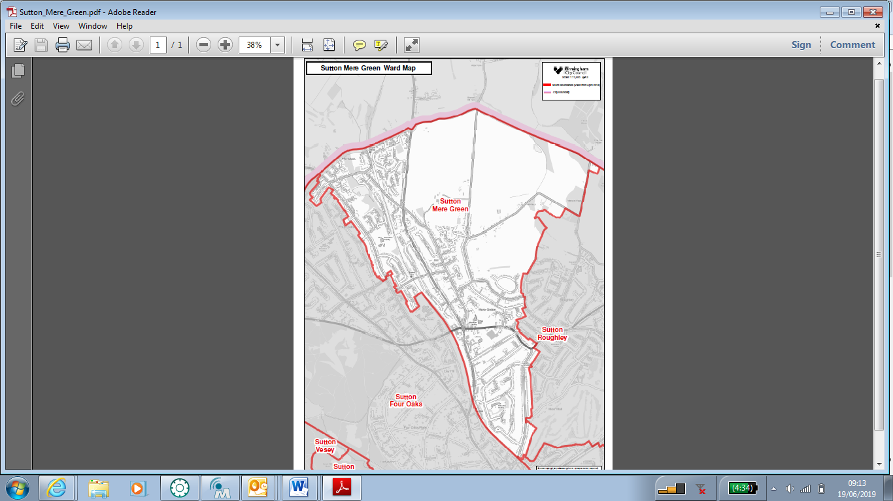



**Contact details**

Council House  
Victoria Square  
Birmingham  
B1 1BB

**Telephone:** 0121 303 2130

**Email:** [**m.jenkins@rapidcomputing.co.uk**](mailto:m.jenkins@rapidcomputing.co.uk)

Sutton Mere Green is a suburban ward located in the north of the city. It has a population of 9,703 making it the 6th smallest ward in the city in terms of population.

The ward has an older age profile than the city as a whole and a lower BAME population share.

Sutton Mere Green is one of the least deprived wards in the city and has the 5th highest average income levels out of the 69 Birmingham wards.

Resident employment rates in the ward are well above the city average and claimant count unemployment proportions are well below the Birmingham average

**KEY INFORMATION**

**Age Breakdown**

**Number Ward % Brum% National%**

|  |  |  |  |  |
| --- | --- | --- | --- | --- |
| All Residents | 9,703 | - | - | - |
| 16-64 | 5,698 | 58.7% | 64.3% | 64.8% |
| Under18 | 1,970 | 20.3% | 25.5% | 21.4% |
| 18-24 | 587 | 6.0% | 12.1% | 9.4% |
| 25-44 | 2,216 | 22.8% | 28.7% | 27.5% |
| 45-64 | 2,674 | 27.6% | 20.7% | 25.4% |
| 65+ | 2,256 | 23.3% | 12.9% | 16.3% |

**Ethnicity**

|  |  |  |  |  |  |  |  |  |  |  |  |  |  |  |  |  |  |  |  |  |  |  |  |
| --- | --- | --- | --- | --- | --- | --- | --- | --- | --- | --- | --- | --- | --- | --- | --- | --- | --- | --- | --- | --- | --- | --- | --- |
| White Total | 8,477 | | | | | 87.4% | | | | | | | 57.9% | | | | | | 85.4% | | | | |
| British | 8,168 | | | | | 84.2% | | | | | | | 53.1% | | | | | | 79.8% | | | | |
| Irish | 135 | | | | | 1.4% | | | | | | | 2.1% | | | | | | 1.0% | | | | |
| Other White | 174 | | | | | 1.8% | | | | | | | 2.7% | | | | | | 4.7% | | | | |
| Mixed or Multiple Ethnicity | 208 | | | | | 2.1% | | | | | | | 4.4% | | | | | | 2.3% | | | | |
| Asian Total | 544 | | | | | 5.6% | | | | | | | 26.6% | | | | | | 7.8% | | | | |
| Indian | 346 | | | | | 3.6% | | | | | | | 6.0% | | | | | | 2.6% | | | | |
| Pakistani | 85 | | | | | 0.9% | | | | | | | 13.5% | | | | | | 2.1% | | | | |
| Bangladeshi | 18 | | | | | 0.2% | | | | | | | 3.0% | | | | | | 0.8% | | | | |
| Chinese | 33 | | | | | 0.3% | | | | | | | 1.2% | | | | | | 0.7% | | | | |
| Other Asian | 62 | | | | | 0.6% | | | | | | | 2.9% | | | | | | 1.5% | | | | |
| Black Total | 142 | | | | | 1.5% | | | | | | | 9.0% | | | | | | 3.5% | | | | |
| Black African | 30 | | | | | 0.3% | | | | | | | 2.8% | | | | | | 1.8% | | | | |
| Black Caribbean | 90 | | | | | 0.9% | | | | | | | 4.4% | | | | | | 1.1% | | | | |
| Black Other | 22 | | | | | 0.2% | | | | | | | 1.7% | | | | | | 0.5% | | | | |
| Other Ethnic Group | 20 | | | | | 0.2% | | | | | | | 2.0% | | | | | | 1.0% | | | | |
|  | | | | | | | |  | | | |  | | | | | |  | | | | | | |
|  | |  | | | | |  | | | | | | |  | | | | | |  | | | | |
|  | |  | | | | |  | | | | | | |  | | | | | |  | | | | |
|  | |  | | | | |  | | | | | | |  | | | | | |  | | | | |
|  | |  | | | | |  | | | | | | |  | | | | | |  | | | | |
|  | |  | | | | |  | | | | | | |  | | | | | |  | | | | |
| **Sutton Mere Green 16-64 Long Term Health Problem or Disability** Source: 2011 Census | | | | | | | | | | | | | | | | | | | | | | | | | | |
| **Level** | | | **Ward Noo** | | | | | | **Ward %** | | | | | | **Birmingham %** | | | | | | | **England %** | | | | |
| Limited a Lot | | | 213 | | | | | | 3.7% | | | | | | 6.8% | | | | | | | 5.6% | | | | |
| Limited a Little | | | 374 | | | | | | 6.6% | | | | | | 8.1% | | | | | | | 7.1% | | | | |
| **Total Work Limiting Health Conditions** | | | **587** | | | | | | **10.3%** | | | | | | **14.9%** | | | | | | | **12.7%** | | | | |
| Not Limited | | | 5,111 | | | | | | 89.7% | | | | | | 85.1% | | | | | | | 87.3% | | | | |
| **Working population** | | | | |  | | | | | |  | | | | | |  | | | |  | | | | |
| 16-64 Population | | | | | 5,698 | | | | | | - | | | | | | - | | | | - | | | | |
| Economically Active Total | | | | | 4,501 | | | | | | 79.0% | | | | | | 69.3% | | | | 77.0% | | | | |
| Employed | | | | | 4,229 | | | | | | 74.2% | | | | | | 60.0% | | | | 71.2% | | | | |
| Unemployed | | | | | 272 | | | | | | 4.8% | | | | | | 9.3% | | | | 5.8% | | | | |
| Economically inactive Total | | | | | 1,109 | | | | | | 19.5% | | | | | | 30.7% | | | | 23.0% | | | | |
|  | | | | |  | | | | | |  | | | | | |  | | | |  | | | | |
|  | | | | |  | | | | | |  | | | | | |  | | | |  | | | | |
| **Occupation Breakdown** | | | | |  | | | | | |  | | | | | |  | | | |  | | | | |
| All Employed | | | | 4,513 | | | | | | - | | | | | | - | | | | | | | - | | | | |
| Managers, directors and senior officials | | | | 707 | | | | | | 15.7% | | | | | | 8.3% | | | | | | | 10.9% | | | | |
| Professional occupations | | | | 1,077 | | | | | | 23.9% | | | | | | 18.3% | | | | | | | 17.5% | | | | |
| Associate professional and technical occu-pations | | | | 732 | | | | | | 16.2% | | | | | | 11.0% | | | | | | | 12.8% | | | | |
| **Higher Skilled Occupations** | | | | **2,516** | | | | | | **55.8%** | | | | | | **37.6%** | | | | | | | **41.1%** | | | | |
| Administrative and secretarial occupations | | | | 598 | | | | | | 13.3% | | | | | | 11.7% | | | | | | | 11.5% | | | | |
| Skilled trades occupations | | | | 331 | | | | | | 7.3% | | | | | | 9.8% | | | | | | | 11.4% | | | | |
| **Intermediate Occupations** | | | | **929** | | | | | | **20.6%** | | | | | | **21.6%** | | | | | | | **22.8%** | | | | |
| Caring, leisure and other service occupa-tions | | | | 324 | | | | | | 7.2% | | | | | | 10.1% | | | | | | | 9.3% | | | | |
| Sales and customer service occupations | | | | 276 | | | | | | 6.1% | | | | | | 9.0% | | | | | | | 8.4% | | | | |
| Process plant and machine operatives | | | | 185 | | | | | | 4.1% | | | | | | 8.5% | | | | | | | 7.2% | | | | |
| Elementary occupations | | | | 283 | | | | | | 6.3% | | | | | | 13.2% | | | | | | | 11.1% | | | | |
| **Lower Skilled Occupations** | | | | **1,068** | | | | | | **23.7%** | | | | | | **40.8%** | | | | | | | **36.0%** | | | | |
| All Employed | | | | | 4,513 | | | | | | - | | | | | | - | | | | - | | | | |
|  | | | | |  | | | | | |  | | | | | |  | | | |  | | | | |

|  |  |  |  |  |
| --- | --- | --- | --- | --- |
| **Mere Green Qualification Levels** Source: 2011 Census | | | | |
| **NVQ Level** | **Sutton Four Oaks** | **Four Oaks %** | **Birmingham %** | **England %** |
| No Qualifications | 424 | 8.1% | 20.8% | 14.8% |
| No Qualifications | 520 | 9.3% | 20.8% | 14.8% |
| Level 1 | 718 | 12.8% | 15.0% | 15.2% |
| Level 2 | 985 | 17.6% | 15.5% | 17.1% |
| Apprenticeship | 141 | 2.5% | 1.9% | 3.1% |
| Level 3 | 811 | 14.5% | 15.0% | 14.5% |
| Level 4 qualifications | 2,288 | 40.8% | 25.2% | 29.8% |

**Average Income**

Ward Birmingham England

£21,763 £16,185 £18,788

**Policy Context**

The Paper Localism in Birmingham: A Framework for Future Policy, March 2018 set out objectives for future ward-based working which will focus on: improved service delivery in neighbourhoods, an agenda of “Neighbourly Neighbourhoods” and a commitment to a “Whole Place” and “Whole System” way of working.

The new ward planning process is one of the main mechanisms by which citizens and communities can participate in setting local priorities themselves. The ward plan will be used to develop and enhance local engagement and community governance. The ward plan will highlight local priorities and planned actions.

All that said, we also have to recognise that the vast majority of interactions between councillors and residents are now made electronically. Regrettably attendance at ward meetings continue to be limited. Therefore, the ward priorities and action plan are based both on comments at the ward meeting on 29th July and information gathered by the councillor through hundreds of interactions with residents by other means.

The ward plan aligns with **Birmingham City Council Vision and Priorities 2017-2020**

**BIRMIINGHAM CITY COUNCIL VISION** –*A city of growth where every child, citizen and place matters.*

***BIRMIINGHAM CITY COUNCIL OUTCOMES – What we want to achieve:***

* **Birmingham is an entrepreneurial city to learn, work and invest in**
* **Birmingham is an aspirational city to grow up in**
* **Birmingham is a fulfilling city to age well in**
* **Birmingham is a great city to live in**
* **Birmingham residents gain the maximum benefit from hosting the Commonwealth Games**

**Ward Priorities**

* Reassurance from police that they can respond appropriately to reported incidents and, if it re-occurs, anti social behaviour in the centre of Mere Green.
* Park and Ride at Blake Street – consider feasibility of multi-level parking to alleviate commuter parking pressure on highways.
* Street cleaning and maintenance of verges.

**Funding/Budgets**

1. The sum of £48k from the old ward arrangements have been devolved to the organisations within the ward to deliver **Local Innovation Fund** (LIF) Projects.

|  |  |  |  |
| --- | --- | --- | --- |
| **Project** | **Org. name** | **Sum awarded** | **Status** |
| St James Dementia Cafe | St James Church | £40,000 | Completed |
|  |  |  |  |
|  |  |  |  |

1. A share of the **Proceeds of Crime funding** (where/if applicable) may be allocated to the ward [insert exact detail]

|  |  |  |  |
| --- | --- | --- | --- |
| **Project** | **Org. name** | **Sum awarded** | **Status** |
|  |  |  |  |
|  |  |  |  |
|  |  |  |  |

1. **Highways Ward Minor Transport Measures budget** [insert exact detail]

|  |  |  |  |
| --- | --- | --- | --- |
| **Project** | **Org. name** | **Sum awarded** | **Status** |
|  |  |  |  |
|  |  |  |  |
|  |  |  |  |

1. **Housing Environmental Works budget** - tba

|  |  |  |  |
| --- | --- | --- | --- |
| **Project** | **Location** | **Sum allocated** | **Status** |
|  |  |  |  |
|  |  |  |  |
|  |  |  |  |

1. **Section 106 funding** (where/if applicable) [insert detail]

|  |  |  |  |
| --- | --- | --- | --- |
| **Project** | **Location** | **Sum allocated** | **Status** |
|  |  |  |  |
|  |  |  |  |
|  |  |  |  |

1. **Neighbourhood Network Scheme** (where/if applicable)

|  |  |  |  |
| --- | --- | --- | --- |
| **Project** | **Location** | **Sum allocated** | **Status** |
|  |  |  |  |
|  |  |  |  |
|  |  |  |  |

1. **Community Infrastructure Levy** (where/if applicable)

|  |  |  |  |
| --- | --- | --- | --- |
| **Project** | **Location** | **Sum allocated** | **Status** |
|  |  |  |  |
|  |  |  |  |
|  |  |  |  |

Please list any other sources of ward-based funding below.

**Useful Links**

<https://www.birmingham.gov.uk/>

<https://public.tableau.com/profile/bcc.ck#!/vizhome/2018BirminghamWardProfiles/2018BirminghamWardProfiles>

<https://www.birmingham.gov.uk/directory_record/624/mere_green_development_framework>

[https://www.birmingham.gov.uk/downloads/file/12711/ward_infographics_-_sutton_coldfield](https://www.birmingham.gov.uk/downloads/file/12711/ward_infographics_-_sutton_coldfield%0c)**Declaration**

*This interim ward plan has been drafted following a ward meeting on 29th July 2019 .*

Signed [elected member(s) signature(s):

Print: Councillor Meirion Jenkins