FOUR OAKS
WARD PLAN 2018 - 2022

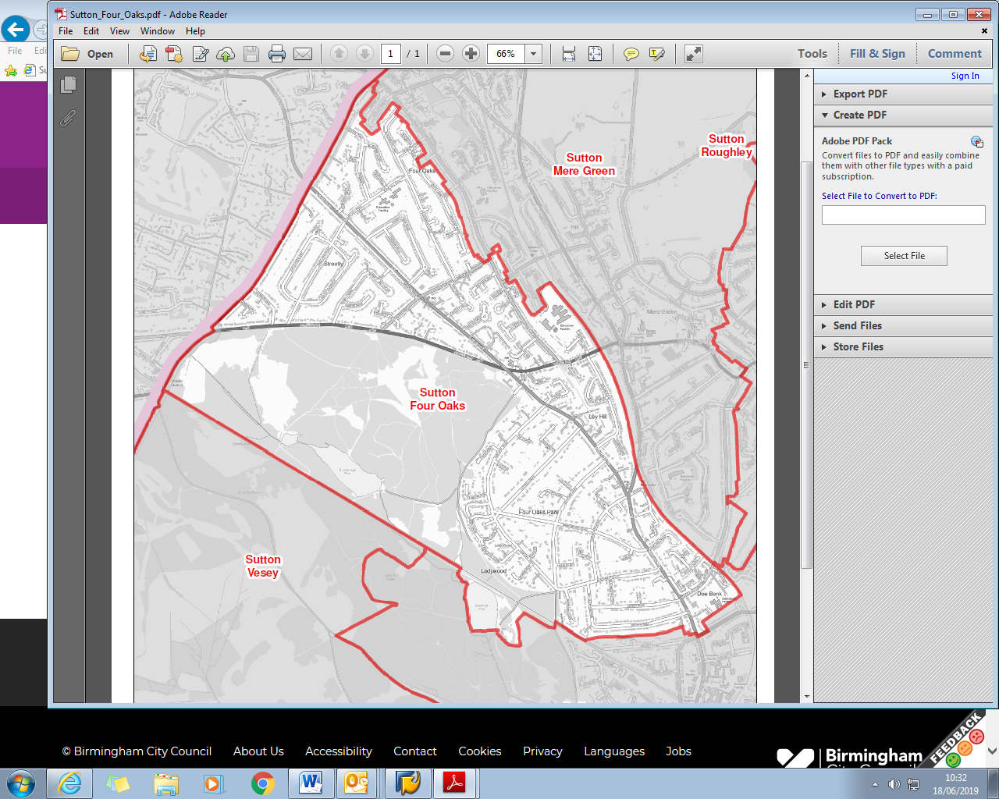

Contents

Item Page
Ward Description 4

Policy context X

Priorities 2012-14 X

Useful Contacts X



Contact details
Council House
Victoria Square
Birmingham
B1 1BB
Telephone: 0121 303 2130
Email: maureen.cornish@birmingham.gov.uk

The place known as Four Oaks, as shown on a plan in the Corporation Survey of 1811, consisted of a number of dwellings near what is now the Four Oaks Gate to Sutton Park. There had been a settlement here for several centuries, long before the building of Four Oaks Hall by Lord Ffolliott in the 1700s, but it had never amounted to more than a few farm houses and labourer's cottages. Being such a small settlement, it is hardly ever mentioned in its own right, being included as part of the Quarter of Hill and Little Sutton in manorial records. The Parish Register of burials in the seventeenth century names 13 different Four Oaks families, and there were probably more, as most entries do not specify where the deceased person lived. It seems reasonable to suppose that the pattern of houses scattered mainly on the eastern side of the irregular common space or green originated at the time of expansion and assarting in the 13th century, when so much of the rest of Sutton was being brought into cultivation.
The earliest written record of the name so far found is in Latin in the court rolls of the Sutton Court Leet of May 1st 1598, when Richard Turner was fined for failing to restore some land which he had ploughed up on the commons near the grain field upon the Coldfield “ultra quattuor quercos” (beyond Four Oaks). The four oak trees for which the place was named were no doubt venerable old trees in 1598, so it seems likely that the four trees marked on the 1811 Survey map were replacements.
There was a local tradition that four trees near Hartopp Road were the original four oaks, and the late Norman Evans identified these trees with the ones marked on the 1811 map. In 1979 three of the trees were still alive, the fourth having died of old age, but they stood on a site which had been sold for housing development. Norman campaigned for the trees to be retained, tree preservation orders were issued, and the three trees can still be seen today.

Sutton Four Oaks is a suburban ward located in the north of the city. It has a population of 9,019 making it the 3rd smallest ward in the city in terms of population.
The ward has an older age profile than the city as a whole and a lower BAME population share.
Sutton Four Oaks is one of the least deprived wards in the city and has the highest average income levels out of the 69 Birmingham wards.
Resident employment rates in the ward are well above the city average and claimant count unemployment proportions are well below the Birmingham average.

KEY INFORMATION

Age Breakdown
Number Ward % Brum% National%
All Residents | 9,019 | - | - | -
16-64 | 5,183 | 57.5% | 64.3% | 64.8%
Under18 | 1,781 | 19.7% | 25.5% | 21.4%
18-24 | 552 | 6.1% | 12.1% | 9.4%
25-44 | 1,816 | 20.1% | 28.7% | 27.5%
45-64 | 2,581 | 28.6% | 20.7% | 25.4%
65+ | 2,289 | 25.4% | 12.9% | 16.3%

Ethnicity
White Total | 7,649 |  |  |  |  | 84.8% |  |  |  |  |  |  | 57.9% |  |  |  |  |  | 85.4%
British | 7,382 |  |  |  |  | 81.8% |  |  |  |  |  |  | 53.1% |  |  |  |  |  | 79.8%
Irish | 105 |  |  |  |  | 1.2% |  |  |  |  |  |  | 2.1% |  |  |  |  |  | 1.0%
Other White | 162 |  |  |  |  | 1.8% |  |  |  |  |  |  | 2.7% |  |  |  |  |  | 4.7%
Mixed or Multiple Ethnicity | 114 |  |  |  |  | 1.3% |  |  |  |  |  |  | 4.4% |  |  |  |  |  | 2.3%
Asian Total | 775 |  |  |  |  | 8.6% |  |  |  |  |  |  | 26.6% |  |  |  |  |  | 7.8%
Indian | 584 |  |  |  |  | 6.5% |  |  |  |  |  |  | 6.0% |  |  |  |  |  | 2.6%
Pakistani | 82 |  |  |  |  | 0.9% |  |  |  |  |  |  | 13.5% |  |  |  |  |  | 2.1%
Bangladeshi | 17 |  |  |  |  | 0.2% |  |  |  |  |  |  | 3.0% |  |  |  |  |  | 0.8%
Chinese | 23 |  |  |  |  | 0.3% |  |  |  |  |  |  | 1.2% |  |  |  |  |  | 0.7%
Other Asian | 69 |  |  |  |  | 0.8% |  |  |  |  |  |  | 2.9% |  |  |  |  |  | 1.5%
Black Total | 11 |  |  |  |  | 1.2% |  |  |  |  |  |  | 9.0% |  |  |  |  |  | 3.5%
Black African | 39 |  |  |  |  | 0.4% |  |  |  |  |  |  | 2.8% |  |  |  |  |  | 1.8%
Black Caribbean | 59 |  |  |  |  | 0.7% |  |  |  |  |  |  | 4.4% |  |  |  |  |  | 1.1%
Black Other | 13 |  |  |  |  | 0.1% |  |  |  |  |  |  | 1.7% |  |  |  |  |  | 0.5%
Other Ethnic Group | 101 |  |  |  |  | 1.1% |  |  |  |  |  |  | 2.0% |  |  |  |  |  | 1.0%
Sutton Four Oaks 16-64 Long Term Health Problem or Disability Source: 2011 Census
Level |  |  | Sutton Four Oaks No |  |  |  |  |  | Sutton Four Oaks % |  |  |  |  |  | Birmingham % |  |  |  |  |  |  | England %
Limited a Lot |  |  | 202 |  |  |  |  |  | 3.9% |  |  |  |  |  | 6.8% |  |  |  |  |  |  | 5.6%
Limited a Little |  |  | 276 |  |  |  |  |  | 5.3% |  |  |  |  |  | 8.1% |  |  |  |  |  |  | 7.1%
Total Work Limiting Health Conditions |  |  | 478 |  |  |  |  |  | 9.2% |  |  |  |  |  | 14.9% |  |  |  |  |  |  | 12.7%
Not Limited |  |  | 4,705 |  |  |  |  |  | 90.8% |  |  |  |  |  | 85.1% |  |  |  |  |  |  | 87.3%
Working population
16-64 Population |  |  |  |  | 5,183 |  |  |  |  |  | - |  |  |  |  |  | - |  |  |  | -
Economically Active Total |  |  |  |  | 4,098 |  |  |  |  |  | 79.1% |  |  |  |  |  | 69.3% |  |  |  | 77.0%
Employed |  |  |  |  | 3,926 |  |  |  |  |  | 75.7% |  |  |  |  |  | 60.0% |  |  |  | 71.2%
Unemployed |  |  |  |  | 172 |  |  |  |  |  | 3.3% |  |  |  |  |  | 9.3% |  |  |  | 5.8%
Economically inactive |  |  |  |  | 1,134 |  |  |  |  |  | 21.9% |  |  |  |  |  | 30.7% |  |  |  | 23.0%
Occupation Breakdown
All Employed |  |  |  | 4,107 |  |  |  |  |  | - |  |  |  |  |  | - |  |  |  |  |  |  | -
Managers, directors and senior officials |  |  |  | 832 |  |  |  |  |  | 20.3% |  |  |  |  |  | 8.3% |  |  |  |  |  |  | 10.9%
Professional occupations |  |  |  | 1,055 |  |  |  |  |  | 25.7% |  |  |  |  |  | 18.3% |  |  |  |  |  |  | 17.5%
Associate professional and technical occu-pations |  |  |  | 605 |  |  |  |  |  | 14.7% |  |  |  |  |  | 11.0% |  |  |  |  |  |  | 12.8%
Higher Skilled Occupations |  |  |  | 2,492 |  |  |  |  |  | 60.7% |  |  |  |  |  | 37.6% |  |  |  |  |  |  | 41.1%
Administrative and secretarial occupations |  |  |  | 563 |  |  |  |  |  | 13.7% |  |  |  |  |  | 11.7% |  |  |  |  |  |  | 11.5%
Skilled trades occupations |  |  |  | 268 |  |  |  |  |  | 6.5% |  |  |  |  |  | 9.8% |  |  |  |  |  |  | 11.4%
Intermediate Occupations |  |  |  | 831 |  |  |  |  |  | 20.2% |  |  |  |  |  | 21.6% |  |  |  |  |  |  | 22.8%
Caring, leisure and other service occupa-tions |  |  |  | 234 |  |  |  |  |  | 5.7% |  |  |  |  |  | 10.1% |  |  |  |  |  |  | 9.3%
Sales and customer service occupations |  |  |  | 224 |  |  |  |  |  | 5.5% |  |  |  |  |  | 9.0% |  |  |  |  |  |  | 8.4%
Process plant and machine operatives |  |  |  | 111 |  |  |  |  |  | 2.7% |  |  |  |  |  | 8.5% |  |  |  |  |  |  | 7.2%
Elementary occupations |  |  |  | 215 |  |  |  |  |  | 5.2% |  |  |  |  |  | 13.2% |  |  |  |  |  |  | 11.1%
Lower Skilled Occupations |  |  |  | 784 |  |  |  |  |  | 19.1% |  |  |  |  |  | 40.8% |  |  |  |  |  |  | 36.0%

Four Oaks Qualification Levels Source: 2011 Census
NVQ Level | Sutton Four Oaks | Four Oaks % | Birmingham % | England %
No Qualifications | 424 | 8.1% | 20.8% | 14.8%
Level 1 | 641 | 12.3% | 15.0% | 15.2%
Level 2 | 891 | 17.0% | 15.5% | 17.1%
Apprenticeship | 117 | 2.2% | 1.9% | 3.1%
Level 3 | 704 | 13.4% | 15.0% | 14.5%
Level 4 qualifications | 2,307 | 44.1% | 25.2% | 29.8%
Other Qualifications | 148 | 2.8% | 6.6% | 5.6%

Average Income
Ward Birmingham England
£22,905 £16,185 £18,788

Key stakeholders within the ward include:
- [insert detail e.g. West Midlands Police, West Midlands Fire Service etc.].

Policy Context

The Paper Localism in Birmingham: A Framework for Future Policy, March 2018 set out objectives for future ward-based working which will focus on: improved service delivery in neighbourhoods, an agenda of “Neighbourly Neighbourhoods” and a commitment to a “Whole Place” and “Whole System” way of working.

The new ward planning process is one of the main mechanisms by which citizens and communities can participate in setting local priorities themselves. The ward plan will be used to develop and enhance local engagement and community governance. The ward plan will highlight local priorities and planned actions.

The ward plan aligns with Birmingham City Council Vision and Priorities 2017-2020

BIRMIINGHAM CITY COUNCIL VISION –A city of growth where every child, citizen and place matters.

BIRMIINGHAM CITY COUNCIL OUTCOMES – What we want to achieve:

- Birmingham is an entrepreneurial city to learn, work and invest in
- Birmingham is an aspirational city to grow up in
- Birmingham is a fulfilling city to age well in
- Birmingham is a great city to live in
- Birmingham residents gain the maximum benefit from hosting the Commonwealth Games

Ward Priorities

Although new ward arrangements provide an opportunity through ward meetings, councillors’ advice surgeries and stakeholder engagement to re-establish local priorities, it is important to revisit and note previously agreed ward priorities and the ward action tracker, which has tracked ward priorities for over 12 months.

Ward Priorities
- Respond to crime and reassurance - while working with police to alleviate fear of crime and criminal activity
- Park and Ride at Blake Street – consider feasibility of multi-level parking to alleviate pressure on highways and remove the inconsiderate parking of individuals accessing the station
- Street cleaning and maintenance of verges.
- Improve the uptake of clean travel mechanisms while increasing lanes and promoting all green styles of travel
- Examine the notion of a pedestrian crossing at Streetly Lane
- Improve highway infrastructure at Tamworth Road to reduce accidents and dangerous driving (right turn filter)
- Increase Alcohol Restricted Signage at The Fordrough
- Focus required on pot holes across the ward

Local Innovation Fund Priorities:
- Engagement with the elderly population – Dementia

Local Community Safety Partnership and/or Neighbourhood Tasking Group Priorities (where applicable):
- [insert priorities] e.g. Community engagement, street crime, etc.

Funding/Budgets

- The sum of £48k from the old ward arrangements have been devolved to the organisations within the ward to deliver Local Innovation Fund (LIF) Projects.

Project | Org. name | Sum awarded | Status
St James Dementia Cafe | St James Church | £40,000 | Completed

- A share of the Proceeds of Crime funding (where/if applicable) may be allocated to the ward [insert exact detail]

Project | Org. name | Sum awarded | Status

- Highways Ward Minor Transport Measures budget [insert exact detail]

Project | Org. name | Sum awarded | Status

- Housing Environmental Works budget - tba

Project | Location | Sum allocated | Status

- Section 106 funding (where/if applicable) [insert detail]

Project | Location | Sum allocated | Status

- Neighbourhood Network Scheme (where/if applicable)

Project | Location | Sum allocated | Status

- Community Infrastructure Levy (where/if applicable)

Project | Location | Sum allocated | Status

Please list any other sources of ward-based funding below.

Useful Links

https://www.birmingham.gov.uk/

https://public.tableau.com/profile/bcc.ck#!/vizhome/2018BirminghamWardProfiles/2018BirminghamWardProfiles

https://www.birmingham.gov.uk/downloads/file/12711/ward_infographics_-_sutton_coldfield
Declaration

This plan has been drafted following engagement and discussions with residents and ward stakeholders. It was been agreed and adopted by those present at the Four Oaks Ward meeting on: 29th August 2019 which was held at Mere Green Library

Signed [elected member(s) signature(s): Maureen Cornish

Print: Cllr Maureen Cornish

Elected member (2) Signed:

Print:

