Sparkbrook & Balsall Heath East
WARD PLAN 2019 - 2022

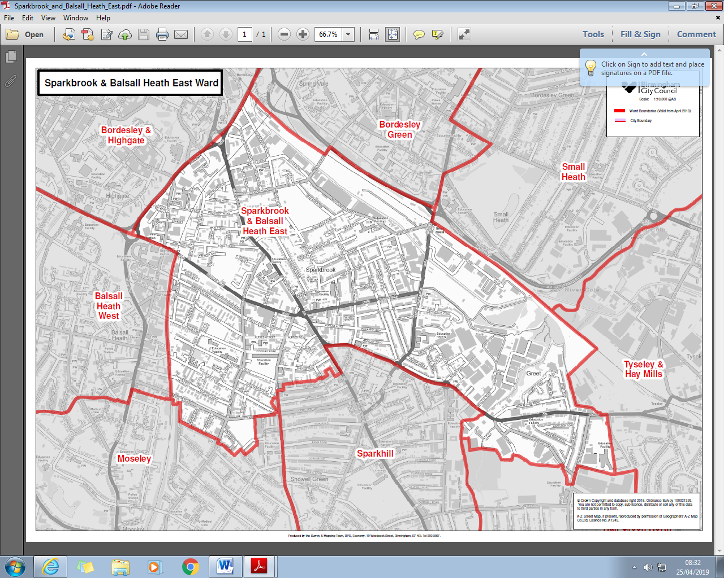

Contents

Item Page

Ward Description 4

Stakeholders 7

Policy context 8

Priorities 2019-22 9

Funding and Budgets 10

Useful Links 12



Contact details
Council House
Victoria Square
Birmingham
B1 1BB
Telephone: 0121 303 2039
Email: shabrana.hussain@birmingham.gov.uk

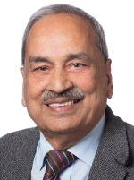

Contact details
Council House
Victoria Square
Birmingham
B1 1BB
Telephone: 0121 303 2039
Email: mohammed.azim@birmingham.gov.uk

Sparkbrook & Balsall Heath East Ward is located in the inner city to the south east of the city centre. It has a population of 25,211 making it the 2nd most populous ward in the city.
The ward has a younger age profile than the city as a whole and has a higher BAME population share.
Sparkbrook & Balsall Heath East is amongst the city's most deprived wards and has the 5th lowest average income out of the city’s 69 wards.
Resident employment rates in the ward are well below the city average and claimant count unemployment proportions are well above the Birmingham average.

Age Breakdown
Number Ward % Brum% National%
All Residents | 25,211 | - | - | -
16-64 | 15,228 | 60.4% | 64.3% | 64.8%
Under18 | 9,029 | 35.8% | 25.5% | 21.4%
18-24 | 2,965 | 11.8% | 12.1% | 9.4%
25-44 | 7,701 | 30.5% | 28.7% | 27.5%
45-64 | 3,658 | 14.5% | 20.7% | 25.4%
65+ | 1,858 | 7.4% | 12.9% | 16.3%

Ethnicity
White Total 25211
British | 2,322 | 9.2% |  |  | 53.1% |  | 79.8%
Irish | 1,620 | 6.4% |  |  | 2.1% |  | 1.0%
Other White | 263 | 1.0% |  |  | 2.7% |  | 4.7%
Mixed or Multiple  Ethnicity | 439 | 1.7% |  |  | 4.4% |  | 2.3%
Asian Total | 861 | 3.4% |  |  | 26.6% |  | 7.8%
Indian | 16,823 | 66.7% |  |  | 6.0% |  | 2.6%
Pakistani | 1,300 | 5.2% |  |  | 13.5% |  | 2.1%
Bangladeshi | 11,668 | 46.3% |  |  | 3.0% |  | 0.8%
Chinese | 2,590 | 10.3% |  |  | 1.2% |  | 0.7%
Other Asian | 128 | 0.5% |  |  | 2.9% |  | 1.5%
Black Total | 1,137 | 4.5% |  |  | 9.0% |  | 3.5%
Black African | 2,317 | 9.2% |  |  | 2.8% |  | 1.8%
Black Caribbean | 851 | 3.4% |  |  | 4.4% |  | 1.1%
Black Other | 788 | 3.1% |  |  | 1.7% |  | 0.5%
Other Ethnic Group | 678 | 2.7% |  |  | 2.0% |  | 1.0%

Working population
16-64 Population | 15,228 | - | - | -
Economically Active Total | 8,269 | 54.3% | 69.3% | 77.0%
Employed | 6,356 | 41.7% | 60.0% | 71.2%
Unemployed | 1,914 | 12.6% | 9.3% | 5.8%
Economically inactive Total | 7,034 | 46.2% | 30.7% | 23.0%

Occupation Breakdown
All Employed | 6,345 | - | - | -
Managers, directors and senior officials | 418 | 6.6% | 8.3% | 10.9%
Professional occupations | 697 | 11.0% | 18.3% | 17.5%
Associate professional and technical occu-pations | 446 | 7.0% | 11.0% | 12.8%
Higher Skilled Occupations | 1,561 | 24.6% | 37.6% | 41.1%
Administrative and secretarial occupations | 588 | 9.3% | 11.7% | 11.5%
Skilled trades occupations | 679 | 10.7% | 9.8% | 11.4%
Intermediate Occupations | 1,267 | 20.0% | 21.6% | 22.8%
Caring, leisure and other service occupa-tions | 635 | 10.0% | 10.1% | 9.3%
Sales and customer service occupations | 784 | 12.4% | 9.0% | 8.4%
Process plant and machine operatives | 849 | 13.4% | 8.5% | 7.2%
Elementary occupations | 1,249 | 19.7% | 13.2% | 11.1%
Lower Skilled Occupations | 3,517 | 55.4% | 40.8% | 36.0%

Sparkbrook & Balsall Heath East Qualification Levels Source: 2011 Census
NVQ Level | Sparkbrook & Balsall Heath East No | Sparkbrook & Balsall Heath East % | Birmingham % | England %
No Qualifications | 5,016 | 32.8% | 20.8% | 14.8%
Level 1 | 2,578 | 16.8% | 15.0% | 15.2%
Level 2 | 2,073 | 13.5% | 15.5% | 17.1%
Apprenticeship | 133 | 0.9% | 1.9% | 3.1%
Level 3 | 1,620 | 10.6% | 15.0% | 14.5%
Level 4 qualifications | 2,281 | 14.9% | 25.2% | 29.8%
Other Qualifications | 1,603 | 10.5% | 6.6% | 5.6%

Average Income
Ward Birmingham England
£11,869 £16,185 £18,788

Our Stakeholders
Key stakeholders identified within the ward include:
Strategic
- Birmingham City Council Directorates
- Job Centre Plus
- West Midlands Police (Neighbourhood Policing)
- West Midlands Fire Service
- West Midlands Ambulance
- Police Crime Commissioner
- Birmingham and Solihull Clinical Commissioning Group
- Sparkbrook Neighbourhood Forum
Places
- Sparkbrook Community and Health Centre
- Local Community Venues
- Parks
People
- Citizens of the Ward
- Local Community Organisations
- Voluntary and Third Sector Organisations
- Resident Associations
- Local Businesses
Programmes
- Sparkbrook Ageing Better – BVSC
- Youth Employment Initiative - Pioneers Group
- The Active Wellbeing Service (TAWS) Health and Wellbeing
- The Concord Centre (Youth Provision)

Further consultation and engagement will identify other stakeholder working, living or delivering services for Citizens of Sparkbrook and Balsall Heath East

Policy Context

The Paper Localism in Birmingham: A Framework for Future Policy, March 2018 set out objectives for future ward-based working which will focus on: improved service delivery in neighbourhoods, an agenda of “Neighbourly Neighbourhoods” and a commitment to a “Whole Place” and “Whole System” way of working.
The new ward planning process is one of the main mechanisms by which citizens and communities can participate in setting local priorities themselves. The ward plan will be used to develop and enhance local engagement and community governance.
The ward plan will highlight local priorities and planned actions.

The Sparkbrook and Balsall Heath East ward plan aligns with Birmingham City Council Vision and Priorities 2017-2020

BIRMIINGHAM CITY COUNCIL VISION

A city of growth where every child, citizen and place matters.

BIRMIINGHAM CITY COUNCIL OUTCOMES – What we want to achieve:

- Birmingham is an entrepreneurial city to learn, work and invest in
- Birmingham is an aspirational city to grow up in
- Birmingham is a fulfilling city to age well in
- Birmingham is a great city to live in
- Birmingham residents gain the maximum benefit from hosting the Commonwealth Games

Ward Priorities

The elected members undertook a series of resident conversations and meeting to determine a set of priorities that the ward can focus. At the Ward Committee it was agreed to identify priorities that impact the whole ward that we can measure, evaluate and track the progress the development

It was agreed to develop a process to identify what services are currently available to address the priorities and working together, harnessing and building local assets for local people to access meeting these priorities.

Four key priorities were identified for the 2018/19 financial year and reviewed quarterly to identify other priorities identified by stakeholders.

The priority are as follows

- HEALTH AND WELLBEING

- Improve access for services for vulnerable Older People and Carers
- Increase access to physical activities, especially those citizens with complex health needs
- Improve Public Health of local citizens
- Ensure every under 5 has the best start in life

- YOUNG PEOPLE
- Reducing Antisocial behaviour and Violent Crime
- Improving access to youth provision
- Ensuring every 16-19 has access to education and career advice
- Reduce unemployment of young people
- ENVIRONMENT
- Improve Street Cleaning, especially weekly collections
- Improve enforcement – illegal parking; improper use of disable bays
- More use of parks and open spaces
- Promote Recycling and Reducing waste
- EDUCATION AND LIFE LONG LEARNING
- Improving literacy skills providing access to ESOL
- Increase ICT training for more people to have access to online tools
- Improve access to relevant training to increase chances to secure employment.
- Provide life skills training to support vulnerable people improve their lives

Funding/Budgets

- Birmingham City Council grants and commissioned services based in the ward

Project | Org. name | Sum awarded | Status

- Birmingham City Council grants and commissioned services benefitting residents of Sparkbrook and Balsall Heath East

Project | Org. name | Service | Duration

- Neighbourhood Network Scheme (where/if applicable)

Project | Location | Sum allocated | Status

- Police Crime Commissioner grants (where/if applicable) may be allocated to the ward [insert exact detail]

Project | Org. name | Sum awarded | Status

- Grants and commissioned services by external bodies serving local citizens in the ward

Project | Org. name | Sum awarded | Status

- Highways Ward Minor Transport Measures budget [insert exact detail]

Project | Org. name | Sum awarded | Status

- Housing Environmental Works budget - tba

Project | Location | Sum allocated | Status

- Section 106 funding (where/if applicable) [insert detail]

Project | Location | Sum allocated | Status

- Community Infrastructure Levy (where/if applicable)

Project | Location | Sum allocated | Status

Please list any other sources of ward-based funding below.

Useful Links

Council
https://www.birmingham.gov.uk/

https://brumnns.wordpress.com/

https://birmingham.cmis.uk.com/birmingham/Committee/Wards/tabid/132/ctl/ViewCMIS_CommitteeDetails/mid/512/id/386/Default.aspx

Health
https://www.birminghamandsolihullccg.nhs.uk/

https://www.the-waitingroom.org/

https://birmingham.connecttosupport.org/s4s/WhereILive/Council?pageId=3889

Police
https://www.west-midlands.police.uk/node/2794

https://www.westmidlands-pcc.gov.uk/

Data
https://public.tableau.com/profile/bcc.ck#!/vizhome/2018BirminghamWardProfiles/2018BirminghamWardProfiles

https://www.birmingham.gov.uk/info/20057/about_birmingham/1294/population_and_census

Declaration

This plan has been drafted following engagement and discussions with local residents and ward stakeholders. It was been agreed and adopted by those present at the [insert ward name] Ward meeting on: [insert day, date and year], which was held at [insert meeting venue name].

Signed [elected member(s) signature(s):

Print:

Elected member (2) Signed:

Print:

