OSCOTT WARD PLAN 2018 - 2022

Contents

Item Page
Ward Description 3

Ward Councillors 4-5

Key Information Facts 6-10

Schools in the Ward 11-12

Key Stakeholders in the Ward 13

Policy context 14

Ward Priorities 2018-22 15

Ward Budgets / Funding 16-17

Useful Contacts/ Links 18

Ward Description

Oscott is a suburban ward located in the north west of the city. It has a population of 19,823 making it the 22nd most populous ward in the city.
The ward has a slightly older age profile than the city as a whole and a lower BAME population share.
Oscott is mid ranking amongst the city's 69 wards for deprivation levels and average income.
Resident employment rates in the ward are above the city average and claimant count unemployment proportions are well below the Birmingham average.

Oscott Ward is ranked 53 on the indices of multiple deprivation.

Oscott is a ward in the northwest of Birmingham, England, within the formal district of Perry Barr.
The Ward is centred on the area known as Old Oscott, originally just "Oscott", and should not be confused with nearby New Oscott. It includes the former Booths Farm sand quarry, Aldridge Road Recreation Ground, and Kingstanding Circle. The ward borders the Metropolitan Borough of Walsall and areas such as Perry Beeches and Queslett. Parts fall within Great Barr.
The area is mainly a housing estate built in the 1930s and 1940s. Before this it was mainly rural farmland.

Ward Councillors:
Councillor Barbara Dring Councillor Keith Linnecor
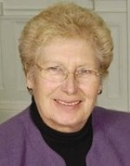
Ward: Oscott Party: Labour Ward: Oscott Party: Labour

Contact details
Council House Council House
Victoria Square Victoria Square
Birmingham Birmingham
B1 1BB B1 1BB
Telephone: 0121 303 2039
Fax: 0121 303 2787
Email: barbara.dring@birmingham.gov.uk & keith.linnecor@birmingham.gov.uk

Council Service
Positions Held by Councillor Barbara Dring:
Positions Held by Councillor Keith Linnecor:
Committee Membership 2018 - 2019:
Planning Committee,
Transport Delivery Committee.

How to Contact Us
You can visit usat the advice surgeries below or contact us by telephone or email.
Advice surgeries are where you are able to visit your local councillors with any issues or concerns that you have.
Councillors will always try to attend their advice surgeries; however there may be times, when an advice surgery has to be cancelled or changed at short notice. There is no legal requirement for Councillors to keep the advice surgery open for the full time.
Oscott Ward Councillors operate a rota -
1st Wednesday of the month, 7:00pm
610 Community Centre, Kingstanding Road, Birmingham, B44
(Induction Loop available and disabled access)
Home visits can be arranged for the elderly/disabled, please contact us for details.

The Oscott Ward is situated within the parliamentary constituency of Perry Barr and the local Member of Parliament is Khalid Mahmood

Key information

Oscott Ward has a population of approximately 19,823 Ward Demography

Oscott Age Structure Source: 2011 Census

Age |  | Oscott No |  | Oscott % |  | Birmingham % |  | England %
All Residents |  | 19,823 |  | - |  | - |  | -
16-64 |  | 12,410 |  | 62.6% |  | 64.3% |  | 64.8%
Under18 |  | 4,730 |  | 23.9% |  | 25.5% |  | 21.4%
18-24 |  | 1,743 |  | 8.8% |  | 12.1% |  | 9.4%
25-44 |  | 5,524 |  | 27.9% |  | 28.7% |  | 27.5%
45-64 |  | 4,613 |  | 23.3% |  | 20.7% |  | 25.4%
65+ |  | 3,213 |  | 16.2% |  | 12.9% |  | 16.3%

Oscott Ward has an older age profile than the City’s average percentage

Oscott Ethnicity Source: 2011 Census

Ethnic Group |  | Oscott No |  |  | Oscott % |  |  | Birmingham % |  |  | England %
White Total |  |  | 15,833 |  |  | 79.9% |  |  | 57.9% |  |  | 85.4%
British |  |  | 15,062 |  |  | 76.0% |  |  | 53.1% |  |  | 79.8%
Irish |  |  | 424 |  |  | 2.1% |  |  | 2.1% |  |  | 1.0%
Other White |  |  | 347 |  |  | 1.8% |  |  | 2.7% |  |  | 4.7%
Mixed or Multiple Ethnicity |  |  | 648 |  |  | 3.3% |  |  | 4.4% |  |  | 2.3%
Asian Total |  |  | 1,225 |  |  | 6.2% |  |  | 26.6% |  |  | 7.8%
Indian |  |  | 717 |  |  | 3.6% |  |  | 6.0% |  |  | 2.6%
Pakistani |  |  | 129 |  |  | 0.7% |  |  | 13.5% |  |  | 2.1%
Bangladeshi |  |  | 149 |  |  | 0.8% |  |  | 3.0% |  |  | 0.8%
Chinese |  |  | 87 |  |  | 0.4% |  |  | 1.2% |  |  | 0.7%
Other Asian |  |  | 143 |  |  | 0.7% |  |  | 2.9% |  |  | 1.5%
Black Total |  |  | 1,280 |  |  | 6.5% |  |  | 9.0% |  |  | 3.5%
Black African |  |  | 138 |  |  | 0.7% |  |  | 2.8% |  |  | 1.8%
Black Caribbean |  |  | 918 |  |  | 4.6% |  |  | 4.4% |  |  | 1.1%
Black Other |  |  | 224 |  |  | 1.1% |  |  | 1.7% |  |  | 0.5%
Other Ethnic Group |  |  | 62 |  |  | 0.3% |  |  | 2.0% |  |  | 1.0%

Oscott Ward has a total claimant unemployed rate of 936 which is approximately 7.5% against a City average of 9.3%

 | Oscott Economic Activity Source: 2011 Census
 | Economic  Activity | Oscott No |  | Oscott % |  | Birmingham % |  | England %
 | 16-64  Population | 12,410 |  | - |  | - |  | -
 | Economically Active Total | 9,874 |  | 79.6% |  | 69.3% |  | 77.0%
 | Employed | 8,937 |  | 72.0% |  | 60.0% |  | 71.2%
 | Unemployed | 936 |  | 7.5% |  | 9.3% |  | 5.8%
 | Economically inactive Total | 2,530 |  | 20.4% |  | 30.7% |  | 23.0%

Claimant Count Unemployment
Ward level claimant count and youth claimant count
Un-employment data is released monthly. The latest data can be found in our Quarterly Labour Market Update

Oscott Occupational Breakdown Source: 2011 Census

Occupation | Oscott No |  | Oscott % |  | Birmingham % |  | England %
All Employed | 9,128 |  | - |  | - |  | -
Managers, directors and senior officials | 607 |  | 6.6% |  | 8.3% |  | 10.9%
Professional occupations | 995 |  | 10.9% |  | 18.3% |  | 17.5%
Associate professional and technical occu-pations | 928 |  | 10.2% |  | 11.0% |  | 12.8%
Higher Skilled Occupations | 2,530 |  | 27.7% |  | 37.6% |  | 41.1%
Administrative and secretarial occupations | 1,262 |  | 13.8% |  | 11.7% |  | 11.5%
Skilled trades occupations | 1,327 |  | 14.5% |  | 9.8% |  | 11.4%
Intermediate Occupations | 2,589 |  | 28.4% |  | 21.6% |  | 22.8%
Caring, leisure and other service occupa-tions | 983 |  | 10.8% |  | 10.1% |  | 9.3%
Sales and customer service occupations | 876 |  | 9.6% |  | 9.0% |  | 8.4%
Process plant and machine operatives | 949 |  | 10.4% |  | 8.5% |  | 7.2%
Elementary occupations | 1,201 |  | 13.2% |  | 13.2% |  | 11.1%
Lower Skilled Occupations | 4,009 |  | 43.9% |  | 40.8% |  | 36.0%

Oscott Qualification Levels Source: 2011 Census
NVQ Level |  | Oscott No |  |  | Oscott % |  |  | Birmingham % |  |  | England %
No Qualifications |  |  | 2,525 |  |  | 20.4% |  |  | 20.8% |  |  | 14.8%
Level 1 |  |  | 2,418 |  |  | 19.5% |  |  | 15.0% |  |  | 15.2%
Level 2 |  |  | 2,457 |  |  | 19.8% |  |  | 15.5% |  |  | 17.1%
Apprenticeship |  |  | 410 |  |  | 3.3% |  |  | 1.9% |  |  | 3.1%
Level 3 |  |  | 1,863 |  |  | 15.0% |  |  | 15.0% |  |  | 14.5%
Level 4 qualifications |  |  | 2,161 |  |  | 17.4% |  |  | 25.2% |  |  | 29.8%
Other Qualifications |  |  | 569 |  |  | 4.6% |  |  | 6.6% |  |  | 5.6%

Oscott 16-64 Long Term Health Problem or Disability Source: 2011 Census

Level |  |  | Oscott No |  |  | Oscott % |  |  | Birmingham % |  |  | England %  5.6%  7.1%  12.7%
Limited a Lot |  |  |  | 754 |  |  | 6.1% |  |  | 6.8%
Limited a Little |  |  |  | 931 |  |  | 7.5% |  |  | 8.1%
Total Work Limiting Health  Conditions |  |  |  | 1,685 |  |  | 13.6% |  |  | 14.9%
Not Limited |  |  |  | 10,725 |  |  | 86.4% |  |  | 85.1% |  |  | 87.3%

Oscott 16-64 Language Barriers Source: 2011 Census
Proficiency in English | Oscott No |  | Oscott % |  | Birmingham % |  | England %
Main language is English | 11,834 |  | 95.4% |  | 82.7% |  | 90.3%
Main language is not English Total | 571 |  | 4.6% |  | 17.3% |  | 9.7%
Main language is not English- Can speak English very well or well | 449 |  | 3.6% |  | 12.4% |  | 7.8%
Main language is not English- Cannot speak English or cannot speak English well | 122 |  | 1.0% |  | 5.0% |  | 1.9%

There are a number schools within the ward [insert number of primary schools and secondary schools.

Oscott Manor School
Old Oscott Hill
Birmingham
West Midlands
B44 9SP
Telephone number
0121 3608222
Email: enquiry@oscottmanor.bham.sch.uk

Maryvale Catholic Primary School
Old Oscott Hill
Kingstanding
Birmingham
West Midlands
B44 9AG
Telephone number: 0121 6751434
Email: enquiry@maryvale.bham.sch.uk

Cardinal Wiseman Catholic School
Old Oscott Hill
Kingstanding
Birmingham
West Midlands
B44 9SR
Telephone number: 0121 3606383
Email: enquiry@cardinalwiseman.net

Great Barr Primary School
Aldridge Road
Birmingham
West Midlands
Postcode
B44 8NT
Telephone number: 0121 4642251
Email: enquiry@grtbarr.bham.sch.uk

Beeches Junior School
Beeches Road
Great Barr
Birmingham
West Midlands
Postcode
B42 2PY
Telephone number: 0121 2725888
Email: enquiry@beechesjnr.bham.sch.uk

Beeches Infant School
Beeches Road
Birmingham
West Midlands
Postcode
B42 2PY
Telephone number: 0121 3604222
Email: enquiry@beechesinf.bham.sch.uk

Priestley Smith School
Perry Beeches Campus, Beeches Road
Great Barr
Birmingham
West Midlands
Postcode
B42 2PY
Telephone number: 0121 3253900
Email: enquiry@priestley.bham.sch.uk

Significant resources in the ward include:

- Queslett Nature Reserve Address: Ashworth Road, Queslett, Birmingham B42
Phone: 0121 380 6486
- 610 Centre, Kingstanding Road, Address: 610 Kingstanding Road, Birmingham B44 9SH
Phone: 0121 464 2268
- Oscott Community Centre 277 Birdbrook Road, Great Barr, Birmingham B44 9TY

- Oscott Residents Elderly Group
- Oscott Neighbourhood Police Initiative

Key stakeholders within the ward include:

Key stakeholders within the ward include:
Contact the Oscott Policing team by email:
Oscott@west-midlands.pnn.police.uk
- Telephone 101
- Follow us on Twitter @oscottWMP
Crime Stoppers: 0800555111
West Midlands Fire Service:
- Fire Safe: 0121 380 7500 Home Safe & Well: 0800 389 5525
- General Enquiries: 0845 5000 900
Housing Department:
- General contact number: 0121 3037048
- Housing repairs: 0121 2163330
- Lettings: 0121 4641427
- ASB : 0121 3037048
- Homelessness: 0121 303 7410

Waste Management Contact: 0121 303 1111

Environment Services Contact: 0121 303 1111

Policy Context

The Paper Localism in Birmingham: A Framework for Future Policy, March 2018 set out objectives for future ward-based working which will focus on: improved service delivery in neighbourhoods, an agenda of “Neighbourly Neighbourhoods” and a commitment to a “Whole Place” and “Whole System” way of working.

The new ward planning process is one of the main mechanisms by which citizens and communities can participate in setting local priorities themselves. The ward plan will be used to develop and enhance local engagement and community governance. The ward plan will highlight local priorities and planned actions.

In January 2019 Cabinet approved the Localisation White Paper “Working Together in Birmingham’s Neighbourhoods”. This commits the City Council to a programme of transformation, “to make Birmingham a localist city, and transform the culture of the city council to support that”. It also commits the city council to:
- Strengthen Ward partnership working and Ward planning
- Strengthen neighbourhood resources
- Make services more responsive to local neighbourhoods

It sets four tests for the success of this programme by 2022:
- Services being different, better suited to the area, and more efficient.
- Officers working for ‘one council’, putting shared outcomes and local places first, not their service or directorate.
- Local councillors having more influence on services.
- Residents feeling they are more in control of their services and their local area.

Oscott Ward plan aligns with Birmingham City Council Vision and Priorities 2017-2020 BIRMIINGHAM CITY COUNCIL VISION –A city of growth where every child, citizen and place matters.

BIRMIINGHAM CITY COUNCIL VISION –A city of growth where every child, citizen and place matters.

BIRMIINGHAM CITY COUNCIL PRIORITIES
- Children – A great city to grow up in
- Housing – A great city to live in
- Jobs and Skills – A great city to succeed in
- Health – A great city to grow old in
- The importance of neighbourhoods – Our neighbourhoods have an important role in shaping the lives of citizens and the city we share

Ward Priorities

Although new ward arrangements provide an opportunity through ward meetings, councillors’ advice surgeries and stakeholder engagement to re-establish local priorities, it is important to revisit and note previously agreed ward priorities and the ward action tracker, which has tracked ward priorities for over 12 months.

Ward Priorities
- Protection of Parks & Open Spaces Including management & maintenance: Glenmead Park, (Village Green Status application) Cooksey Lane, Aldridge Recreation grounds and Queslett Nature Reserve
- Support the Village Green Status for the protection of Oscott Green Open Spaces
- Parking outside of Schools – Inconsiderate Parking, Parking enforcement,
- Environment issues e.g. Fly tipping, street collections/cleansing, Pot holes, Pavements, tree pruning
- Neighbourhood Policing & ASB issues
- Provisions for Young & Older people
- Jobs & Skills opportunity
- More Housing Provision for the older and disabled residents
- Support the Neighbourhood Network Scheme

Local Innovation Fund Priorities:
- Support & save our local Library Joint Venture with Witton Lodge

Local Community Safety Partnership and/or Neighbourhood Tasking Group Priorities (where applicable):
- Community engagement,
- Street crime & ASB issues
- House burglaries & theft from vehicles

Funding/Budgets

- The sum of £48k from the old ward arrangements have been devolved to the organisations within the ward to deliver Local Innovation Fund (LIF) Projects.

Project | Org. name | Sum awarded | Status
Support The Library | Witton Lodge | £48,000 | On Going

- A share of the Proceeds of Crime funding will be allocated to the

Project | Org. name | Sum awarded | Status
Support intergeneration projects | Late Late Club | £200.00 | On Going
Equipment for the Nature Reserve | Queslett Nature Reserve | £250.00 | On Going
Remove Social Isolation | Oscott Elderly Resident Group | £200.00 | On Going
Graffiti Removal | Oscott Residents Group | £300.00 | On Going
Elevate Youth Club |  | £200.00 | On Going

- Highways Ward Minor Transport Measures budget

Project | Org. name | Sum awarded | Status
Non identified as yet | N/A | £13,000 | Waiting Allocation

- Housing Environmental Works budget –

Project | Location | Sum allocated | Status
Installation of 54 Metre High open Pale Fencing | 1-17 Howley Avenue | £4,115.02 | Signed off
Security Lighting | 6 -12 Howley Avenue | £5,087.80 | Signed off
Replace trip railing with bow top fence on communal grassed area | Penge Grove – Garage Site | £1,197.18 | On going

- Section 106 funding No Funding allocation available

Project | Location | Sum allocated | Status

- Neighbourhood Network Scheme No funding allocated as yet

Project | Location | Sum allocated | Status

- Community Infrastructure Levy No Funding allocated as yet

Project | Location | Sum allocated | Status

Useful Links

https://www.birmingham.gov.uk/
https://www.birminghammail.co.uk/.../a-walk-in-the-park-queslett-nature-reserve
https://www.yell.com/biz/610-community-centre-birmingham-1622278

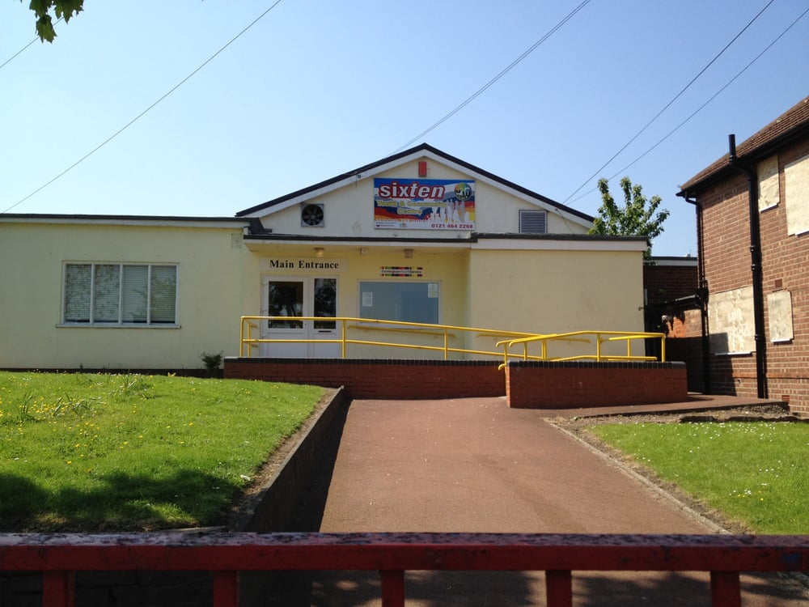
Declaration

This plan has been drafted following engagement and discussions with local residents and ward stakeholders. It was been agreed and adopted by those present at the [insert ward name] Ward meeting on: [insert day, date and year], which was held at [insert meeting venue name].

Signed [elected member(s) signature(s):

Print:

Elected member (2) Signed:

Print:

