HOLYHEAD WARD PLAN 2018 - 2022

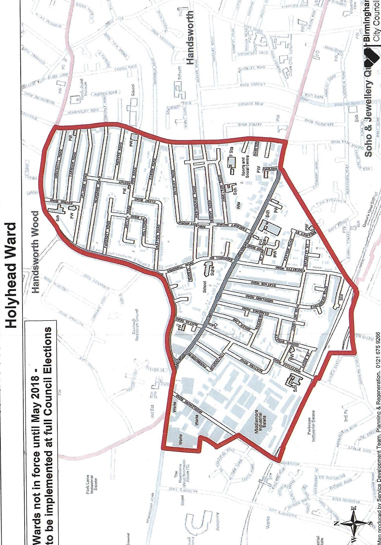

Contents

Item Page
Ward Description 3 - 6

Policy context 7 - 8

Priorities 9

Funding/Budgets 10 - 11

Useful Contacts 11

Declaration 12

Action Plan Appendix 1

Ward Description

The Holyhead Ward is within the parliamentary constituencies of Ladywood and Perry Barr.

Holyhead Ward is an inner city ward located to the north west of the city centre. It has a population of 11,133 making it the 50th most populous ward in the city. The ward has a younger age profile than the city as a whole and has a higher BAME population share. Holyhead is amongst the more deprived wards in the city and has the 15th lowest average income out of the 69 wards in the city. Resident employment rates in the ward are lower than the city average and claimant count unemployment proportions are well above the Birmingham average.

Ward Councillor:

Paulette Hamilton



Council Service
Elected: Holyhead Ward
Joined Council: 10 June 2004
Office Expires: 2022
Political Party: Labour
Council Service: June 2004 to date
Position Held: Cabinet Member for Health and Social Care
Committee Membership 2019 - 2020:
- Cabinet, Cabinet Member for Health and Social Care
- WMCA Wellbeing Board
- WMCA Board (Substitute Member).

Contact details
Council House
Victoria Square
Birmingham
B1 1BB
Telephone: 0121 303 4789
Email: paulette.hamilton@birmingham.gov.uk

All about me
I have the pleasure in serving you as your local councillor for the Holyhead Ward. I was appointed to the role of Mental Health Champion for the City Council in October 2013 and appointed to Cabinet Member for Health and Social Care in May 2015.

I am very keen to work with all the local community including our local forums and neighbourhood watch groups and other statutory agencies.

Being the local residents advocate for anti-social behaviour, environmental issues, women issues and community cohesion, I have worked hard to ensure as a Councillor of the Handsworth Wood Ward your concerns are addressed.

If you would like to take any issues up with me, please get in touch!

How to Contact Me
You can visit me at the advice surgeries below or contact me by telephone or email.
Advice surgeries are where you are able to visit your local councillors with any issues or concerns that you have.
Councillors will always try to attend their advice surgeries; however there may be times, when an advice surgery has to be cancelled or changed at short notice. There is no legal requirement for Councillors to keep the advice surgery open for the full time.
No advice surgeries held in August, December or on Bank Holidays
3rd Monday of the month, 4.00pm - 5.30pm
Hamilton School, Hamilton Road, Handsworth, Birmingham, B21 8AH.
If you would like to pop along for a chat and a coffee, I will be holding a drop in Coffee morning / advice surgery, between 11.00am - 1.00pm, on the following dates:
Friday 10th May, Friday 12th July, Friday 13th September, Friday 8th November 2019,
Friday 10th January and Friday 13th March 2020.
Beacon Church, 47 Sandwell Road, Handsworth, Birmingham, B21 8NH.
I hope that you will be able to join me, I will also be inviting guest speakers along with information that you may find useful.

The local Member of Parliament for Perry Barr Constituency within which Holyhead Ward is situated is: Mr Khalid Mahmood.

Parliamentary
House of Commons, London, SW1A 0AA
Tel: 020 7219 8141
Fax: 020 7219 1745
Email: mahmoodk@parliament.uk

Constituency
18 Heathfield Road, Handsworth, Birmingham, B19 1HB
Tel: 0121 356 8264; 0121 356 8268
Fax: 0121 356 8278
@khalid4PB

And Ladywood Constituency is: Ms Shabana Mahmood

Parliamentary
House of Commons, London, SW1A 0AA
Tel: 020 7219 7818
Email: shabana.mahmood.mp@parliament.uk

Constituency
Constituency office
Tel: 0121 661 9440

Web & Social media
Website:www.shabanamahmood.org...
Twitter:@shabanamahmood

Interesting history or facts about Holyhead Ward [information to be added]

Holyhead Ward is bounded by Handsworth Wood Ward to the north, Handsworth Ward to the east and Soho & Jewellery Quarter to the south.

Key information
Source: 2011 Census
Holyhead Ward:
- has a population of approximately 11,133;
- profile: U18’s - 29.8%, 18 - 24 - 11.1%, 25 - 44 - 32.2%, 45-64 - 17.3%, 65+ - 9.6%;
- has a super-diverse demographic profile with 48% of residents being born outside of the UK;
- has a total claimant unemployed rate of 6.8%;
- is ranked 23rd on the indices of multiple deprivation and is in the 10% most deprived wards nationally;
- has a tenure profile of mainly [insert detail i.e. owner occupier, rented, housing or mixed] properties.

Source/references: file:///C:/Users/bccanlda/Downloads/Holyhead__Profile.pdf

Schools
The following 5 schools are within the ward:
name | type
Hamilton School | Special
Holyhead School | Secondary
St Augustine's Catholic Primary School | Primary
St James Church of England Primary School, Handsworth | Primary
Wattville Primary School | Primary

Significant resources in the ward include:
- [insert detail]

Key stakeholders within the ward include:
- West Midlands Fire Service – Handsworth Community Fire Station
- West Midlands Police – Soho NPU
- Oaklands Youth Centre
- Holyhead School
- Rookery Road business community
- Soho Road business community
- Faith organisations [decide if these need to be inserted]
- Voluntary and Community sector organisations [decide if these need to be inserted]

Policy Context

In January 2019 The Birmingham City Council’s Cabinet Committee approved the Working Together in Birmingham’s Neighbourhoods sets out the council’s approach to working more closely with neighbourhoods to enable active citizens and effect improvements in local areas.

The policy sets out the council’s commitment to:
- Make the services that matter most to local neighbourhoods more responsive to their needs and priorities
- Redesign council jobs so that staff are free to work with residents to make a difference
- Support ward councillors to focus on local issues and represent their residents more effectively
- Develop Ward Forum meetings and Ward Plans to make them more effective
- Modernise key local services
- Tackle priority issues such as jobs, health and housing at the local level.

In addition to this the council’s community cohesion strategy which sets out the council’s vision, “of an ambitious and inclusive city, where everyone is able to fully contribute and play their part in building strong, resilient communities.”

The ward plan will seek to align with five priorities within The Council Plan and Strategy 2018+:
five key priorities:
- Birmingham is an entrepreneurial city to learn, work and invest in
- Birmingham is an aspirational city to grow up in
- Birmingham is a fulfilling city to age well in
- Birmingham is a great city to live in
- Birmingham residents gain the maximum benefit from hosting the Commonwealth Games.

And finally the - BIRMIINGHAM CITY COUNCIL VISION –A city of growth where every child, citizen and place matters.

Ward Priorities

Although new ward arrangements provide an opportunity through ward meetings, councillors’ advice surgeries and stakeholder engagement to re-establish local priorities, it is important to revisit and note previously agreed ward priorities and the ward action tracker, which has tracked ward priorities for over 12 months.

Ward Priorities (Conference September 2015)
- Health, Wellbeing and Social Care
- Governance
- Crime and Disorder
- Cleaner and Greener
- Economy, Jobs and Skills
- Community Support and Development

Local Innovation Fund Priorities (latest ward priorities) 2017
- Traffic flow – College Road /Cornwall by the Co-op
- Community Cohesion
- Environmental/Cleanliness-Education working with Schools and the local
- Health and Wellbeing – Elderly and young (Dementia and childhood obesity)
- Jobs and skills – Re-skilling the over 50’s
- Healthy Villages – Mental Health issues and Dementia .Local café and get together areas
- Crime Reduction
- Public spaces enhancement

Ward Tracker Priorities (from ward meetings May 2016 – April 2018)
- Environment
- Highways - parking/speeding
- Crime and Policing (including ASB)
- Housing – Regulation of Private Rented Sector properties and Houses of Multiple Occupation (HMOs)

Current priorities:
- ASB including prostitution
- Cleaner Streets – Tackling dumping, fly-tipping and enhancing street cleaning in key areas
- Improving local pride in the ward
- Regulating Houses of Multiple Occupation
- Regulating the Private Rented Sector
- Supporting residents’ local action.

Funding/Budgets

- A share of the Proceeds of Crime funding (tba where/if applicable) may be allocated to the ward [insert exact detail]

Project | Org. name | Sum awarded | Status

- Highways Ward Minor Transport Measures budget - tba

Project | Org. name | Sum awarded | Status

- Housing Environmental Works budget - tba

Project | Location | Sum allocated | Status

- Section 106 funding (tbawhere/if applicable)

Project | Location | Sum allocated | Status

- Neighbourhood Network Scheme (tba where/if applicable)

Project | Location | Sum allocated | Status

- Community Infrastructure Levy (where/if applicable)

Project | Location | Sum allocated | Status

Please list any other sources of ward-based funding below.

Useful Links

https://www.birmingham.gov.uk/

https://public.tableau.com/profile/bcc.ck#!/vizhome/2018BirminghamWardProfiles/2018BirminghamWardProfiles

file:///C:/Users/bccanlda/Downloads/Holyhead__Profile.pdf

https://www.west-midlands.police.uk/node/2745

[additional important links to be agreed and added]
Declaration

This plan has been drafted following engagement and discussions with local residents and ward stakeholders. It was been agreed and adopted by those present at the [insert ward name] Ward meeting on: [insert day, date and year], which was held at [insert meeting venue name].

Signed [elected member’s signature] :
Councillor Paulette Hamilton

Date:

BCC Working Together in Birmingham’s Neighbourhoods Strategy, January 2019
BCC Community Cohesion Strategy, November 2018

