Highters Heath
WARD PLAN 2018 - 2022

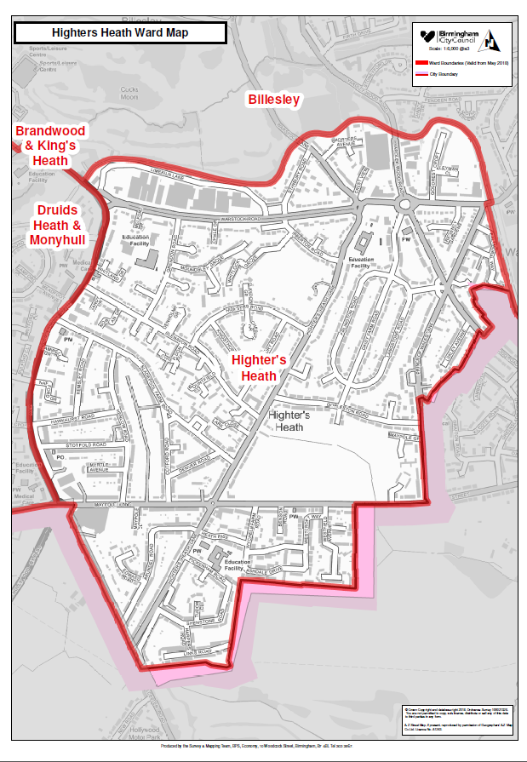

Contents

Item Page
Ward Description 4

Policy context 6

Priorities 7

Useful Contacts 9

Ward Councillor:
Adam Higgs


Contact details
Council House
Victoria Square
Birmingham B1 1BB

Telephone: 07548 122176
Fax: 303 1371
Email: adam.higgs@birmingham.gov.uk

The local Member of Parliament for Selly Oak Constituency within which Highters Heath ward is situated in is Steve McCabe.

Ward Description

Highter’s Heath is an outer city ward located in the south of the city. It has a population of 11,182 making it the 48th most populous ward in the city.
The ward has an older age profile than the city as a whole and a lower BAME population share.
Highter’s Heath is mid ranking amongst the city's 69 wards in terms of deprivation and average income.
Resident employment rates in the ward are well above the city average (70.7%) and claimant count unemployment proportions are below the Birmingham average.

Age Breakdown
All Residents | 11,182
16-64 | Number  7,216 | Ward %  64.5% | Birm %  64.3% | National %  64.8%
Under18 | 2,612 | 23.4% | 25.5% | 21.4%
18-24 | 1,042 | 9.3% | 12.1% | 9.4%
25-44 | 3,124 | 27.9% | 28.7% | 27.5%
45-64 | 2,731 | 24.4% | 20.7% | 25.4%
65+ | 1,673 | 15.0% | 12.9% | 16.3%
Ethnicity  White Total | 9,312 | 83.3% | 57.9% | 85.4%
British | 8,942 | 80.0% | 53.1% | 79.8%
Irish | 223 | 2.0% | 2.1% | 1.0%
Other White | 147 | 1.3% | 2.7% | 4.7%
Mixed or Multiple | 398 | 3.6% | 4.4% | 2.3%
Asian Total | 668 | 6.0% | 26.6% | 7.8%
Indian | 255 | 2.3% | 6.0% | 2.6%
Pakistani | 252 | 2.3% | 13.5% | 2.1%
Bangladeshi | 15 | 0.1% | 3.0% | 0.8%
Chinese | 22 | 0.2% | 1.2% | 0.7%
Other Asian | 124 | 1.1% | 2.9% | 1.5%
Black Total | 360 | 3.2% | 9.0% | 3.5%
Black African | 129 | 1.2% | 2.8% | 1.8%
Black Caribbean | 197 | 1.8% | 4.4% | 1.1%
Black Other | 34 | 0.3% | 1.7% | 0.5%
Other Ethnic Group | 71 | 0.6% | 2.0% | 1.0

Average Income The following are average income figures for individuals (16+) not household income

Highter’s Heath Ward Birmingham England

£17,082 £16,185 £18,788

Key information

Significant resources in the ward include:
Warstock Community Centre, Daisy Farm Road B14 4QA
Maypole Children’s Centre
Maypole Methodist Church
Yardley Wood Baptist Church
Immanuel Church
Daisy Farm Park

Key stakeholders within the ward include:
West Midlands Police
West Midlands Fire Service

Policy Context

The Paper Localism in Birmingham: A Framework for Future Policy, March 2018 set out objectives for future ward-based working which will focus on: improved service delivery in neighbourhoods, an agenda of “Neighbourly Neighbourhoods” and a commitment to a “Whole Place” and “Whole System” way of working.

The new ward planning process is one of the main mechanisms by which citizens and communities can participate in setting local priorities themselves. The ward plan will be used to develop and enhance local engagement and community governance. The ward plan will highlight local priorities and planned actions.

The ward plan aligns with Birmingham City Council Vision and Priorities 2017-2020

BIRMIINGHAM CITY COUNCIL VISION –A city of growth where every child, citizen and place matters.

BIRMIINGHAM CITY COUNCIL OUTCOMES – What we want to achieve:

- Birmingham is an entrepreneurial city to learn, work and invest in
- Birmingham is an aspirational city to grow up in
- Birmingham is a fulfilling city to age well in
- Birmingham is a great city to live in
- Birmingham residents gain the maximum benefit from hosting the Commonwealth Games

Ward Priorities

Although new ward arrangements provide an opportunity through ward meetings, councillors’ advice surgeries and stakeholder engagement to re-establish local priorities, it is important to revisit and note previously agreed ward priorities and the ward action tracker, which has tracked ward priorities for over 12 months.

Ward Tracker Priorities
- Highways/parking
- ASB
- Crime/Policing
- Environment/Litter

Ward Priorities 2018/19

Residents came up with the following priorities for the ward;
- Reduce grass verge/pavement parking
- Tree roots causing uneven pavements & roads
- Regular cleaning of the brook in Henlow Road allotments & flood defence system
- Grendon Road – action on speeding cars & motor bikes
- Removal of grass cuttings left in the road, especially Henlow Road & surrounding roads
- More routine gulley cleaning schedule to aid reduction in flooding
- Need for pavement repairs & better street lighting
- Action on dog fouling
- Action in relation to aggressive begging & community safety issues
- Action on car crime
- double yellow lines in Pickenham Road
- turn grass verges into parking spaces
- more bins

From the above, 3 top priorities were chosen as issues that could be addressed in the next 12 months. Other priorities such as flood defence were longer term goals.
- More bins
- Pavement repairs – illumination of tree roots, uneven slabs & other trip hazards
- Community Safety – setting up Street Watch, Speed Watch & Neighbourhood Watch groups.

Local Innovation Fund Priorities:
Employment

Local Community Safety Partnership and/or Neighbourhood Tasking Group Priorities (where applicable):
Funding/Budgets
- The sum of £48k from the old ward arrangements have been devolved to the organisations within the ward to deliver Local Innovation Fund (LIF) Projects.

Project | Org. name | Sum awarded | Status
Skills For Work | Brandwood Community Centre | £48,000 | Completed

- A share of the Proceeds of Crime funding (where/if applicable) may be allocated to the ward [insert exact detail]

Project | Org. name | Sum awarded | Status
 |  |  | Completed

- Highways Ward Minor Transport Measures budget

Project | Org. name | Sum awarded | Status
Double Yellow Lines Crest View & Warstock Lane |  | £6,500  TRO combined with another ward to economise available budget

- Housing Environmental Works budget

Project | Location | Sum allocated | Status
Installation of hard standing bin areas | 26-36, 38-44, 46-56 Maypole Grove | £5,058.25

- Section 106 funding (where/if applicable) [insert detail]

Project | Location | Sum allocated | Status

- Neighbourhood Network Scheme (where/if applicable)

Project | Location | Sum allocated | Status

- Community Infrastructure Levy (where/if applicable)
Project | Location | Sum allocated | Status

Useful Links

https://www.birmingham.gov.uk/

https://public.tableau.com/profile/bcc.ck#!/vizhome/2018BirminghamWardProfiles/2018BirminghamWardProfiles

https://www.birmingham.gov.uk/info/50120/public_health/1332/local_area_health_profiles/3
Declaration

This plan has been drafted following engagement and discussions with local residents and ward stakeholders. It was been agreed and adopted by those present at the [insert ward name] Ward meeting on: [insert day, date and year], which was held at [insert meeting venue name].

Signed [elected member(s) signature(s):

Print:

Elected member (2) Signed:

Print:

