BIRCHFIELD
WARD PLANS 2018 - 2022

Contents

Item Page
Ward Description 3

Ward Councillor 4

Key Information 5-6

Schools in Birchfield Ward 7

Religious Establishment 8 - 9

Policy context 10

Ward Priorities 2019-14 11-12

Funding & Budgets 13-14

Useful Contacts 15

Useful Links 16

Ward Description

Birchfield Ward is made up of the following neighbourhoods (or roads): [insert neighbourhoods or roads]. Livingstone road, Havelock Road, Westminster Road, Haughton Road, Turville Road, Stamford Road, Stamford Grove, Charles Road, Churchill Road, Radnor Road, Gibson Road, Wellesborne Road, Beaudesert Road, Hamstead Road, Hutton Road, Wilton Road, Grosvenor Road, Crick Lane, St. Peters Road, Wye Cliff Road, North Drive, West Drive, Robert Road, Apollo Way, Gibson Drive, Maxwell Avenue, Putney Road, Putney Avenue, Crompton Road, Victoriana Way, Parklands Avenue, Wilmore Road, Leslie Road, David Road, Upper Grosvenor Road, Calthorpe Road, James Watt Drive, Winston Drive, Ashleigh Drive, Church Vale,

Birchfield is an area of Perry Barr, Birmingham, England. It gave its name to the Birchfield Harriers athletics club, now based at the nearby Alexander Stadium, also in Birmingham.

Birchfield Ward is an inner city ward located to the north of the city centre. It has a population of 11,465 making it the 46th most populous ward in the city.
The ward has a younger age profile than the city as a whole and has a higher BAME population share.
Birchfield is amongst the most deprived wards in the city and has the 14th lowest average income. Resident employment rates in the ward are much lower than the city average and claimant count unemployment proportions are well above the Birmingham average.
.

Ward Councillor(s): Mahmood Hussain
- Ward: Birchfield Party: Labour 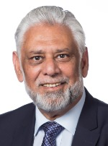Contact details
Council House
Victoria Square
Birmingham
B1 1BB
Telephone: 07930 528954
Fax: 0121 303 2787
Email: mahmood.hussain@birmingham.gov.uk

How to Contact Me

You can visit me at the advice surgeries below or contact me by telephone or email.
Advice surgeries are where you are able to visit your local Councillors with any issues or concerns that you have.
Councillors will always try to attend their advice surgeries; however there may be times, when an advice surgery has to be cancelled or changed at short notice. There is no legal requirement for Councillor’s to keep the advice surgery open for the full time.
1st Wednesday of the month (except August), 6.00 - 7.00pm
Wilton Road United Reformed Church, 13 Wilton Road, Handsworth, B20 3RX.
4th Thursday of the month (except August), 6.00 - 7.00pm
Wilton Road United Reformed Church, 13 Wilton Road, Handsworth, B20 3RX.
Birchfield Ward is within the parliamentary constituency of Perry Barr

The local Member of Parliament for Perry Barr Constituency within which Birchfield Ward is situated is Khalid Mahmood MP

Key information

Birchfield Ward:
- has a population of approximately 11,465

- has a young/older/or mixed age profile

Birchfield Age Structure Source: 2011 Census

Age |  | Birchfield No |  | Birchfield % |  |  |  | Birmingham % |  | England %
All Residents | 11,465 |  |  |  | 11,465
16-64 |  | 7,383 |  | 64.4% |  |  |  | 64.3% |  | 64.8%
Under18 |  | 3,415 |  | 29.8% |  |  |  | 25.5% |  | 21.4%
18-24 |  | 1,495 |  | 13.0% |  |  |  | 12.1% |  | 9.4%
25-44 |  | 3,561 |  | 31.1% |  |  |  | 28.7% |  | 27.5%
45-64 |  | 1,966 |  | 17.1% |  |  |  | 20.7% |  | 25.4%
65+ |  | 1,028 |  | 9.0% |  |  |  | 12.9% |  | 16.3%
- Birchfield has a Varied demographic profile;

Birchfield Ethnicity Source: 2011 Census

Ethnic Group | Birchfield No |  |  | Birchfield % |  | Birmingham % |  |  | England %
White Total | 1,007 |  |  | 8.8% |  | 57.9% |  |  | 85.4%
British | 446 |  |  | 3.9% |  | 53.1% |  |  | 79.8%
Irish | 106 |  |  | 0.9% |  | 2.1% |  |  | 1.0%
Other White | 455 |  |  | 4.0% |  | 2.7% |  |  | 4.7%
Mixed or Multiple  Ethnicity | 554 |  |  | 4.8% |  | 4.4% |  |  | 2.3%
Asian Total | 5,988 |  |  | 52.2% |  | 26.6% |  |  | 7.8%
Indian | 1,621 |  |  | 14.1% |  | 6.0% |  |  | 2.6%
Pakistani | 2,809 |  |  | 24.5% |  | 13.5% |  |  | 2.1%
Bangladeshi | 831 |  |  | 7.2% |  | 3.0% |  |  | 0.8%
Chinese | 127 |  |  | 1.1% |  | 1.2% |  |  | 0.7%
Other Asian | 600 |  |  | 5.2% |  | 2.9% |  |  | 1.5%
Black Total | 3,093 |  |  | 27.0% |  | 9.0% |  |  | 3.5%
Black African | 846 |  |  | 7.4% |  | 2.8% |  |  | 1.8%
Black Caribbean | 1,787 |  |  | 15.6% |  | 4.4% |  |  | 1.1%
Black Other | 460 |  |  | 4.0% |  | 1.7% |  |  | 0.5%
Other Ethnic  Group |  |  | 254 2.2% |  | 2.2% |  | 2 2.0% |  | 1.0%

- Birchfield has a total claimant unemployed rate of 1,030 (8.4%)

Birchfield Economic Activity Source: 2011 Census

Economic Activity |  | Birchfield No |  | Birchfield % |  | Birmingham % |  | England %
16-64 Population |  | 12,280 |  | - |  | - |  | -
Economically  Active Total |  | 8,951 |  | 72.9% |  | 69.3% |  | 77.0%
Employed |  | 7,922 |  | 64.5% |  | 60.0% |  | 71.2%
Unemployed |  | 1,030 |  | 8.4% |  | 9.3% |  | 5.8%
Economically inactive Total |  | 3,358 |  | 27.3% |  | 30.7% |  | 23.0%

- Birchfield is ranked 7th on the indices of multiple deprivation for Birmingham;

There are 4 schools within the ward

St Mary's C of E Primary and Nursery Academy,
Hamstead Road
Handsworth
West Midlands England
B20 2RW

Westminster Road Primary and Junior School
Westminster Road
Handsworth
Birmingham
B20 3PR

Holy Trinity Church of England Primary School
Havelock Road
Handsworth
B20 3LP

St Clare’s Catholic Primary School
Robert Road
Handsworth
Birmingham, B20 3RT
Tel. 0121 554 3289

RELIGIOUS ESTABLISHMENTS:

St Teresa’s R C Church
273 Wellington Road
Handsworth
Birmingham, B20 2QQ
Contact Rev Fr David Newell – Tel. 0121 356 4402

United Reformed Church
13 Wilton Road
Handsworth,
Birmingham, B20 3RX
Contact Rev Peter Little – Tel. 0121 327 6364

Muslim Foundation & Cultural & Social Centre Mosque
55 Hutton Road,
Birmingham, B20 3RA
Tel. Mobile 07811104801

Shree Geeta Bhawan Temple
107 – 117 Heathfield Road
Handsworth,
Birmingham, B19 1HL
Tel. 0121 554 4120

Seventh Day Adventist Church
98 Hutton Road,
Handsworth,
Birmingham, B20 3RD
0121 344 3672

Bethel Apostolic Church
2 Gibson Road,
Handsworth,
Birmingham, B20 3UE

St Mary’s Church
By Hansdworth Park
Hamstead Road
Birmingham, B20 2RW
0121 554 3407

Putney Road Mosque
27 Putney Road
Handsworth
Birmingham, B20 3PP
0121 551 9012

Masjid Quba Mosque
6 wyecliff Road,
Handsworth
Birmingham, B20 3TB
0121 523 7529

The Redeemed Christian Church of God
Salvation Thearte
Westminster Road
Handsorth
Birmingham, B20
0121 515 2125

53 Church Vale, Mosque
Handsworth
Birmingham, B20
07957346064

Sikh Temple
Sachkhand Nanak Dham (Internation)
11, Churchill Road
Handsworth
Birmingham, B20 3TN
0121 554 - 2422

Policy Context

The Paper Localism in Birmingham: A Framework for Future Policy, March 2018 set out objectives for future ward-based working which will focus on: improved service delivery in neighbourhoods, an agenda of “Neighbourly Neighbourhoods” and a commitment to a “Whole Place” and “Whole System” way of working.

The new ward planning process is one of the main mechanisms by which citizens and communities can participate in setting local priorities themselves. The ward plan will be used to develop and enhance local engagement and community governance. The ward plan will highlight local priorities and planned actions.

In January 2019 Cabinet approved the Localisation White Paper “Working Together in Birmingham’s Neighbourhoods”. This commits the City Council to a programme of transformation, “to make Birmingham a localist city, and transform the culture of the city council to support that”. It also commits the city council to:
- Strengthen Ward partnership working and Ward planning
- Strengthen neighbourhood resources
- Make services more responsive to local neighbourhoods

It sets four tests for the success of this programme by 2022:
- Services being different, better suited to the area, and more efficient.
- Officers working for ‘one council’, putting shared outcomes and local places first, not their service or directorate.
- Local councillors having more influence on services.
- Residents feeling they are more in control of their services and their local area.

Birchfield Ward plan aligns with Birmingham City Council Vision and Priorities 2017-2020 BIRMIINGHAM CITY COUNCIL VISION –A city of growth where every child, citizen and place matters.

BIRMIINGHAM CITY COUNCIL PRIORITIES
- Children – A great city to grow up in
- Housing – A great city to live in
- Jobs and Skills – A great city to succeed in
- Health – A great city to grow old in
- The importance of neighbourhoods – Our neighbourhoods have an important role in shaping the lives of citizens and the city we share

Ward Priorities

Although new ward arrangements provide an opportunity through ward meetings, councillors’ advice surgeries and stakeholder engagement to re-establish local priorities, it is important to revisit and note previously agreed ward priorities and the ward action tracker, which has tracked ward priorities for over 12 months.

Ward Tracker Priorities
- ASB
- Environment (Street Cleansing & Waste Collection)
- Housing – Private Rented Sector / HMOs etc.
- Community Safety

Local Innovation Fund Priorities:
- Community & Organisation Cohesion,
- Local engagement,
- Environment improvement etc.

Local Community Safety Partnership and/or Neighbourhood Tasking Group Priorities
- Community engagement,
- Street Crime
- Neighbourhood / Street Watches
- CCTV in Hot Spots

Ward Priorities Discussed at Ward Forum meeting recently are as follows:

- Proper regulations of HMO & Hostels (invoked article 4)
- 20 miles Per Hour Zones throughout the Ward
- Health & Well-being facilities for disabled & older people
- More leisure facilities for Young & older people
- More Adult Education lessons
- Continue to support Birchfield In Bloom
- Support Voluntary & 3rd Sector Organisation (Support Funding)
- Development of Community HUB / Community Centre
- All and new Business to be regulated & Licence (Proper Trade Waste etc)
- Policing and Community Safety around Drugs and late night parties
- Appropriate maintenance of roads, Pavements and street lights

- Install Pelican Street Crossing by Handsworth Park on Hamstead Road opposite Wellesborne Road

- Local councillors having more influence on services.

- Residents feeling they are more in control of their services and their local area.

- Birchfield Ward also propose to become a ‘Pioneer Ward’ which will allow us to road-test some of the new ideas in the ‘Transforming Neighbourhoods’ Localisation scheme. in order to test out ways of improving /transforming library or community hub if we have one in the future.

Funding/Budgets

- The sum of £48k was from the old Lozells & East Handsworth Ward which was awarded to the below organisations within the ward to deliver various projects using Local Innovation Fund (LIF) Projects.

Project | Org. name | Sum awarded | Status
Community Sensory Gardens | Friends of Handsworth Park | £4,500 | Completed
Collaboration of Lozells Projects | Asian Resource Centre | £2,500 | On-going
Grow Together | The Crick Project | £10,000 | On-going
Supported Living | Aspire Supported Living | £26,000 | On-going

- A share of the Proceeds of Crime funding (where/if applicable) will be allocated to the ward [insert exact detail]

Project | Org. name | Sum awarded | Status

- Highways Ward Minor Transport Measures budget [insert exact detail]

Project | Org. name | Sum awarded | Status
Speed Bumps | BCC Highways Department | 6,500 | Scheme completed

- Housing Environmental Works budget - £2,507.12

Project | Location | Sum allocated | Status
Security Lighting, External Security Lights to be fitted | 1-16 Burton Wood Drive | £2,507.12 | Scheme Completed

- Section 106 funding (There are no funds available at present)

Project | Location | Sum allocated | Status
Housing Development | Birchfield Ward | 105,378 | Funds to be spent by 2021

- Neighbourhood Network Scheme (Funds should be available soon)

Project | Location | Sum allocated | Status

- Community Infrastructure Levy (There are no funds available at present)

Project | Location | Sum allocated | Status

Please list any other sources of ward-based funding below.

- Birchfield Big Local (where/if applicable)

Project | Location | Sum allocated | Status
Various projects | Birchfield Ward | £1,000,000m over 10 years | Ongoing Programme ends 2026

Significant Resources in the ward include:

- Birchfield Big Local organisation

Key stakeholders within the ward include:
Contact the Birchfield Policing team by email:
lozells@west-midlands.pnn.police.uk
- Follow us on Twitter @LozellsWMP
Crime Stoppers: 0800555111
West Midlands Fire Service:
- Fire Safe: 0121 380 7500 Home Safe & Well: 0800 389 5525
- General Enquiries: 0845 5000 900

Housing Department:
- General contact number: 0121 3037048
- Housing repairs: 0121 2163330
- Lettings: 0121 4641427
- Anti-Social Behaviour: 0121 3037048
- Homelessness: 0121 303 7410

Waste Management Contact: 0121 303 1111

Environment Services Contact: 0121 303 1111

Birchfield Big Local Contact: Andrew Simons 0121 448 5595 Mobile: 07421994752

Birchfield Neighbourhood Forum Contact: Michael Tye bnhforum@yahoo.co.uk

Birchfield Residents Action Group (BRAG) Contact: Mrs Barbara Petris & Tom Clements Website: www.facebook.com/groups/bragallotment/ Email: tom.clements555@gmail.com

Handsworth Help Hands Contact: Mr Simon Baddeley: Email: simon@baddeley.be

Midland Heart Housing Association Contact: contact@midlandheart.org.uk:
20 Bath Row, Birmingham, B15 1LZ

Useful Links & Contacts:

https://www.birmingham.gov.uk/
https://www.birchfieldbiglocal.org

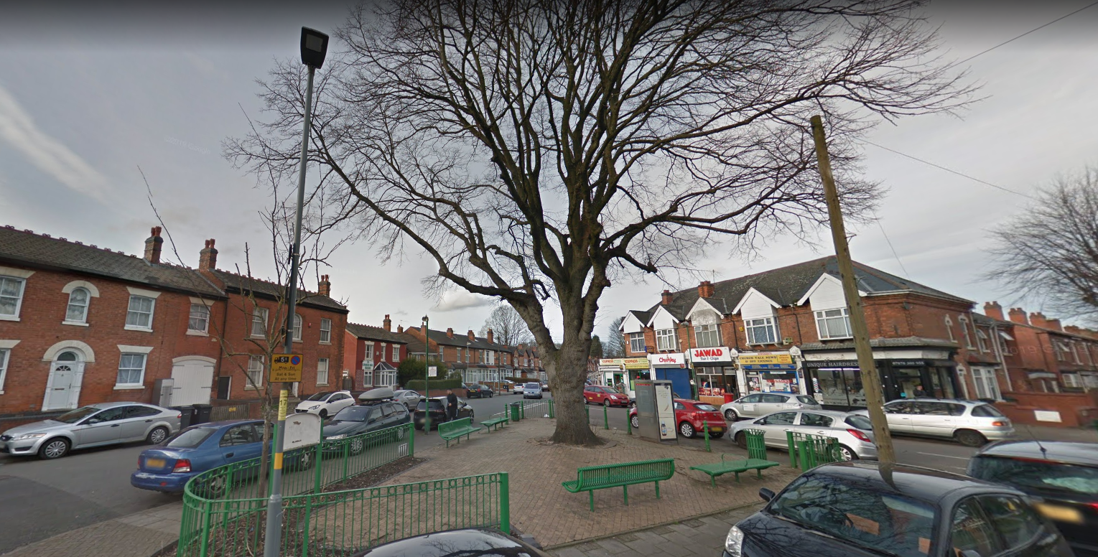

Declaration

This plan has been drafted following engagement and discussions with local residents and ward stakeholders. It was been agreed and adopted by those present at the [insert ward name] Ward meeting on: [insert day, date and year], which was held at [insert meeting venue name].

Cllr Mahmood Hussain:

Signature:

