COMMUNITY COHESION STRATEGY FOR BIRMINGHAM
Forward together to build a fair and inclusive city for everyone

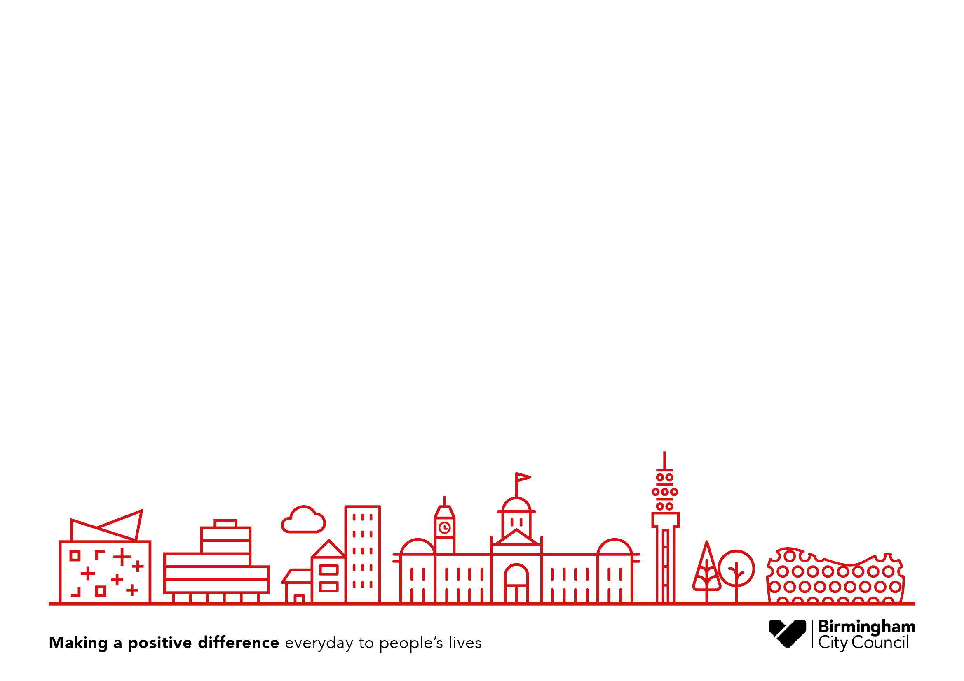
CONTENTS

FOREWORD

EXECUTIVE SUMMARY

SECTION 1
Introduction

SECTION 2
Birmingham’s vision and approach

SECTION 3
Building blocks for making it happen

APPENDIX A
Acknowledgements

APPENDIX B
Case studies

APPENDIX C
Factors affecting community cohesion in Birmingham

FOREWORD
______________________
A city commitment to community cohesion
We want to build a fair and inclusive city for everyone who lives in, works in, and visits Birmingham.
Councillor Tristan Chatfield
Cabinet Member for Social Inclusion, Community Safety
and Equalities

This strategy is our understanding of what community cohesion means in Birmingham. It sets out a collaborative approach; one in which communities, faith organisations, public sector agencies, businesses, and individuals work alongside one another to marshal scarce resources and make more creative use of the assets and skills we have in our city and neighbourhoods.
This strategy is not a ready-made solution to what is a complex challenge, but represents a collective understanding of what we can do to improve community cohesion as part of an ongoing process. We want to create an open and ongoing dialogue across the city in which we all continuously consider how our decisions, our resources, and our relationships across communities can be used to promote community cohesion.
Together, we are making a commitment to ensure Birmingham becomes stronger and more resilient - a city where people from different backgrounds and organisations can come together to improve things for themselves and their communities.

EXECUTIVE SUMMARY
______________________________________
What is community cohesion?  Community cohesion is about how we can all live, work, learn, and socialise together.  When we talk about community cohesion, we are not just talking about new communities or arrivals. We are talking about how all people of different social backgrounds, ethnicities, faiths, and generations can interact with and relate to each other in a positive way.  While there is no universally agreed definition of community cohesion, it is usually understood to describe what is needed to foster trust and good relationships between and within diverse communities.  Our vision for Birmingham  Our bold and challenging vision is of an ambitious and inclusive city, where everyone is able to fully contribute and play their part in building strong, resilient communities.  We want Birmingham to be a city of equal opportunity, where everyone is able to achieve their aspirations, regardless of where they live or grow up. Everyone should have the same chance to succeed and flourish in life, regardless of race, gender, sexual orientation, faith, disability, or class.  Birmingham is a welcoming city, where everyone has an opportunity to contribute and benefit from its success. It is a safe and flourishing place to live, work and grow up in. Birmingham is a well-connected place where people from all backgrounds trust and support each other and are able to realise their full potential while exercising their rights and responsibilities. |  | Our understanding of what makes a cohesive and resilient city has been developed in partnership with citizens, communities and organisations across the city, listening to what people have told us about the strengths and the challenges that they see in Birmingham. We want to achieve this vision in the same way – by working together, harnessing the collective assets of the city to build strong community cohesion.  This strategy sets out how we can build a sense of belonging and trust in and across all our communities, tackling the barriers that can cause divisions and hostility between communities and neighbourhoods.  Our guiding principles  We have identified eight guiding principles to support our vision and underpin this strategy:  - Mainstream cohesion: making cohesion everyday business  A shared understanding of building community cohesion will be part of everyday policy and practice for all partners.  - Connect and exchange ideas that promote cohesion and mobilise  social action  We will connect people, places and communities to share knowledge, exchange ideas and drive local innovation.  - Nurture and support aspiration of young people  Every child should have the best start in life no matter what their background, with a fair chance to realise their aspirations.
- Promote rights and responsibilities  Everyone should have a strong sense and understanding of their rights and responsibilities: what is expected of them, and what they can expect of others.  - Progress equality in all spheres of social and economic life  We will work together to eliminate all forms of inequality and gender-based violence, and challenge the cultural norms that prevent people from living their lives fully.  - Promote inclusive economic  growth that benefits everyone  across Birmingham  We will work with partners at all levels to ensure that the benefits of economic growth are shared and accessible to all.  - Empowered and engaged neighbourhoods  We will empower communities to be active participants in local solutions, harnessing the skills and expertise of local people and organisations.  - Uniting people and communities through cultural and sporting engagement, expression and celebration  We will use sports, arts and cultural events to drive cohesion, celebrating the voices, talents and energies of our communities.  How do we make it happen?  We need strong, balanced leadership and a long-term commitment from key partners across the city, including local communities, public sector bodies, the business sector, voluntary and community organisations, and faith organisations. |  | Working together, our first priorities will be:  - Understanding our city and communities: building a strong evidence base  We will build our knowledge and understanding of our diverse communities to enable evidence-based policy and decision making.  - A strategic partnership approach  We will work together with new and existing partners across communities and sectors in Birmingham.  Working with local communities, we will develop an annual calendar of local community events across the city.  Where possible, we will strategically align our approach with national and regional policies.  - Inclusive growth that benefits everyone  We will work with the West Midlands Combined Authority to make sure that regional investment into transport, homes, employment and businesses benefits all citizens.  - Targeted and place-based activities  We will pool our collective assets, expertise and experiences to develop targeted local solutions to the complex issues that undermine community cohesion.  We will establish a city-wide network and knowledge so that ideas and information can be shared across neighbourhoods.  - Measuring and monitoring where  we are making a difference  We will work with communities and partners to develop performance measures and indicators of success, to ensure that we know how well we are doing.
- Identify resources to trial innovations  We will identify a variety of funding sources and resources to allow us to innovate, pilot and test out innovative new solutions.  Challenges to community cohesion  The factors that affect community cohesion are complex and multi-layered, varying across different neighbourhoods and communities:  - Changing demographics  The rapidly changing demography of our city means that communities and neighbourhoods are becoming ever more dynamic, complex and culturally diverse.  - Social and neighbourhood  segregation  Social and neighbourhood segregation is driven by a number of complex social factors, including a lack of shared community spaces.  - Neighbourhood deprivation  Some neighbourhoods have experienced persistent deprivation over a number of decades, even during periods of wider economic growth.  - Education  Despite an overall improvement in educational attainment in Birmingham, there are still significant differences in attainment between certain social groups.  - Employment  Insecure work, zero hours contracts and low paid jobs can make it difficult for individuals and families to escape a life of poverty and participate fully in their communities. |  | - Housing  A lack of affordable and high quality housing creates instability and isolation for individuals and families, affecting all areas of their lives including their ability to form positive social relationships.  - Communication barriers  The inability to communicate confidently in the English language is a significant barrier to achieving greater participation and engagement in communities.  - Marginalised and disadvantaged  young people  Many young people are struggling with major difficulties that drastically affect their chances of success in life, and their ability to participate in society.  - Mental health  Poor mental health can affect anyone, regardless of their background and it can impact on many aspects of people’s lives, increasing social isolation.  - Gender inequality  Despite some major cultural and social changes in the UK over the last 50 years, people are still not always treated equally by society. Many women experience gender-based violence.  Developing strong communities in Birmingham will involve tackling all these factors to create the right conditions for community cohesion to flourish.  Our approach to community cohesion needs to be resilient and flexible, adapting and responding to new challenges and opportunities as they arise.  That is why we intend this strategy to be a living document, continuing to develop in response to new ideas, research and examples of cohesion in action.
SECTION 1
______________________________________
INTRODUCTION
Community cohesion is about how we can all live, work, learn, and socialise together. This strategy sets out a vision for how we can build a sense of belonging and trust in and across our communities, tackling the barriers that can cause divisions and hostility between communities and neighbourhoods.
Birmingham is a welcoming city, and we are proud of our diversity of cultures, people, and communities. It is home to 1.15 million people, which includes people from more than 200 countries who have made Birmingham their home, and is one of the most diverse cities in the UK. This diversity brings with it a rich mix of creativity, entrepreneurship, skills and talent that all contribute to the city’s social and economic vitality. Our city has a proud history of civic engagement and social action through which many different communities have been empowered to create thriving places to live and work. As a City of Sanctuary, Birmingham is committed to creating a culture of hospitality and support for people seeking refuge and asylum. We can and should build on all of these strengths to make sure that Birmingham is a great place of opportunity for everyone.
However, the city also faces some significant challenges. There are vast differences in people’s experiences of housing, education, health, employment, and accessing public services, all of which can exacerbate inequality, create divisions between communities and threaten the cohesion of our city. These are deep seated and complex challenges which will require joined-up, sustainable solutions.
That is why a long-term commitment to community cohesion is needed; building on the strengths of our communities and working in collaboration across the city to create the right conditions in which all individuals, families and communities can thrive.
A city vision
Our bold and challenging vision is of an ambitious and inclusive city, where everyone is able to fully contribute and play their part in building strong, resilient communities. We want Birmingham to be a city of equal opportunity where everyone is able to achieve their aspirations, regardless of where they live or grow up. Everyone should have the same chance to succeed and flourish in life, regardless of race, gender, sexual orientation, faith, disability, or class.
Birmingham is a welcoming city, where everyone has an opportunity to contribute and benefit from its success. It is a safe and flourishing place to live, work and grow up in. Birmingham is a well-connected place where people from all backgrounds trust and support each other and are able to realise their full potential while exercising their rights and responsibilities.

Our vision of what makes a cohesive and resilient city has been developed in partnership with citizens, communities and organisations across the city, listening to what people have told us about the strengths and the challenges they see in Birmingham. We want to achieve this vision in the same way – by working in partnership, harnessing the collective assets of the city to build strong community cohesion.
What do we mean by community cohesion?
Community cohesion has different meanings to different people. While there is no universally agreed definition of community cohesion, it is usually understood to describe what is needed to foster trust and good relationships between and within diverse communities.
In developing our approach to community cohesion, we have decided not to focus solely on differences of ethnicity and faith, but to also look more widely at a range of factors such as social class, economic disadvantage, disability, gender and sexual orientation.
For the purpose of this strategy we have adopted the Commission for Integration and Cohesion’s definition of community cohesion. Public sector, private, faith and community organisations felt that this definition best reflected a joint understanding of what community cohesion means in Birmingham:
- A defined and widely shared sense of the contribution of different individuals and groups to a future local or national vision;
- A strong sense of an individual’s local rights and responsibilities;
- A strong sense that people with different backgrounds should experience similar life opportunities and access to services and treatment;
- A strong sense of trust in institutions locally, trust that they will act fairly when arbitrating between different interests and trust that they be subject to public scrutiny;
- A strong recognition of the contribution of the newly arrived and of those who have deep attachments to a particular place – focusing on what people have in common;
- Positive relationships between people from different backgrounds in the workplace, schools and other institutions.”
When we talk about community cohesion, we are not just talking about new communities or arrivals. We are talking about how all people of different social backgrounds, ethnicities, faiths, and generations can interact with and relate to each other in a positive way - underpinned by shared values. British values that promote tolerance, freedom and equality of opportunity can facilitate greater integration.

BIRMINGHAM COMMUNITY HOSTING NETWORK (BIRCH)

Birch was established in 2011 and is a volunteer led charity working to harness the enthusiasm of local people, to offer friendship and hospitality to people seeking sanctuary in Birmingham. Birch supports asylum seekers and refugees through three separate projects: a Hosting Network, Family Befriending project and a Meet and Greet project.

The Hosting Network aims to relieve the destitution of asylum seekers whose support and accommodation from the Home Office has been cut off. Over the last seven years, volunteers in Birmingham have welcomed guests into their homes and provided over 9000 nights of accommodation to asylum seekers in need.

The Family Befriending project matches young refugees (aged 16-25) with volunteer families who offer to share a weekly or fortnightly meal with them on a regular basis. The young refugees who benefit from this project have all come to the UK alone, without their families. They benefit from being welcomed into a family environment and feel better supported and less isolated.

The Meet and Greet project runs a weekly lunch, play and activity session in central Birmingham for newly arrived asylum seeking families. The majority of the families live in a nearby hostel where conditions are cramped and children are without school places whilst awaiting longer term accommodation. The Meet and Greet has an emphasis on improving well-being and provides families with some rest bite from the difficulties of day to day life, with around 40 children and adults attending each session.

The work that Birch and its volunteers carries out enables newcomers to our city, who are often in great need of support, to connect with and feel valued by local people.

Website: www.birchnetwork.org

Why is community cohesion important?
We have chosen to focus on community cohesion as a priority for Birmingham because we believe that through building strong, resilient communities we can tackle many of the challenges that we face as a modern city.
Migration and changing identities
Birmingham has a long history of migration and settlement reaching all the way back to its birth. We have long been a city made up of many faiths, ethnicities and cultures, with people coming together from all different backgrounds to form positive relationships. However, over the past two decades, the increased pace of globalisation and new patterns of migration have brought more people and families from all over the world to settle in Birmingham, resulting in rapid changes in populations of some communities.
These population changes, when coupled with wider patterns of economic and social inequality, can spark fears of competition for jobs, services and resources. These fears can in turn create tensions between communities, especially between new and settled communities. Building community cohesion can help to dissolve these tensions, breaking down barriers between communities and dispelling fears of competition and negative stereotypes by building relationships of understanding and trust.
The idea of community cohesion is not limited to differences in race or ethnic identity, just as every person’s identity is not solely based on race or faith. As people, we all create our identities by drawing on a number of other individual, social and cultural markers including class, gender, sexual orientation and disability (to name but a few). Every person is unique and will have their own unique experience of living in Birmingham.
Focusing on community cohesion as a priority encourages us think about people in all of the different ways that they identify themselves and interact with each other. It also provides an opportunity to consider how relationships across and within all types of communities can be strengthened.
New technologies connecting people
A focus on building community cohesion can also address the impact of new technologies and means of communication, including social media, on our communities and social relationships. New communication technologies have enriched the lives of many people by allowing them to communicate with friends and family across the world, and form new social relationships online.
Social media can be a positive force for building understanding and trust between different communities as it provides opportunities for people from different backgrounds and social groups to ‘meet’ in a way that they might not otherwise. However, the rapid growth of new technologies also has the potential to increase social isolation and weaken the relationships within communities, as some people may find themselves withdrawn and losing the time, confidence or opportunity to get to know their neighbours ‘offline’. We must also consider the role of social media in the rise of so-called fake news and the ease with which negative or misleading information can be spread online to undermine community relations.

PLACES OF WELCOME

The idea of Places of Welcome was developed in 2012 while thinking about whether Birmingham was a welcoming city. Places of Welcome are run by local community groups who want everyone in their neighbourhood to have a space to go where they feel safe to belong, connect and contribute. Places of Welcome are community spaces that are open to all and take place in different kinds of venues including temples, libraries and community centres.

There are five principles that underpin a Place of Welcome:

- Place - An accessible and hospitable building that’s open at the same time every week
- People - Open to everyone regardless of their circumstances or situation, and staffed by volunteers
- Presence - A place where people actively listen to one another and guests are treated as individuals
- Provision - Offering free refreshments and basic information about the local area and signposting to key organisations
- Participation - Every person will bring talents, experiences and skills that they may be willing to share locally

Birmingham currently has over 50 Places of Welcome around the city and efforts are being made to encourage more groups to participate. The idea is developing across the country, with over 200 places open nationally as people respond to the challenge to make our cities and neighbourhoods more welcoming.

Places of Welcome offer a non-judgemental and unconditional welcome in a relaxed environment and they enable people to come together as equals and to connect to others in their local community.

Website: www.placesofwelcome.org.uk

Civil society mobilising social action
Thriving, cohesive communities empower people to fully participate in society, giving them the social capital to take positive action and improve their lives and the lives of those around them. We know from evidence that an individual’s economic prosperity not only contributes to community cohesion but also supports the economic development and growth of the city. Birmingham has a strong network of grassroots civil society organisations that play a crucial role in building social capital in and across their local communities. These organisations often work with the most vulnerable and disadvantaged people in our society and deliver a range of different services, such as providing warm meals and shelters for homeless people, setting up Places of Welcome, building financial resilience, and supporting people into employment. With their expert knowledge of the strengths and needs in local communities, civil society organisations are vital partners in developing community cohesion.
Factors affecting community cohesion in Birmingham:
Our challenges
Community cohesion can thrive under the right conditions: decent secure homes, economic security, good neighbour relations, mutual support and respect, shared common values, and high levels of social capital. However, due to a range of social factors, it is becoming increasingly difficult to create these conditions. These include: a shrinking affordable housing sector, the impact of welfare reforms, educational disparities, health inequalities and the rapid pace of demographic change in some communities. The factors that affect community cohesion are complex and multi-layered, varying across different neighbourhoods and communities.
Feedback from consultation on the Green Paper shows that an individual’s personal characteristics (for example, socio-economic status, attitudes, and beliefs), coupled with the characteristics of the community they live in, have an effect on community cohesion. Equally, ethnicity, identity, national and local politics, crime, civic participation, social capital and immigration are all factors that impact upon cohesion.
Changing demographics
As a consequence of changing patterns of migration and labour markets, Birmingham’s demographic landscape is increasingly ‘super diverse’ both in terms of ethnicity and socio-economic class. Our communities and neighbourhoods are becoming more dynamic, complex and culturally diverse – which means that we all need to develop a greater understanding and awareness of the range of cultural norms and identities that exist in our city. This is a big social and cultural shift for some people, with big changes for the way that we all live, work, and learn together.
Social and neighbourhood segregation
The national debate on segregation often centres on ideas of ethnic minorities living parallel lives and the self-segregation of communities. However, the drivers of social and neighbourhood segregation are much more complex, and the discussion must move beyond a narrow focus on ethnicity and faith. People make decisions about where they live, work and socialise based on a range of factors, including their economic and social circumstances, as well as a desire to live among people of a similar background, language and faith and this can also lead to enclaves of communities by social class.
Asked what drives segregation, communities highlighted the lack of shared community spaces and services. Where community spaces do exist, they are often neglected or under-resourced. Shared community spaces are seen as places where people of all different backgrounds can mix. They help to cultivate new intercultural social interactions and build resilient support networks.

THE FEAST

The Feast is a charity that was established after a number of successful events were held across Birmingham that brought Christian and Muslim young people together. Working predominantly with people aged 11-16, The Feast has broadened its work and now offers a safe and open space for people of different faiths and cultures to build friendships, explore faith, and change lives.

The Feast works by building good relationships with groups of young people and then inviting them to ‘encounter’ events where they can meet one another. These ‘interfaith’ events involve warm up activities, discussion starters, group work, and games which enables participants to engage with one another with respect and honesty.

The Feast is a valuable opportunity for young people to overcome their fears and gain the confidence to live well with people from different communities and faiths, and the participants are encouraged to take what they learn and look to make positive change in their own lives, as well as in the lives of their families and communities.

Website: www.thefeast.org.uk
Neighbourhood deprivation
Deprivation remains a key influencer of cohesion. Despite the efforts of successive regeneration initiatives, some neighbourhoods have experienced persistent deprivation over a number of decades, even during periods of wider economic growth. These communities can feel left behind and that wealth is not being fairly distributed – real concerns for marginalised groups that can cause tensions and misunderstandings between communities and neighbourhoods.
On the other hand, some more affluent communities feel that they have not experienced the same level of local government or third sector investment as other, more deprived areas, creating the conception that communities are ‘competing’ for a limited pool of resources.

FINANCIAL INCLUSION PARTNERSHIP
People who don’t have access to bank accounts and low cost loans, and those living on low incomes are more likely to use the ‘alternative credit market’. This market includes ‘loan sharks’ that charge exorbitant interest rates which makes a difficult situation even more challenging for families and individuals.
The Financial Inclusion Partnership has been set up to support individuals and families improve their financial capability. The Partnership is involved in a wide variety of activities across the city, including:
- Increased Credit Union membership and take up of social housing contents insurance;
- delivering digital and financial literacy training (delivered by Catalyst CIC);
- briefings to local community organisations on the impacts of welfare reforms on individuals, children and families;
- an employment pilot for young people for 15 – 29 year olds, delivered in partnership with People Plus (YPP funded) targeting young people from St Georges. FIP is negotiating trainee and apprenticeship opportunities for this cohort of young people; and
- piloting placed based activity in St Georges, Ladywood. This pilot works with locally based agencies and community organisations to support families and individuals build financial resilience.
Birmingham’s Financial Inclusion Partnership works alongside partner organisations, such as Citizens Advice, the Consumer Credit Counselling Service, Job Centre Plus, credit unions, housing associations, banks and utility companies (gas, electricity and more).
In its aim to promote a sustainable approach to financial inclusion, the FIP has developed a strategy and action plan to address the factors that lead to financial difficulties. The strategy and action plan are underpinned by the three key principles: prevent, survive and recover.

Education
Education levels have improved in recent years, with Birmingham GCSE rates now in line with the national average. However, despite this overall improvement there are still significant differences in educational attainment between certain social groups in the city. Increasingly we find that white boys from poorer economic backgrounds underachieve at school, compared to their peers in other ethnic groups. Gypsy, Roma and Traveller children experience some of the worst educational outcomes of all ethnic groups, regardless of gender.
The odds are still stacked against working class children achieving well at school when compared to their wealthier peers. Evidence from research suggests that:
“If you’re a working class child, you’re starting the race halfway round the track behind the middle class child. Middle class parents do a lot via extra resources and activities.”
These educational disparities persist despite policy efforts to reduce them, most notably Pupil Premium funding (introduced in 2011).

ASTON MEDICAL SCHOOL: NURTURING AND SUPPORTING ASPIRATIONS OF YOUNG PEOPLE

In 2016, Aston University launched the Sir Doug Ellis Pathway to Healthcare Programme for students in years 12 and 13 from non-traditional backgrounds who meet ‘widening participation’ criteria and come from Birmingham, the Black Country and Solihull. Pathway to Healthcare comprehensively prepares students, who do not already have the resources and connections but have talent and potential, to make competitive applications to medical school. Over 200 local young people have already taken part in, or are currently part of the programme.

The two-year intensive programme consists of a suite of activities specifically designed to remove barriers, uplift attainment, and comprehensively prepare students to enter medical school - at Aston or elsewhere - including:
- Medical taster days
- Master classes
- Work experience placements in a local GP practice or hospital
- Professional mentoring
- Application workshops
- A residential summer school, which includes a research project
- UKCAT support sessions and multi mini interviews (MMI) and interview practice support
- A-level boot camps.

The medical school was recently awarded 100 government-funded medical school places to help support our aim to create the most socially-inclusive medical school in the UK, and to train local doctors for the local community.

The Social Mobility Commission’s State of the Nation report (2017) highlighted Birmingham as ‘punching below its weight’ on social mobility measures. Social mobility is closely linked to attainment at school, with young people and parents highlighting the disparities in educational outcomes between poor and affluent areas as a barrier to social mobility. Some young people we spoke as part of the green paper consultation said that their aspirations were limited because of poor quality careers advice and a lack of encouragement from teachers, and those schools in wealthier areas provided far more support and opportunities than schools in disadvantaged areas of the city. Feedback from one of the focus group discussions on the green paper suggested that there was a lack of positive role models in schools for pupils from Black and Minority Ethnic (BME) backgrounds and that cultural misunderstanding could arise between teachers and pupils from different communities that led to problems in the classroom.
Employment
Insecure work, zero hours contracts and low paid jobs can make it difficult for individuals and families to escape a life of poverty and participate fully in their communities. In April – June 2018 there were 73,000 people in the West Midlands on Zero hours contracts 2.6% of all employed, the joint 3rd highest out of the regions. Unemployment remains high in Birmingham – in the first quarter of 2018, our unemployment rate was 7.9%, compared to a national average of around 4.0%. Alongside this, our skills deficit means that many people are stuck in lower paid jobs, unable to progress to higher paid roles. 13% of people in Birmingham have no formal qualifications, which limit access to employment and training opportunities.
There is not only a moral imperative to improve wages and standards of living but a strong economic case. According to a report by the Joseph Rowntree Foundation, for every unemployed person that moves into a job paying the voluntary Living Wage (which is set with regard to the cost of essentials), the boost to the local economy is £14,400 on average. Paying people a fair wage builds a stronger and more inclusive economy from which we all benefit.
BIRMINGHAM CITY COUNCIL’S LIVING WAGE BOOSTS INCOME

The Council is an accredited Living Wage (LW) employer. Contracted suppliers and their subcontractors will pay the Living Wage to employees servicing Council contracts as part of their commitments under the Birmingham Business Charter for Social Responsibility (BBC4SR). 627 non BCC employees have been uplifted through our contracting arrangements. The LW also forms part of the Conditions of Grant Aid.

The Council works closely with the LW Foundation to encourage employers, particularly in Birmingham and the West Midlands, to pay the LW and is also part of the National Social Value Taskforce which develops and promotes best practice to deliver greater social value.

When the Council became a LW accredited organisation, 3000 employees were uplifted to the LW. These included part time cleaners, lunch time assistants at schools, all internal home care staff and those working within the Council’s internal care delivery services.

In 2016, the Birmingham Care Wage was implemented, which was amended in 2017 to align to the National Living Wage, for all age workers. This means that anyone under 25 (who would normally be paid National Minimum Wage) is now paid equivalent to the National Living Wage in the care sector.

The LW is not the same as the National Living Wage which is a statutory requirement as a minimum wage for over 25s. The LW is based on the cost of living, is promoted by the Living Wage Foundation and reviewed each November.

Insecure housing and high levels of transience
Due to a shrinking affordable housing sector and historically low house building rates, we are experiencing both a national and local housing crisis, leading to rising levels of homelessness.
A lack of affordable and high quality housing creates instability and isolation for individuals and families, with a particularly negative impact on children and young people. Moving home frequently, experiencing homelessness or living in temporary accommodation affects all aspects of people’s lives – the ability to find sustainable employment, access to health services, educational attainment, and the chance to build rewarding friendships and social networks. Insecure housing makes it harder for people to maintain employment and can also mean that children change schools frequently, disrupting their education.
Birmingham City Council’s homelessness review identified the local population is growing at a faster rate than homes are being built, leading to an increase in overcrowding across all levels of housing.
Communication barriers
During the Community Cohesion Green Paper consultation with communities, one of the key issues identified through feedback was the need to promote the English language to help bridge cultural differences and enable people to confidently participate in wider society. The inability to communicate in the English language or to speak it well is a significant barrier to achieving greater participation and engagement, making accessing health services, employment and learning opportunities difficult. A shared language and means of communication is a prerequisite for community cohesion.
Marginalised and disadvantaged young people
Many young people are struggling with major difficulties that drastically affect their chances of success in life, such as poor mental health, social isolation, poverty and family breakdown. The young people we spoke to during the consultation clearly articulated the things that they felt would improve community cohesion: better social mobility through educational attainment, more opportunities for social interaction to build meaningful connections, and access to youth service provision and safe spaces to socialise.
Antisocial behaviour and crime is both a cause and an effect of poor community cohesion. Of course crime cannot be attributed to any single cause, but we know that vulnerable young people who lack a supportive social network are more likely to be drawn into criminal activity such as knife crime and drug dealing. A recent troubling development is the exploitation of young people by organised criminal networks to traffic and sell drugs within the UK, known as ‘county lines’. Recently national report has revealed an increase in Class A drug use by young people and argues that the ‘vacuum left by service reduction’ has left some young people more isolated and vulnerable to this kind of exploitation by criminal gangs. Once involved in this kind of activity, young people are left ‘feeling trapped with no one to help them’, which only further isolates them. The rise in youth violence and knife crime could be attributed to young people indebted to these gangs .
People from Black and Minority Ethnic (BME) communities continue to face racial bias in parts of the criminal justice system, as identified by the Lammy Review . More specifically, young people from black and black British ethnic groups are more likely to receive a custodial sentence if charged with a crime. A recent report by Birmingham Children’s Trust found that black or black British young people aged 10-17 make up 46.3% of young people receiving a custodial sentence, despite making up only 10.7% of the general 10-17 population.
“…if the people we see in our area are drug dealers, what do you expect. Go to Harborne and the kids there see people in suits going to work”.
Mental health
Mental health and wellbeing has a huge impact on people across the UK and the West Midlands. Poor mental health can affect anyone, regardless of their background, and it can impact on many aspects of people’s lives - not only on the individual and their family but also on communities, workplaces, public services, the economy and society as a whole. One in four adults in the West Midlands has a mental health issue. Particular groups of people are at greater risk of mental illness, including people from BME communities, lesbian, gay, bisexual and transgender (LGBT) people, the homeless, those dealing with addictions and those in contact with the criminal justice system. Many factors influence the risk of poor mental health including social and economic factors, and the physical environment.
The West Midlands Combined Authority has recognised the importance of tackling poor mental health in our region, and has developed the Thrive Action Plan to bring organisations and the public together to improve mental health and wellbeing in the region. These actions span all areas of public services and the wider community, not just the NHS and social care, with the aim of using resources more effectively to build stronger and happier communities.
Gender inequality
Despite some major cultural and social changes in the UK over the past 50 years, people are still not always treated equally by society. Many of the issues identified such as poverty, low pay and skills, mental health and homelessness - continue to disproportionately affect women. Many women experience gender-based violence and harassment, including domestic abuse, sexual violence and so-called ‘harmful cultural practices’ such as female genital mutilation (FGM) and forced marriages.
Gender inequality and gender-based violence does not just negatively affect women but whole families and communities. Gender-based violence is illegal in the UK and a clear violation of human rights, leaving lasting emotional and physical trauma that exacerbates existing gender inequalities.
While gender-based violence occurs in all communities – across all ethnicities, cultures and faiths – there are certain social and cultural factors that can make women and girls more vulnerable to abuse. According to the latest Office of National Statistics data:
- Women with a long-term illness or disability are more than twice as likely to have experienced domestic abuse in the last year than other women;
- Women living in households with an income of less than £10,000 are more than four times as likely to have experienced domestic abuse in the last year than women living in households with an income of £50,000 or more;
- Women from mixed/multiple ethnic groups were more likely to have experienced domestic abuse in the last year than any other ethnic group;
- Women living in social housing were nearly three times more likely to have experienced domestic abuse in the last year than women who owned their homes.
A prominent theme of the Community Cohesion Green Paper consultation was the need to understand and challenge the cultural practices and norms that hold women and girls back from realising their full potential, and which make them more vulnerable to gender-based violence. Many people shared their experiences of specific cultural practices that they felt deepened existing gender inequalities such as women being discouraged from learning English, restrictions being placed on the movement and activities of women and girls, and young men and women being forced into marriages.
Recognising that gender-based violence and inequality exists in all our communities, we need to have an open and honest dialogue about what we can do to make sure that women and girls from all backgrounds are able to fulfil their potential and live lives free from violence and abuse.

SMART WOMEN

Smart Women Community Training Centre is a grassroots organisation based in Sparkbrook that was set up in 2012. The centre provides a safe and supportive space for women and girls to meet, as well as facilitating a range of activities such as coffee mornings, gym and fitness, sewing, and national and international trips.

The centre supports up to 50 women a day in different ways including offering support to women who are victims of domestic abuse, teaching them about their rights, and supporting them to improve their English. The centre also enables women to come together to identify local issues and possible solutions to these problems. Women are able to seek support and guidance on issues such a domestic violence, mental welling and social isolation.

In 2017, using funding from the Big Lottery, the centre organised a marketplace event that was attended by members of the local community, police officers and councillors. Local women were invited to have a stall for things they wanted to sell, such as dishes or items they’d made themselves.

The centre enables local women to come together as a community whilst also empowering them, reducing social isolation and enabling them to have completely new experiences.

Contact email address: swctc@hotmail.co.uk

It is important that the voices of women and girls, especially those from low income or BME communities, are heard in conversations about community cohesion. Often women are under-represented in decision-making processes.
Despite representing 51% of the population, women make up only 34% of councillors in Birmingham. One of the key issues expressed in the consultation on the green paper was that individuals and communities with low social capital and no influential contacts were excluded from the corridors of power. At a time when public services are being cut – often with the biggest impact on the most vulnerable groups in society – it is more crucial than ever that we engage with and listen to the people that are not always heard.
We believe that community cohesion is important if we are going to create a city where the diversity of local people and neighbourhoods is valued and where everyone has a sense of belonging. But in order to promote community cohesion, we need to tackle these challenges and create the right conditions in which everyone has the same social and economic opportunities.

TOGETHER WE CAN!

Together We Can! Is a three year intergenerational, community-building project within the Firs and Bromford neighbourhood (east Birmingham). The overall aim of the project is to “contribute to a flourishing community, with flourishing connections between flourishing people”.

TWC! pursues three parallel strands of work across two age bands (young people and adults):
- Street connecting – making connections with and between local people, e.g. supporting people to plan and run micro-level street events;
- Doing stuff together – facilitating places and groups which local people feel they belong to and can contribute to, e.g. supporting young people to hold afternoon tea sessions with older people in the neighbourhood;
- Support and development – supporting local people to grow in the confidence, skills and connections needed to be able to participate in and contribute to the life of their neighbourhood and the wider world, e.g. facilitating weekly drop-in sessions for young people.

Through a range of focused activity, TWC! brings together youth work and adult-focused community work to maximise the opportunities for intergenerational (as well as cross-cultural) interaction and relationship-building. TWC! seeks to help and support local people to establish sustainable livelihoods, including developing personal skills, strong social networks, and financial security.

Website: www.firsandbromford.co.uk
We want Birmingham to be a place where people of different backgrounds have the same life chances and the ability to achieve their aspirations; where there are strong positive relationships in neighbourhoods, workplaces, and schools between people of all different ethnic and social identities.

MINDAPPLES – HODGE HILL ARTS FORUM

During 2016, Hodge Hill Arts Forum ran an arts project that was part of a 2 year Connecting Communities through Culture Programme (funded by the Department for Communities and Local Government, Arts Council England, and Birmingham City Council). The project focussed on improving mental wellbeing after people living and working in the area identified depression, isolation and a lack of provision for families as significant issues for them. The project used the Mindapples framework which encourages everyone to take care of their minds in the same way we take care of our bodies.

Hodge Hill Arts sits under No. 11 Arts which is an umbrella organisation created to support Birmingham’s network of neighbourhood arts forums. No 11. Arts promotes and facilitates arts activities with communities across the city since research has shown that arts based approaches can help people to stay well and experience a better quality of life.

Mindapples encouraged local citizens in Hodge Hill to take up regular creative activity to relax, meet new people, spend time with loved ones, and be kind to their minds. People were first asked to share their 5 Mindapples and were then invited to take part in a range of free arts activities in their local area across three venues and over several months.

Mindapples provided people with the opportunity to come together with others and participate in arts activities in a safe space and over a sustained period of time, and the outcomes of this project were extremely encouraging with participants showing and referring to great changes in their mental wellbeing. Many participants are still linked into the host groups and venues, now regularly participating in other creative, health and fitness related activities, as well as having access to support groups and other No. 11 Arts projects and activities.

Website: www.number11arts.co.uk/arts-forums/hodge-hill

A living strategy: Proactive and adaptive to new challenges and opportunities
The rapid pace of change in our communities and national/local policy drivers mean that our approach to community cohesion needs to be resilient and flexible, adapting and responding to new challenges and opportunities. This is why the Community Cohesion Strategy will be a living document that will adapt and respond to new ideas, robust research and examples of community cohesion in action.
Birmingham will develop a knowledge bank that will help build our understanding of our people, communities, neighbourhoods and city, and of the methods to measure our progress. Our collective knowledge and understanding will support evidence based policy and practice.
SECTION 2
______________________________________
BIRMINGHAM’S VISION AND APPROACH: A SHARED RESPONSIBILITY
Promoting community cohesion is the responsibility of everyone of Birmingham. This means we need a city-wide approach that harnesses all our resources, expertise and experience to find the right solutions to be a fair, caring, welcoming and inclusive city for everyone.
Our vision for a great city:
Birmingham is a welcoming city where everyone has an opportunity to contribute and benefit from the success of the city. The city and its neighbourhoods are safe and flourishing places to live, work and grow up in, they are well connected places where people from all backgrounds trust and support each other. People of all backgrounds realising their full potential and exercising their rights and responsibilities.

SPARKBROOK CLEAN UP

The Sparkbrook Neighbourhood Forum was set up in 2011 and is run by local people who want to make a difference. After speaking to residents, the Forum found that the top priority in the local area was to tackle litter and fly-tipping which affected them on a daily basis.

The Forum created an on-street campaign, Clean Medina, which runs every three months and has up to 100 people taking part. Volunteers include parents, children and neighbours from the local church, Mosque and community organisations, as well as councillors and the police. Children participating in the clean-up are rewarded with a either a healthy treat bag or activity, such as a visit to the Safari Park, London Science Museum or thrill activities. As the initiative is becoming a constituted body, volunteers can apply for small pots of funding to help pay for these trips, treats and much needed equipment. The Forum has recently bought a community litter pickup truck and Birmingham City Council provides free access to the council’s tip which means volunteers can regularly drive round the area picking up rubbish.

The benefit of working together has not only meant that hundreds of tonnes of rubbish has been collected over the years, but residents have managed to create better relationships with one another and fulfil dreams that may never have happened, such as going horse riding. Clean Medina has meant that residents have become better organised and are now working across different faiths to tackle local issues in the community.

Realising our vision will mean that, as a city, we continue to learn and adapt to new challenges and opportunities.
The responsibility of promoting and building strong community cohesion is everybody’s business and no single agency alone can combat the barriers to cohesion. Our approach will build on the experience and skills of all our partners, and celebrate all that is great about Birmingham.
Our strategy
This Community Cohesion Strategy outlines the city’s joint commitment and approach to promoting cohesion. It sets a clear strategic direction for greater alignment of all our priorities and activities, to deliver real impact. Eight guiding principles, identified from city-wide discussions, support our vision and underpin the strategy. Community cohesion and integration happens at different levels, including across the city, in neighbourhoods, schools and work places. Therefore, the success of our approach will rely on the city, the council and communities embedding these principles in strategic and local approaches that promote cohesion and support communities to develop a sense of belonging.
The following set of proposed guiding principles should be integrated in policies, plans and initiatives:
- Mainstream cohesion: making cohesion everyday business
Mainstreaming community cohesion means that it should become part of everyday policy, practice, design and delivery - it should not be just a bolt on project or agenda. All partners will have a collective understanding of community cohesion and recognise that it needs to be integral to all their strategies and practices. Embedding a joint approach to cohesion in all our core services and responsibilities will help us to recognise any challenges early and prevent issues from escalating.
- Connect and exchange ideas that promote cohesion and mobilise social action
We will connect places, people and communities and encourage them to share knowledge, exchange ideas and drive local innovation in building confidence and tackling local challenges.
We will support residents to co-produce services and solutions, empowering communities to be active participants in change.
- Nurture and supporting the aspirations of young people
We need to give every child the best start in life no matter what their background. All young people should get a fair chance to realise their ambitions and hopes for the future. They should not be held back because of a lack of resources or influential connections, who they are or where they live. They should be able to safely travel around the city to enable them to build social connections and access opportunities that enhance their life chances. Every young person should have access to safe spaces to learn, play and socialise.
- Promote rights and responsibilities
We will create a city where everyone has a strong sense and understanding of their rights and responsibilities - both what is expected of them and what they should expect of others. We will tackle the tensions that arise within and between communities and promote understanding and awareness of the many diverse communities and cultures in our city. This includes promoting respectful attitudes and behaviours towards others who may be different from ‘us’. We will ensure that everyone has access to advice and guidance on their rights, with a focus on housing, financial inclusion, and education.
We will increase take up and provision of ESOL (English as a Second Language) training to support non-English speakers to understand and exercise their rights, engage with democratic processes, access services and take advantage of the city’s economy opportunities. We agree with the recent report from The All-Party Parliamentary Group (APPG) on Social Integration which states that:
‘…the ability to speak English should be viewed as a right extended to everyone in our society no matter what their background or income level.’
- Progress equality in all spheres of social and economic life
We want to eliminate all forms of inequality and gender based discrimination and violence in Birmingham. We will challenge practices and social norms that hold people back from realising their ambitions and participating in the city’s social and economic life.
We will ensure that everyone is treated fairly, with dignity and respect, including those with protected characteristics (age, disability, gender reassignment, marriage and civil partnership, pregnancy and maternity, race, religion or belief, sex, and sexual orientation).
Diversity in the workplace is an economic and social asset which should be at the heart of all organisations and reflected at all levels of the organisational workforce. Our workplaces should aspire to represent the communities we serve.
- Promote inclusive economic growth that benefits everyone across Birmingham
The benefits of economic growth should be shared and accessible to everyone. Working with partners at a local, regional and national level, we will seek to ensure that economic strategies are inclusive and impact locally; addressing the distinct social, economic and cultural challenges and opportunities within our neighbourhoods. We will improve social mobility by promoting routes into employment, career progression in work and create opportunities to boost earning power.

WOMEN’S LEADERSHIP PROGRAMME

The Women’s Leadership Programme began in 2017 and was run by Near Neighbours. The two six-month long leadership development programmes supported women from different faith backgrounds who were active locally and had the potential to be regional or national leaders.

The sessions enabled women to develop their skills and confidence, look at habits that damage success, develop self-awareness and build strong, supportive relationships. The first programme included a two day residential in which the participants learnt to use coaching techniques and the courses concluded with a conference on International Women’s Day (called Women, Equality and Faith) which looked at issues that marginalise women in the faith and interfaith arena.

During the final session of the last course one woman said, “When I stood in the room, I was myself for the first time – and I was astonished by the impact that has on others”. Another said, “I felt more in control at work – and happier about the things I can’t control”.

After the formal part of the programme ended, the women continue to meet in four local coaching groups offering support and development to others. Near Neighbours intends to continue to offer workshops and conferences to build on the confidence, skills and relationships that have been nurtured over the past year.

Website: www2.cuf.org.uk/thrive-together-birmingham/near-neighbours-birmingham

- Empowered and engaged neighbourhoods
We will promote asset-based approaches that empower individuals, families and communities to be active participants in the conception and design of solutions that improve their wellbeing, rather than passive recipients of poorly conceived responses. This will involve harnessing all our strengths including the skills, expertise and experiences of local people, community networks, buildings and public spaces. We will create shared spaces for communities to come together to celebrate events and run activities that serve to bring people of different backgrounds together; as well as constructive spaces to have ‘difficult conversations’ to dispel myths and misunderstandings between and across communities.

NEW FRANKLEY IN BIRMINGHAM PARISH COUNCIL

New Frankley in Birmingham Parish is a community in the South West of Birmingham. As a tier of local government, parish and town councils are elected bodies with limited discretionary powers and rights, laid down by Parliament, to represent their communities and to provide services to them. New Frankley Parish Council serves nearly 10,000 residents and is paid for by a precept as part of residents’ council tax.

The Parish’s main functions are provide advice, guidance, and information to local people, and to provide funding to local groups and facilities in the area. Some of the projects and activities the Parish supports include:
- Frankley Street Champions – local volunteers collecting rubbish and fly tipping from the streets, as well as dealing with other environmental issues in the Parish;
- Frankley Carnival – an annual carnival organised by local residents, community groups, and other organisations;
- Frankley Neighbourhood Forum – made up of local residents with the aim of sharing information and ideas to improve the area.

While the Parish hopes for more devolved powers so that it can facilitate more services, it has already made a huge difference to the local area, particularly around improving the environment. Working together with local people at a micro-level has enabled the area to become a proper community.

Website: www.newfrankleyinbirminghamparishcouncil.gov.uk
- Uniting people and communities through cultural and sporting engagement, expression and celebration
Cultural and sports participation will be a key driver for cohesion through a rolling programme of projects and activities that celebrates the voices, talents and energy of our communities and shares them across the city and the world. This approach is proven to have powerful health and social benefits, to support and accelerate other aspects of the strategy, and will become a key and distinctive approach leading up to the 2022 Commonwealth Games.

COLOUR ME QUEER

Colour Me Queer was a series of workshops aimed at young LGBTQI people of colour. They were run in 2017 in Balsall Heath by The GAP and UNMUTED and commissioned through Birmingham City Council’s Next Generation Arts Activities funding. The GAP is a Birmingham based company that originally has its roots in education and theatre, and now runs as a venue and project space working in drama and other forms of creative and cultural action. UNMUTED is a community led social and peer support network in Birmingham for people of colour who identify as Lesbian, Gay, Bisexual, Transgender, Queer or Intersex (LGBTQI).

Participants were supported by queer artists of colour to create a series of three ‘zines’ (non-commercial magazines), in a space they could call their own, and to hold a public launch event. Providing dedicated time, space and a public platform for young queer people of colour was a key achievement, and it was apparent in the first few sessions just how much this was needed. The workshops provided the opportunity for young queer people of colour to share their experiences, produce work together and support one another, and the launch event gave the participants a platform from which to share their stories and raise public awareness about issues relating to a minority group.

The production of zines that focus on the experiences of young LGBTQI people of colour, written and edited by them, and available to the public, is an important achievement of the project as there is limited literature available on the subject, and certainly barely any produced by these people themselves. This is a source of significant pride for each of the participants and has created a sense of collective identity for the group that continues after the project ended.

Websites: www.thegapartsproject.co.uk
www.unmutedbrum.com

SECTION 3
_____________________________________
BUILDING BLOCKS FOR MAKING IT HAPPEN
Community cohesion strategy for Birmingham
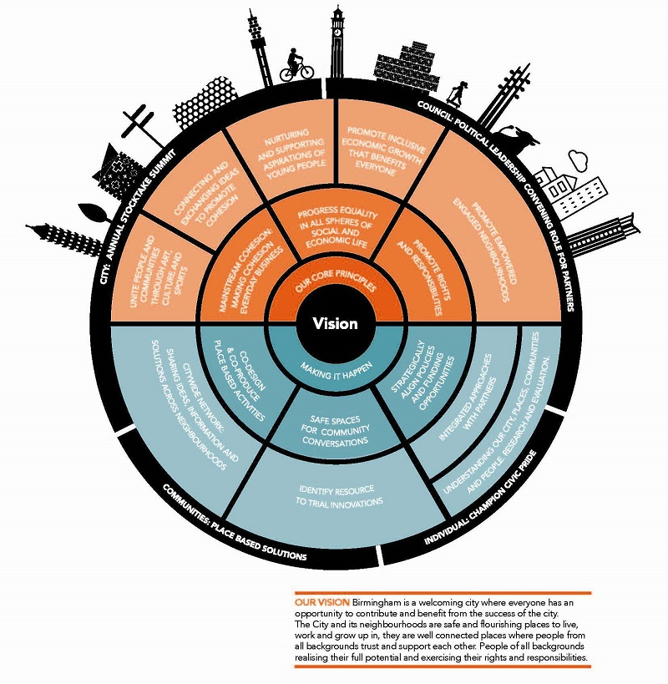
Leadership
Strong balanced leadership and a long term commitment is needed from across communities, individuals, public and business sectors, as well as voluntary and community and faith organisations, to deliver the ambitions of our approach.
City: Strategic leaders within their own spheres of influence will drive policy and practice to address the drivers of social and economic inequality that undermines the cohesion of the city. City leaders will mobilise their collective resources, influence and expertise to promote Birmingham as great place to live, learn, visit and to do business. They will also be ready to respond to any risks that threaten the security and safety of our city; all of which are important to creating better and safe environments, promoting greater economic participation and more cohesive communities. There will be moments when strategic partners, at a city-wide level, can celebrate success, confront challenges together and share learning from local initiatives.
Council: The council will fulfil its democratic mandate from Birmingham communities to provide leadership and accountability on promoting cohesion. Equally, it will provide strong cross-party political leadership, influencing policy at a city, regional and national level; and continuing to work with government on dismantling structural inequalities that undermine cohesion of the city. The council will also play a convening role for partners that go beyond the ‘usual suspects’ to share and exchange ideas and champion ‘what works’. Similarly, it will monitor and respond to any local or national influences that threatens cohesion. It will be vital to support a robust evidence base by working with partners and communities to collect and analyse data and local intelligence from national and local sources.
Community: Neighbourhoods are where many people construct a sense of place and identity. Local communities and individuals have a crucial role to play in building resilience by supporting each other to overcome challenges, hardship and divisions. The voluntary, community and faith sector organisations are well placed to provide leadership in identifying and supporting community based solutions. There is strong evidence that is already happening across the city and we will build on this by supporting the sector.
Individual: Individual action and championing civic pride makes a positive contribution to cohesion. There is a range of ways in which individuals can promote cohesion. Engaging in volunteering can empower individuals to affect positive change and form networks with new people in their communities, participating in civic life and design the right solutions that promote cohesion. Everyone should challenge and reject all forms of discrimination and extremism that undermine equality and fairness; gender based violence, harmful sociocultural norms and practices.

ST. PAUL’S COMMUNITY DEVELOPMENT TRUST

St. Paul’s Community Development Trust is a charity that was established by three small groups working with the community of Balsall Heath. The Trust works with and alongside children, young people, and adults in Balsall Health and the wider neighbourhood to promote education, recreation, and life-long learning.

The Trust provides a number of services, including an independent school, Early Years Services, nurseries, St Paul’s City Farm, and the Ellen Gee canal boat. Across these different services, the Trust delivers and facilitates a wide range of events and activities including:
- #GetBalsallHeathReading – a literacy campaign in partnership with Smartlyte which aims to improve the skills of parents to enable them to better support their child’s development, enhance their own social mobility, and create a more integrated community;
- Coffee mornings – an opportunity for people aged over 50 to have refreshments, socialise, and take part in activities at the Trust’s farm;
- Housing, benefit and debt advice – working in partnership with Narthex to offer free advice for local families;
- Talking Together Stay and Play – sessions for parents/carers and their children to learn English through play and fun activities.

The Trust is dedicated to working for and with the local community to help secure better opportunities and better quality of life for people who are disadvantaged in a deprived area of the city.

Website: www.stpaulstrust.org.uk
Smartlyte: www.smartlyte.co.uk
Narthex: www.narthex.org.uk

How do we make it happen?
Translating the ambitions of the strategy will require action from across all sectors and communities. As a city we will make the best of our resources and assets to deliver on tackling the stubborn drivers that undermine cohesion. As start we will work on:
Understanding our city and communities: building a strong evidence base
We will develop evidence based approaches to promote community cohesion. Aston University will convene a research and intelligence group including academics, government, public agencies, social researchers, and the voluntary/community sector. This is a central aspect to building our knowledge and understanding of the dynamic nature of diverse communities. Continual research and analysis of the challenges and opportunities will enable evidence based policy and decision making. We will do this by:
- Identifying trends by city-wide data collection and analysis of quantitative and qualitative research that takes a deep dive into root causes, risks and quality of life/wellbeing factors
- Developing and publishing a set of robust measures and indicators to monitor how Birmingham is doing overall and evaluation of interventions.
- Capturing data from local community insights and narratives, local Voluntary Community Sector (VCS) and councillors. Using different channels to capture data including social media and online platforms.
- Building on global, UK and regional insights - looking at ‘what works’ and lessons for Birmingham.
- Setting measures for community cohesion and support the collection of data and its analysis.
This approach will help us monitor progress and impact.
A strategic partnership-led approach
Through strong partnerships we will help create the conditions for a fairer and cohesive city. Making a success of our approach will require leadership and commitment of our partnerships which underpin our approach to span the public sector, faith and community organisations, communities, universities, colleges and schools, the business community, and the arts and cultural sector. Our collective approach will enable individuals, families and communities to take control of their own lives and participate fully in the social and economic life of the city. We will do this by:
- Continuing to build on the work of our existing partnerships where community cohesion is integral to the successful delivery of their plans and strategies, including (but not limited to): Birmingham Community Safety Partnership, Financial Inclusion Partnership, City Partners, Birmingham Social Housing Partnership, Birmingham Education Partnership, Birmingham Migration Partners, Birmingham Health and Wellbeing Partnership and Child Poverty Action Forum.
- Where it makes sense for Birmingham, we will strategically align our approach to national and regional policies, including the Government’s Integrated Communities Strategy and the West Midlands Combined Authority’s approach to inclusive growth, and work constructively with national and regional teams.
- Birmingham Partners will work with local communities to hold an annual programme of local community events across the city. The Community Cohesion Summit and local events will enable communities, council and city partners to understand and respond to the changing needs of our city and communities; share learning and exchange ideas; forge new relationships and identify opportunities for joint working; evaluate our learning and identify what works and what doesn’t, and collectively respond to new opportunities and challenges. It’s crucial that we continuously learn and take stock of our approaches through ongoing dialogue and engagement between communities, practitioners and partners from different spheres of influence.
- The 2022 Commonwealth Games presents a great opportunity for Birmingham and its citizens to capitalise and build on our rich and diverse sports and cultural offer. The Games aim to provide a number of key opportunities for our citizens to engage in and benefit from, including:
- Chances for our citizens to get active and feel healthy, both physically and mentally;
- Making the city more connected and encourage more active travel by extending and enhancing walking/cycling networks and cycle schemes;
- Recruiting approximately 12,000 volunteers (reflecting the diversity of our city) to welcome people to Birmingham during the Games;
- Delivering a cultural programme that includes and reflects Birmingham’s diverse communities.
Inclusive growth that benefits everyone
We want the city’s economic prosperity to benefit everyone. We will work with the West Midlands Combined Authority to deliver their ambition to “link cranes with communities”, so that investment into transport, homes, and business premises benefits all citizens. We will do this by:
- Making the most of High Speed 2 (HS2), a major new planned rail line linking Birmingham, London and cities across the North, estimated to create around 15,000 jobs by 2020. A programme of activity will support local people into secure employment across a range of construction, planning and engineering opportunities arising through the delivery of HS2. The National College of High Speed Rail based in Birmingham will train engineers and upskill the workforce. The HS2 programme will coordinate and promote a ‘HS2 ready’ careers inspiration programme offer to young people in schools, colleges, universities.
- Continued engagement with the business networks such as the Thrive network and big sector business across the city will play a crucial role in career advice and development. Members of the business community can make a valuable input not only in advising pupils on the range of career opportunities available but also drive the direction of schools through for example, sitting on their governing bodies.
Targeted and place-based activities
We want to pool our collective assets, expertise and experiences to locally target some of the stubborn and complex issues that undermine community cohesion. We will do this by:
- Encouraging all schools to be awarded Rights Respecting School status to improve well-being and develop every child’s talents and abilities to their full potential.
- Protect vulnerable young people from violence and crime. We will work with partners to deliver a range of activities that will work on preventative activity.
- Remove barriers to communication: Birmingham City Council will work with communities and partners to promote an offer of English provision that is flexible and responsive to individual’s needs. We will build on the Council’s programme of ESOL provision including, ESOL for Work, engaging employers to promote English at work and Voluntary Sector organisations to support flexible delivery of provision that leads to confidence and fluency in speaking, reading and writing in English.
- Tackling homelessness: there are two key stages to tackling homelessness: prevention and support at an individual’s crisis point. Earlier this year, Birmingham launched its homelessness prevention strategy which is a partner-led strategy and a joint commitment from those across public, private and third sector organisations to work together to eliminate homelessness in Birmingham. This recognises that homelessness can affect anyone at any stage of their lives and seeks to identify those who are at high-risk and to prevent them from becoming homeless. Extensive work is also taking place to support those who are already sleeping rough with multi-agency teams set up to offer guidance and help to individuals who have multiple and complex needs.
- Intercultural and interfaith conversations and action to create mutual understanding and trust. We will design local events to bring different ethnicities and faith communities to share their cultural and social life.
- Co-designing and co-producing local solutions that promote an asset based approach to local problem solving, such as improvements to open public spaces; friends of local parks groups; and community clean-ups. This approach enables individuals and communities to find local community-led solutions; encourage collective action to build stronger and more resilient places.
- We will establish a city-wide network and a repository that will facilitate sharing ideas, information and solutions across a network of neighbourhoods. Gather good ideas and good practice from around the country and communicate it widely to enable people to be inspired by things happening elsewhere.
- Local Councillors in their community leadership role will deliver on Localism by working with communities and local organisations to design place based approaches that shapes council policy and practice.
Measuring and monitoring where we are making a difference
It’s important for us to know if and where we are making a difference: to know which policies and initiatives are working and which are not. This will help us identify any gaps, and where more work and investment is needed.
We will do this by:
- Developing performance measures to help monitor improvements and gaps.
- We will work with communities to develop indicators to measure success in different settings.
- We will use our annual residents’ survey to measure community cohesion.
Identify resources to trial innovations
To support the effective delivery of the strategy will require resources to innovate, upscale and test out new ideas by looking at how we can reshape our existing resources. The impact of austerity and reductions in public sector provision on community cohesion was an overwhelming concern from the responses to the Green Paper.
Reducing public sector resources and provision are having worrying consequences on community cohesion. However, there are opportunities around strategic agencies, schools, higher and further education organisation and VCS working in-kind or with project funds in a co-ordinated approach to shared actions. Many respondents offered ideas and how their respective organisations could play a role. Similarly, opportunities arising from Trusts and other funders can sponsor activity that promotes cohesion. Equally, we will work with Government departments and the West Midlands Combined Authority to explore piloting activity that promotes community cohesion.
APPENDIX A
______________________________________
ACKNOWLEDGEMENTS

Thanks to all the individuals and organisations that contributed their time and expertise to this strategy, including:

Written submissions
ACAS
Acocks Green Neighbourhood Forum
Aston University
Birmingham St Mary’s Hospice
Birmingham SACRE
Culture Central
John Taylor Hospice
NHS Birmingham and Solihull Clinical Commissioning Group
University of Birmingham
West Midlands Police

Focused discussions facilitated by the following organisations and supported by Suwinder Bains and Naomi Todd, Strategic Policy Team, Birmingham City Council

Birmingham Aspiring Youth Council: Darnish Amraz and Tom Muirhead, Youth Service
Balsall Heath Children's Centre - Hafsha D Shaikh, SMARTLYE & Alison Moore
Birmingham Social Housing Partnership - Sophie Hall
Concord Youth Centre – Habib Ullah, Youth Service
Naseby Youth and Community Centre – Surinder Ark-Sandal, Youth Service
Oakland Young People’s Centre – Habib Ullah, Youth Service
Nechells POD – Noran Flyn & Shantel Carty
SMART Women – Rubina Tareen,CEO
Thrive - Nick Venning and Fidelis Navas (Co-chairs)
United Midlands Black Organisations – Ricky Delany (Co-chair)
Voluntary & community network with Women Acting In Today’s Society (WAITS) – Marcia Lewision, CEO
Women to Women Forum – Rahila Mann, Prevent Engagement Officer

Birmingham councillors and officers who contributed to the Strategy:

Councillor Tristian Chatfield, Cabinet Member for Social Inclusion, Community Safety and Equalities
Councillor Ian Ward, Leader of Birmingham City Council
Councillor Ewan Mackey (Con)
Councillor Roger Harmer (Lib Dem)
Jonathan Tew, Assistant Chief Executive
Suwinder Bains, Cohesion and Partnership Manager
Naomi Todd, National Graduate Development Programme (ngdp)
Mary Crofton, National Graduate Development Programme (ngdp)
APPENDIX B
______________________________________
CASE STUDIES

Highlighted below are more examples of projects and services that are helping to develop community cohesion in neighbourhoods across Birmingham.

CLIMATE ACTION NETWORK WEST MIDLANDS

Climate Action Network West Midlands (CANWM) is a free and open network that aims to increase public awareness of and engagement with tackling global warming. CANWM works with individuals, environmental groups, community groups, faith networks, sustainable businesses, local authorities, and others to develop and distribute information on the causes and impacts of global warming, as well as supporting community-level action.

As part of their work, CANWM has delivered workshops on key topics, including transport, food, energy and resources, housing, employment, and education. As part of their current work, the network is focussing on how the region can deliver an environmentally friendly 2022 Commonwealth Games.

CANWM is built on the ethos that we’re stronger together, and it centres on establishing connections between people who share similar aims and values. The network brings together people from different backgrounds and spheres, whose actions span from personal to political and from local to national to global.

Website: www.climateactionwm.org.uk

THRIVEBRUM

ThriveBrum is a volunteer-led network that promotes Responsible Business in Birmingham. Founded in 2005, they aim to identify and share best practice in the field of Responsible Business / Corporate Responsibility / Sustainability in order to make best practice become universal across the city. Their three key objectives are to:
- Share - provide a platform to share good practice;
- Promote - connect people to share our goals; and
- Do - help employers be responsible with practical action.

The network organises a range of events and campaigns with policy makers, practitioners, businesses and academics, for example they have an active LinkedIn group with more than 450 users and 700 followers on Twitter. They also organise an annual summit in partnership with Aston Business School. These open events explore ideas to promote responsible business and effective policy making that creates a fairer city for everyone.

Website: https://www.thrivebrum.org/

BIRMINGHAM SACRE

Birmingham’s SACRE (Standing Advisory Council on Religious Education) is one of the most active in the UK. It’s sixty or so members drawn from faith and non-faith communities work together to agree a syllabus for the teaching of Religious Education in school. This syllabus is mandatory for those schools that are run by the local authority but many academies, free and independent schools choose to follow the SACRE syllabus. Consequently, 80% of all Birmingham primary schools and 53% of all secondary schools use the agreed syllabus.

SACRE’s entitlement statement, last revised in 2015, is clear in its regard for Community Cohesion:

“… the focus of RE is the development of character of pupils with 24 dispositions that will enable pupils to live well and in harmony with their neighbours…pupils have the right to learn about a range of faiths found in the City of Birmingham as well as the tradition to which their family may belong.”

The Syllabus revolves around the 24 dispositions. These are a set of values that have been agreed by SACRE. They are wide ranging for example ‘Appreciating Beauty’, ‘Living by Rules’ and the particularly pertinent ‘Creating Unity and Harmony’ and ‘Cultivating Inclusion, Identity and Belonging’.

Birmingham children that follow the SACRE agreed syllabus have values-based lessons using the disposition as a starting point. Over time, children of all faiths and none will see the dispositions being exemplified through the nine largest religious traditions in Birmingham and from non-religious world views. Children find out that all the City’s faiths believe in the same basic values and that these are in harmony with national government’s British Values. First and foremost, our children are therefore learning FROM faith rather than learning ABOUT religious traditions.

A dedicated web site provides primary schools with routes through a comprehensive lesson bank, the lessons being selected and ordered so that children start to explore the disposition through the most prominent religious tradition or universal view in their school. The lessons use the scriptures from faith traditions as well as first-hand contemporary examples of faith in action often from an extensive bank of films made in Birmingham.

You can see a trailer for the films at https://app.box.com/v/BirminghamSACRE

Website: https://www.faithmakesadifference.co.uk

CULTURE CENTRAL

Culture Central is a collective voice and development body for culture in the Birmingham City Region and its purpose is to make the region an internationally recognised place for culture and creativity. Culture Central is committed to developing and leading projects, alongside other leadership bodies in the city region, that have the potential for a positive impact on both the sector and on the region alike. Culture Central prides itself on their inclusive understanding of culture, and it covers everything from heritage to ballet, and bhangra to virtual reality.

Working with organisations and institutions of all sizes and all interests is a key part of this work and Culture Central engages with major anchor institutions (such as universities and businesses) as well as smaller creative businesses and arts organisations. This collective approach makes sure cultural and creative industries can play a central role in important strategic initiatives relating to skills, economy and community development.

Website: www.culturecentral.co.uk

COMMUNITY ENVIRONMENTAL TRUST

The Community Environmental Trust (previously called the Castle Vale Community Environmental Trust) was set up during the regeneration process of Castle Vale and was tasked with ensuring that the regeneration took into account the environment at all stages of the process.

Towards the end of the regeneration process, the Trust started to focus on projects that benefitted Castle Vale but could also be run in other areas of Birmingham. The Trust is now an integral part of the environmental movement in Birmingham and has partnerships with charities, community groups, the City Council, and other groups across the city.

The Trust supports and delivers a number of projects, including:
- Forest Schools – an innovative educational approach of playing and learning that uses the environment as a tool to develop children’s personal, social and emotional skills, including engaging with children with additional support needs;
- Confidence Through Conservation – a project for those interested in the environment to protect and improve these areas while gaining valuable transferable workplace and practical skills;
- Community Garden – a project that enables residents who wouldn’t normally be able to participate in gardening activities in a safe and friendly environment to do so, while also promoting intergenerational socialising.

The Trust enhances community cohesion and local resilience by enabling people to explore, improve, and benefit from local community assets, bringing people together who would not usually socialise, and promoting healthier life choices.

Website: www.environmentaltrust.org.uk

ST BASILS

St Basils is a local charity that works with young people aged 16-25 who are homeless or at risk of homelessness across the West Midlands. St Basils has a range of prevention, accommodation, and support services to help young people regain the stability they need to rebuild their lives, gain skills, training and employment and move on. Their aim is to help young people successfully break the 'cycle of homelessness' so that they can go on to experience a bright, fulfilling future and never return to a state where they are at risk of homelessness again.

Some of St Basils’ services include:
- Schools Training and Mentoring Project - Awareness raising with young people about the causes of homelessness and where to go for help before situations escalate
- Family Mediation Service - Support for young people who are in conflict with family/carer which may result in them becoming homeless
- Learning, Skills and Work - Supporting young people to engage in meaningful activities including employment, education, and training
- Supported Accommodation - Offering young people accommodation with different levels of support to ensure they can live independently once they move on

Website: www.stbasils.org.uk

NECHELLS POD

Nechells POD is a charity that works with local schools, voluntary and statutory organisations, and local partners to support the Nechells Community by providing advice, information and guidance, diversionary activities, adult and family learning, and parent support. It provides a safe and welcoming space in which residents can get together to participate in a wide range of activities and access services that empower them to lead self-determined, fulfilled lives, and feel a sense of belonging to their community regardless of age, gender, race, faith or social background.

Some of these activities include:

- Nechells Safe Haven – A project that aims to engage residents in activities that improve community cohesion and reduce social isolation, engage residents in training, volunteering and self-development activities, and ensure residents experience improved mental and physical well-being through participation in activities that promote healthier lifestyles
- Parent and Child Language Course – Offers parents and toddlers whose first language is not English the opportunity to learn the language together
- Summer Reading Challenge – Taking part in the Reading Agency’s annual reading challenge that rewards children for visiting their local library and reading during the holidays
- Cook and Taste – Working with Food Net to improve the nutrition and diets of Nechells’ residents
- Meetings with West Midlands Police – Holding regular meetings with the police for Nechells’ residents to keep up to date with what is happening in their neighbourhood

Website: www.nechellspod.com

UNICEF RIGHTS RESPECTING SCHOOL AWARD:
CELEBRATING CHILDREN’S RIGHTS

The UNICEF UK Rights Respecting School Award (RRSA) is based on principles of equality, dignity, respect, non- discrimination and participation. The RRSA seeks to put the UN Convention on the Rights of the Child at the heart of a school’s ethos and culture to improve well-being and develop every child’s talents and abilities to their full potential. A Rights Respecting School is a community where children’s rights are learned, taught, practised, respected, protected and promoted. Young people and the school community learn about children’s rights by putting them into practice every day.

Birmingham City Council has developed a partnership with UNICEF to train and support Birmingham schools in becoming Rights Respecting schools. The initiative has been promoted through the safeguarding networks and has been introduced as a long term approach to building resilience, improving safeguarding and community cohesion. The programme has grown at pace and we have engaged 200 schools across all phases and designations.

Birmingham nursery schools are first in the country to run this programme of activity.

APPENDIX C
______________________________________
FACTORS AFFECTING COMMUNITY COHESION IN BIRMINGHAM
Factors that affect community cohesion are complex and multi- layered. These include: ethnicity, identity, where people live and socialise, social and economic status, national and local politics, crime, civic participation and social capital and immigration.
Social and spatial segregation
Segregation can be broadly divided into two types: spatial segregation (the physical/geographic separation of certain groups), and social segregation (groups living in the same geographic area but not interacting socially).
The most common way to measure neighbourhood segregation is by calculating the Index of Dissimilarity (IoD). The IoD is a measure of the evenness with which two groups are distributed across a geographic area. The higher the IoD score, the more segregation exists. A maximum score of 1 would mean a community where two groups are completely segregated. An IoD score of 0 would mean that two groups are exactly evenly distributed.
In Birmingham the IoD score between white and non-white ethnic groups was 0.49 in 2011 (the last year for which we have data). This is a decrease of 8.9% since 2001, which means between 2001 and 2011 Birmingham on the whole became less segregated between white and non-white ethnic groups.
Levels of segregation are different between wards as shown in the above graphic. In 2011, the most segregated wards in terms of ethnic identity were Washwood Heath, Sparkbrook and Bordesley Green. The least segregated wards were Edgbaston, Hall Green and Stockland Green.
There is a strong association between spatial segregation and deprivation. Often it is the neighbourhood you live in, rather than your ethnic identity that has the biggest impact on your chances of living in deprivation. The term ‘neighbourhood effect’ describes the impact that living in a certain place can have on the life trajectories of individuals.
Segregation does not just occur along the lines of ethnic identity alone. We are also seeing an increase in economic inequality between neighbourhoods. A more sophisticated debate is need on how we define and agree our understanding of segregation, so that our policy responses consider the whole range of factors affecting community cohesion.
Neighbourhood deprivation
Despite the efforts of successive initiatives, community cohesion becomes a particular challenge in neighbourhoods and areas in which communities have not benefited from the perceived economic growth experienced in other parts of the city. This leads to a sense of being ‘left behind’ and that wealth is not fairly distributed, instead offered to other areas and communities. These real concerns of marginalised communities cause misunderstanding and mistrust of other areas and communities. Part of the problem has been historically flawed social and economic policies and planning programmes that have allowed some areas in the city to fall into decline, where High streets are lined with betting shops, fast food outlets and off licences; local parks and public spaces become unsafe because of gangs, anti-social behaviour or littered with drug paraphernalia; homelessness, crime and poor housing.
Our population
Birmingham is a growing dynamic and vibrant global city with a population of 1.15 million people; it is the second largest city in the United Kingdom. Our growing and diverse population presents both strengths and challenges for the city.
In the next five years we will see a population growth of 3% - largely due to ‘natural changes’ of more births than deaths.
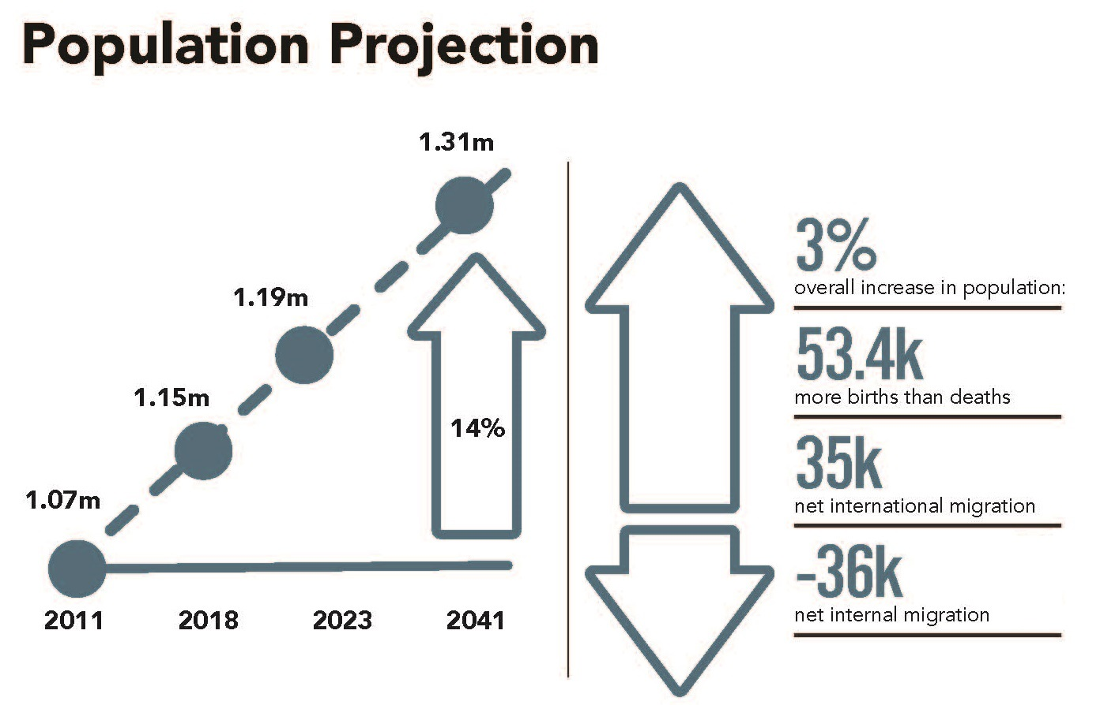
A young city
We are a young city, 46% of our population is aged under 30. Having a younger population means a larger pool of working age residents for businesses to draw from and great potential for the economic growth of the city. However, low skills and educational attainment, poverty and poor health are holding back some of our most disadvantaged young people.
Based on 2016 ONS projections, between 2018 and 2022 children under 15 are due to grow by 3%. Of these, children aged 0 to 4 are due to grow by 1.5% to 86,000 children, but the latest growth rate in Birmingham children will be the 10 to 14 age group – increasing by 6.0% to 84,900.
More than 40% of Birmingham’s school children have a first language that is known or believed to be other than English (42%). Growing school age population places demands on school places and good quality childcare. Educational attainment levels vary in relation to different areas of the city and social backgrounds. Schools are places that cultivate and promote social cohesion; bringing children of different backgrounds to build tolerance and understanding of different cultures and faiths.
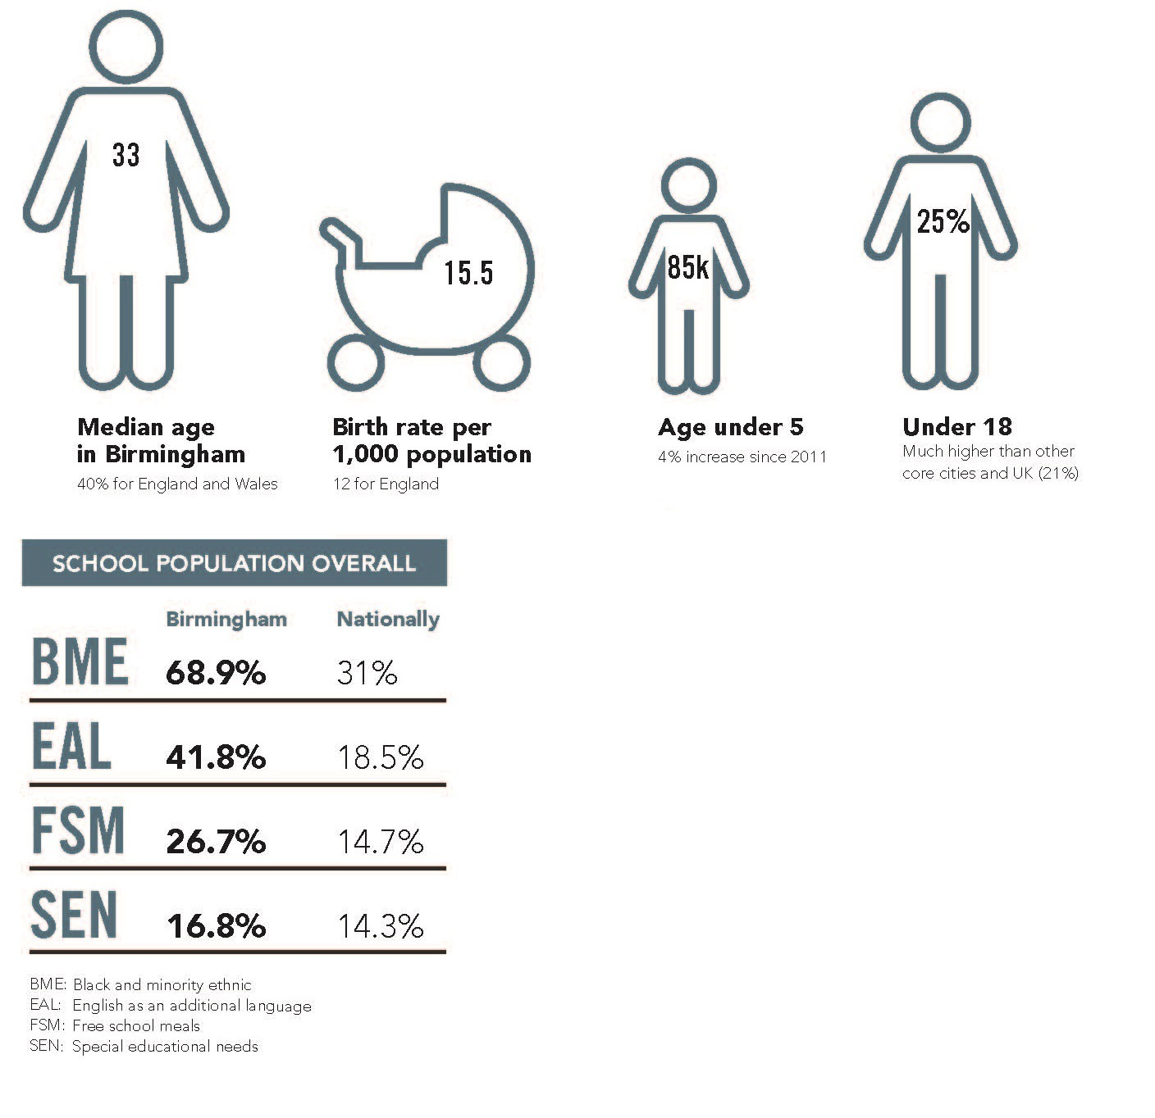
Outer city areas worst performing at key stage 4
Chart 3.8 shows Birmingham compared to the national performance, along with the three best and worst performing wards for each Key Stage 4 measure. Although Birmingham as whole performs s close to the national average, there are very wide local variations, with the lowest attainment being in general in outer city wards, traditionally white working class areas. White British disadvantaged boys are 18% below the LA average for Key Stage 2, reading, writing and maths. Pakistani disadvantaged boys are 13% below LA and Bangladeshi disadvantaged boys are 2% below LA average
Chart 3.8: Attainment at the end of Key Stage 4 2016
Attainment 8 |  | Progress 8 |  | A*-C in English & Maths |  | English Baccalaureate
Birmingham | 49.4 | Birmingham | 0.00 | Birmingham | 59.9 | Birmingham | 24.6
England | 49.8 | England | -0.03 | England | 63.0 | England | 24.7
Top 3 wards
Edgbaston | 58.0 | Moseley & Kings Heath | 0.49 | Sutton Four Oaks | 86.4 | Harborne | 45.9
Sutton Four Oaks | 58.0 | Harborne | 0.37 | Sutton Vesey | 80.7 | Sutton Four Oaks | 44.7
Harborne | 57.6 | Selly Oak | 0.30 | Edgbaston | 78.9 | Edgbaston | 44.2
Bottom 3 wards
Shard End | 43.8 | Longbridge | -0.30 | Kingstanding | 46.0 | Tyburn | 13.9
Kingstanding | 43.6 | Kingstanding | -0.35 | Tyburn | 45.5 | Oscott | 13.8
Longbridge | 43.5 | Shard End | -0.37 | Ladywood | 43.5 | Longbridge | 12.5

Source: DfE/BCC
Our ageing population
Despite being a young city, we are expected to see a larger growth of older adults age 65+ (6%) and 90+ (10.3%) by 2023.
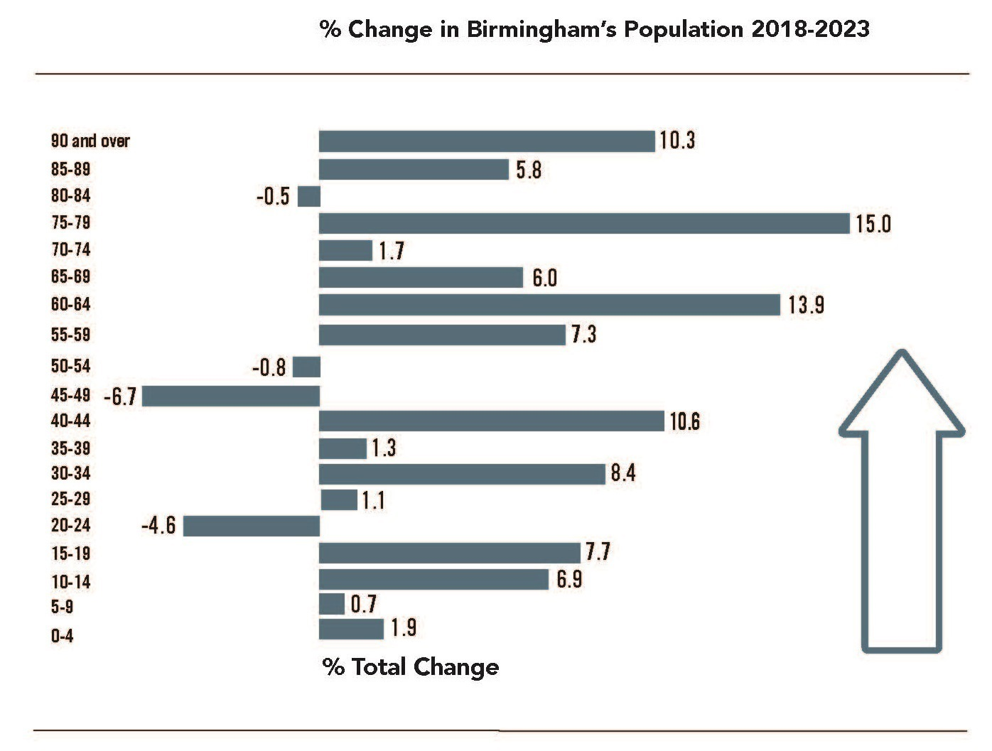
90+
largest growth c. 18%
65+7% growth overal
Source: ONS Mid-2016 Projections

The older adult population has and will continue to rise in Birmingham, with increases of 15% for those aged 85+ years expected in the next 10 years (see infographic overleaf).
With nearly a fifth of households being older people living alone with health problems and/or disability, there needs to be a joined up approach to services that support this vulnerable group.
There are over 100,000 unpaid carers in Birmingham. Carers themselves are ageing; by 2025 it is predicted there will be a 128% increase in carers over the age of 85+ years; a large scale survey of carers found 46% have suffered depression due to their caring role.
Older people living alone or as carers make them vulnerable to social isolation and loneliness, this can have adverse effects on their health and wellbeing and is growing challenge for the city.
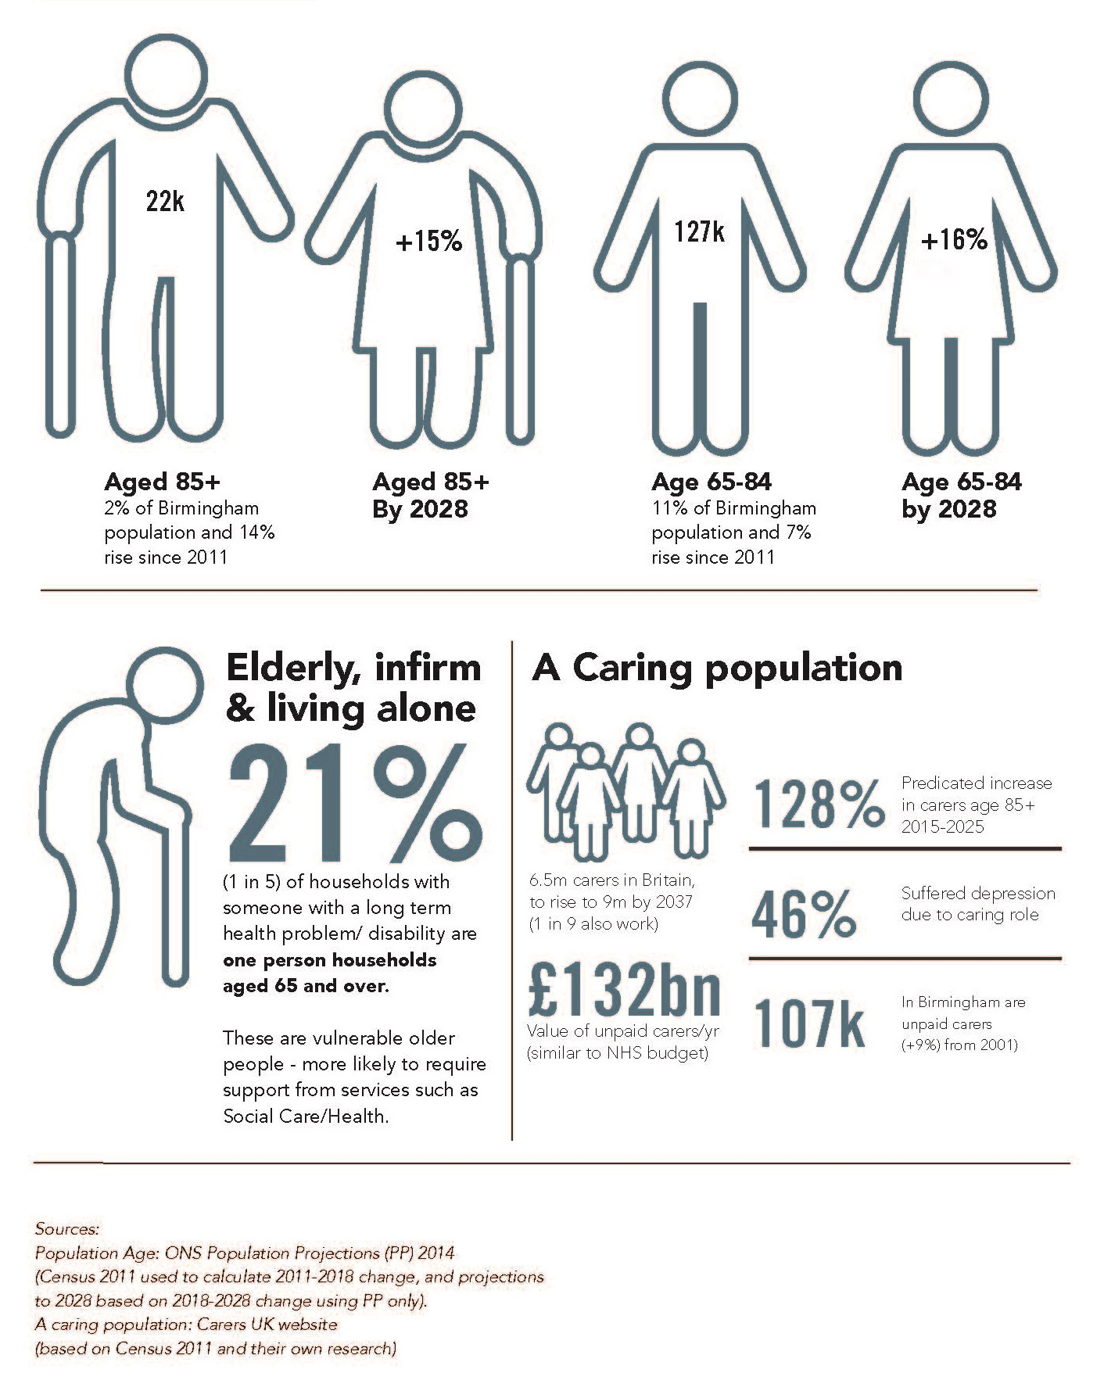
Our diversity
The city is also very diverse, with 42% of the population being from an ethnic minority background, reflecting the city's rich and varied cultural heritage. Birmingham is a “super-diverse” city. Academic research suggests that there are people from nearly 200 countries who have made Birmingham their home.. The 2011 Census revealed that 42.1% classified themselves within an ethnic group other than white British, compared to 30% in 2001, a rise of 12%. Birmingham is soon to become a majority minority city.
The demographic makeup of Birmingham’s young people has also changed significantly over recent years and is becoming increasingly diverse. For example, according to the 2011 census over 60% of the under 18 population is now from a non-white British background, compared to around 44% in 2001.
Ethnic diversity can bring many benefits such as transnational trading links and high levels of cultural resource. Birmingham has benefited from its diverse migrant communities who have settled in the city and successfully contributed to its economic vitality, becoming leaders in education, medicine, sports, arts and business and providing employment opportunities to local people.
Our demographic landscape is increasingly becoming ethnically and socially ‘super diverse’, which means a greater understanding of the changes in cultural norms, identities and social shifts in how we live work and learn is needed. Community cohesion is an approach that enables us to respond to the wide ranging and kaleidoscope of identities, rather than simply focussing on a white majority and small number of ethnic minority identities.

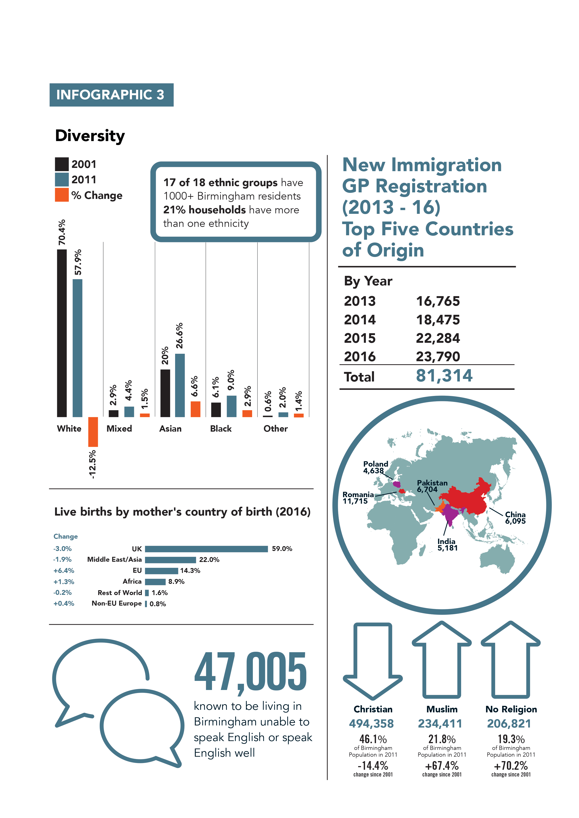
Gender inequality
Birmingham’s population is made up of 50.5% females and 49.5% males. Female residents in Birmingham earn less than males, with average gross incomes for full time workers having a £5k gender pay gap. The city has the second lowest share of women in higher skilled jobs (41.2%) amongst the Core Cities and the rate is lower than the national average (43.0%). The employment rate for working age male residents is 73.5%, while the female rate is 53.5%. Nearly half (48%) of working age black and ethnic minority females residents are economically inactive (not employed or actively seeking work).

Most victims of sexual offences are women (83% of reported total crime victims). Domestic abuse of women and children has been increasing since the economic downturn in 2009. More men are victims of homicide than women, however where women are killed they are more likely to be killed by someone they know.

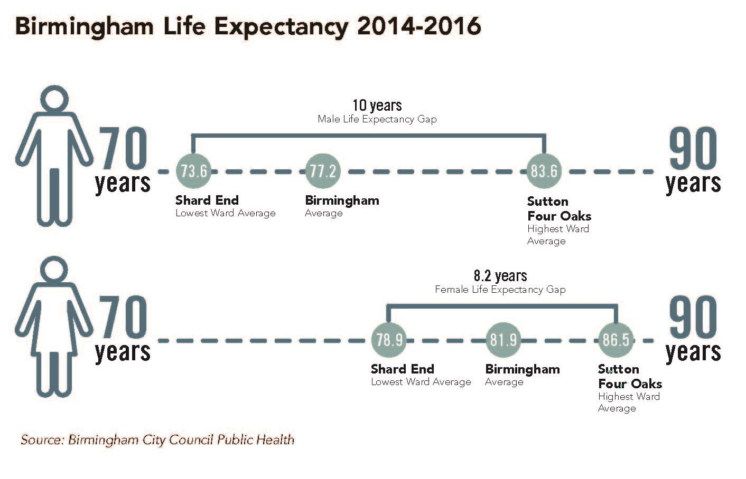
In 2015/16, almost three quarters (74%) of applications deemed homeless and in priority need were female applicants; with 26% being male. If left unchallenged, these gender inequalities based on discriminatory: social norms, values, practice and structures will seriously damage life chances. Notably, social class, race and ethnicity create deeper inequalities and exclusion.

Poverty and income inequality
Poverty and income inequality is a well-researched factor that undermines community cohesion. Birmingham is the sixth most deprived local authority in England according to the 2015 English Indices of Deprivation and 21.3% of Birmingham’s Lower Super Output Areas (LSOAs) were in the 5% most deprived areas in England. Some parts of the city rank amongst the poorest in England.
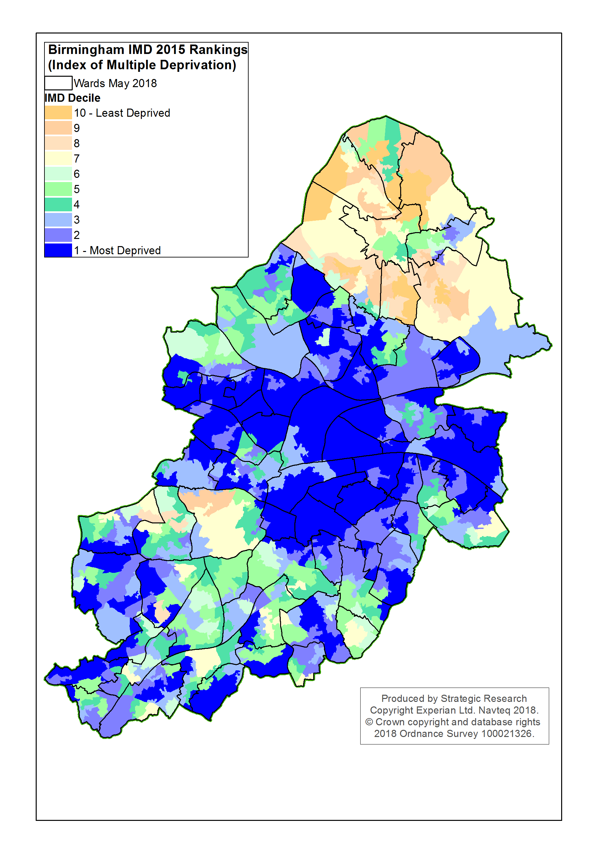

Child poverty
There are neighbourhoods in the city where over 50% of all children are growing up in poverty, two thirds of these children live in working households.
Almost 3 in 10 (29.8%) households with children in Birmingham are living in lone parent households, against an England and Wales average of 25%. According to the Birmingham Child Poverty Commissions report, over half (54%) of parents in poverty believing their children will have a worse life than their own, compared to just 30% of those parents not in poverty.
Families in insecure or low incomes jobs are more vulnerable to financial insecurity. In many cases, taking out payday loans with high interest rates is the only option to meet rising household costs - this can exacerbate an already difficult situation.
Health of our population
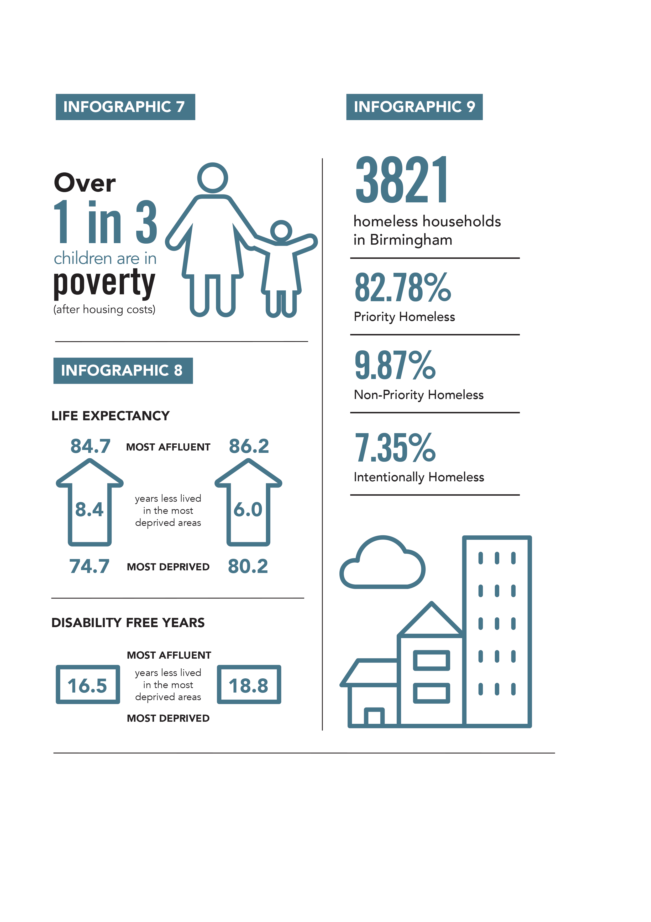
Having good health creates a state of wellbeing. Social factors such as low income, poor and unstable housing and education undermine good health outcomes.
There are significant health inequalities across the city and across different community groups. Earlier deaths, higher rates of ill-health and the socio economic consequences of ill-health such as poverty disproportionately impact on those least economically able to cope. Activities that prevent social isolation promote greater mental wellbeing and quality of life.
Irrespective of deprivation and ethnicity some specific groups often suffer additional social exclusion. Two of these are people with learning disabilities and people with mental health issues. In Birmingham around 1% of supported working age adults with a learning disability are in in paid employment compared to the England average of 5.8%, this relates to just 21 in 2,166 people; and only 4% working age adults who are receiving secondary mental health services and who are on the Care Programme Approach are in paid employment.
Being in employment has clear health and social benefits:
- employment is generally the most important means of obtaining adequate economic resources, which are essential for material wellbeing and full participation in today’s society
- work meets important psychosocial needs in societies where employment is the norm
- work is central to individual identity, social roles and social status
- employment and socio-economic status are the main drivers of social gradients in health

The health inequalities experienced by these two groups are starkly illustrated in their life expectancy. People with learning disabilities die on average 15-20 years younger than the general population, with almost half of all deaths estimated to be avoidable. In Birmingham, the life expectancy of women with a learning disability is 18 years shorter than for women in the general population; and the life expectancy of men with a learning disability is 14 years shorter than for men in the general population. Those with severe mental illness die earlier than the rest of the population, in Birmingham this has been calculated at 19.2 years earlier for men and 14.9 years earlier for women.
Housing and neighbourhoods
Neighbourhoods are local communities of place where cohesion can thrive under the right conditions, including: neighbourliness, mutual support and respect, friendly social interactions, high levels of social capital, decent secure housing. Decent affordable housing creates stability and a sense of belonging. Individuals and families having to move frequently, experience homelessness or are living in temporary accommodation affects their education, health, ability to find sustainable employment, unable to build friendships and social networks.
Due to a shrinking affordable housing sector and rising populations we are experiencing both a national and local housing crisis leading to rising levels of homelessness.
According to the Birmingham Homelessness Prevention Strategy 2017 :

- more than 20,000 (estimated) households in Birmingham each year either homeless, at risk of becoming homeless or transitioning out of homelessness – the overall long term health and wellbeing of the city is under at risk

- There are 4,118 young people facing homelessness in Birmingham, most of whom have been made homeless from their family home (42%).

Homelessness has become a significant challenge for the city. Key drivers for people becoming homeless are short-term tenancies ending and domestic abuse. This instability causes strain on individuals and families. Children in temporary accommodation and poor housing suffer higher rates of ill health, low educational attainment and poor life chances.
Areas with heavily concentrated numbers of houses in multiple occupation (HMOs) can challenge the stability of communities due to high turnover rates and poor housing conditions. HMOs owned by rouge landlords can be unsafe and pose a health risk to tenants. These properties are typically rented by migrant workers and their families, those on low incomes and vulnerable people. Although the Government has taken steps to tackle this issue, more needs to be done locally to prevent rouge landlords exploiting vulnerable tenants.
Jobs and skills

Birmingham has a growing reputation internationally as a city that offers world-class business and cultural facilities. As a key driver of the regional economy, Birmingham is a leading business destination with an economic output of over £26bn. More recently, we have seen major investment in infrastructure such as HS2 and the Midland Metro. The city has also attracted international companies such Deutsche Bank and HSBC. Furthermore, Birmingham offers high quality education facilities through its five universities and ten further education colleges.
Despite these opportunities and successes, unemployment remains high in Birmingham and our skills deficit means people are unable to take up better paid jobs. The City has a higher proportion of working age residents with no qualifications (12.6%) compared to the national average (8.0%) which limits access to employment and training opportunities. Qualification levels are particularly low in the city for some communities. A high percentage of Pakistani and Bangladeshi residents have no qualifications, and a low percentage have higher level qualifications. Around 47,000 people living in in Birmingham are unable to speak English or speak English well.
Discrimination in recruitment, low wages and insecure employment are some of the challenges that hold back the life chances and social mobility of individuals and families. ONS Annual Survey of Hours & Earnings figures for 2018 show 88,000 (21%) employees are earning below the Living Wage.

Being unemployed can have deep seated effects on community cohesion, it impacts on the social stability of families, individuals and communities. The Unemployment rate in the city stands at 7.2% well above the UK rate of 4.3% and the 2nd highest amongst the UK Core Cities.

The latest data for June 2018 shows that the employment rate for Birmingham residents was 64.5%, over 10 percentage points lower than the UK employment rate of 74.9%. Having a decent paid job leads to a good standard of living and financial stability. Equally, the workplace can help develop social connections through daily social interactions between people of different ethnic backgrounds - a driver of social cohesion.
Economic growth and investment is overwhelming concentrated in the city centre, if there is an expectation that this growth will ripple outwards, those living in the outer ring of the city ‘white working class’ are furthest away from any potential benefits. These are some of the conditions that create a mix of low aspiration and low self-worth, isolation, neglect and misunderstandings and tensions. Policy makers, including the council need to involve residents in shaping regeneration plans and policies that affect local areas at the early stages that are based on evidence of need.

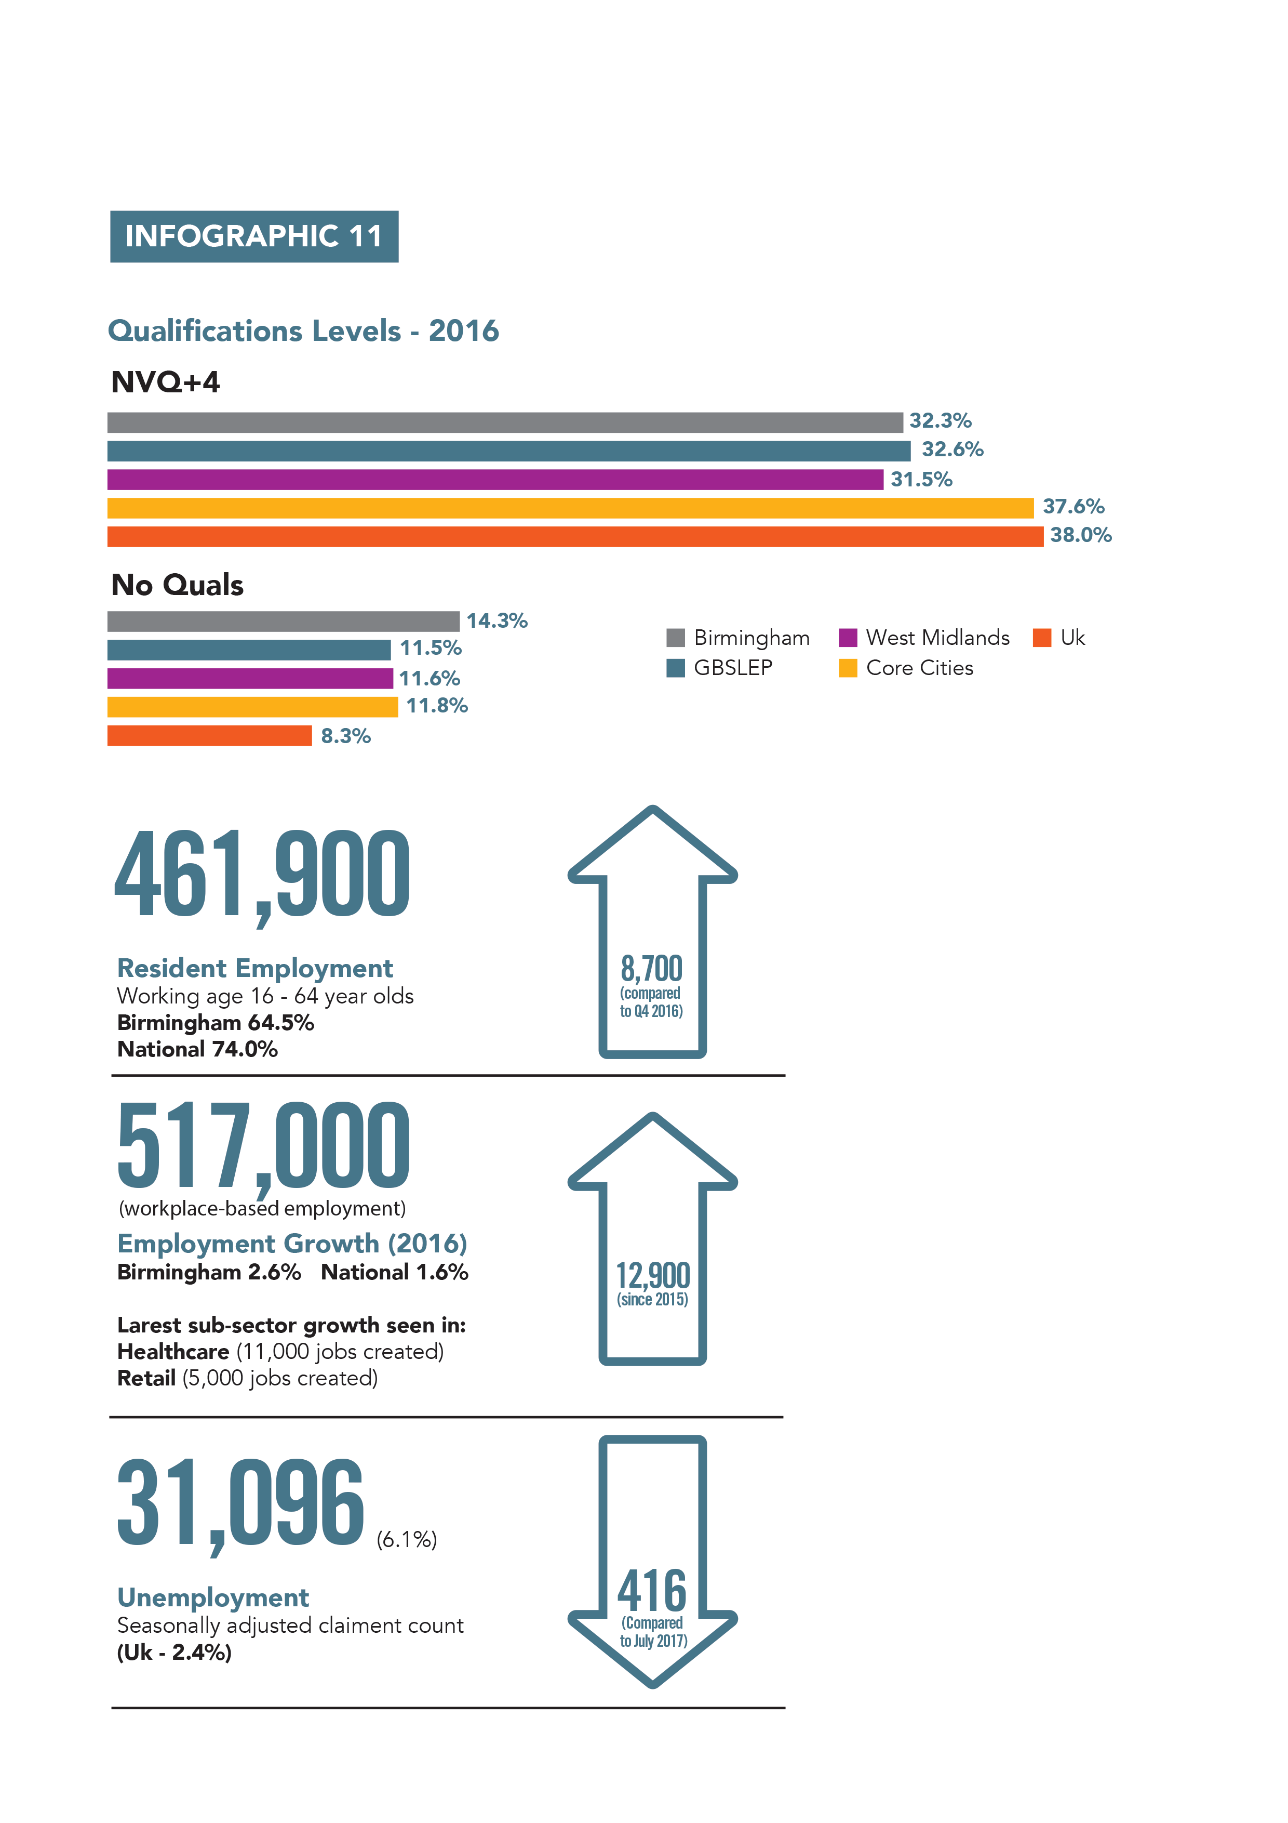

http://image.guardian.co.uk/sys-files/Education/documents/2007/06/14/oursharedfuture.pdf
ttps://assets.publishing.service.gov.uk/government/uploads/system/uploads/attachment_data/file/696993/Integrated_Communities_Strategy.pdf
https://www4.shu.ac.uk/research/cresr/sites/shu.ac.uk/files/community-led-approaches-to-reducing-poverty-in-neighbourhoods.pdf
https://www.placesofwelcome.org.uk/
http://image.guardian.co.uk/sys-files/Education/documents/2007/06/14/oursharedfuture.pdf
https://publications.parliament.uk/pa/cm201415/cmselect/cmeduc/142/142.pdf
https://www.theguardian.com/education/2017/nov/21/english-class-system-shaped-in-schools
https://assets.publishing.service.gov.uk/government/uploads/system/uploads/attachment_data/file/662744/State_of_the_Nation_2017_-_Social_Mobility_in_Great_Britain.pdf
ONS Labour Force Survey
https://www.birmingham.gov.uk/downloads/file/2541/birmingham_employment_update
file:///C:/Users/perasrbs/Downloads/west_midlands_-_mayoral_briefing_online_0%20(2).pdf
Birmingham Homelessness Review 2016, Birmingham City Council
\\Cendmclr\pdt\Equalities and Cohesion\Community Cohesion Strategy\research papers\County Lines National Summary - Simon Ford WEB (4).pdf
https://www.gov.uk/government/publications/lammy-review-final-report
Feedback from young person in inner city ward as part of the Community Cohesion Green Paper Consultation
https://www.wmca.org.uk/media/1420/wmca-mental-health-commission-thrive-full-doc.pdf
https://www.ons.gov.uk/peoplepopulationandcommunity/crimeandjustice/articles/womenmostatriskofexperiencingpartnerabuseinenglandandwales/yearsendingmarch2015to2017
https://the-challenge.org/uploads/documents/APPG-Integration-not-Demonisation-Report.pdf
http://www.legislation.gov.uk/ukpga/2010/15/contents
https://www.wmca.org.uk/media/2218/leadership-diversity-in-the-west-midlands_-002.pdf.
https://birminghamchildpovertyactionforum.org/
Attainment 8 measures the achievement of a pupil across 8 qualifications including maths (double weighted) and English (double weighted), 3 further qualifications that count in the English Baccalaureate (EBacc) measure and 3 further qualifications that can be GCSE qualifications (including EBacc subjects) or any other non-GCSE qualifications on the DfE approved list. ▪Progress 8 is a value added measure and compares the Attainment 8 scores of similar pupils grouped using their prior attainment at key stage 2.
(Institute for Research into Superdiversity (IRiS) University of Birmingham 2013)
2017 Population Estimates
file:///C:/Users/perasrbs/Downloads/Child_Poverty_Commission_Report%20(1).pdf
https://www.birmingham.gov.uk/downloads/file/2531/birmingham_homelessness_prevention_strategy_2017
https://www.gov.uk/renting-out-a-property/houses-in-multiple-occupation-hmo

